<https://www.w3schools.com/REACT/DEFAULT.ASP>

Basics fundamentals

<https://www.youtube.com/watch?v=4UZrsTqkcW4>

<https://www.youtube.com/watch?v=dGcsHMXbSOA>

Code

<https://www.geeksforgeeks.org/axios-in-react-a-guide-for-beginners/>

<https://github.com/gopinav/React-Tutorials>

<https://github.com/gopinav/React-Tutorials/tree/master/React%20Fundamentals>

<https://github.com/gopinav/React-Tutorials/tree/master/React%20and%20HTTP/react-http>

<https://github.com/gopinav/React-Tutorials/tree/master/React%20Hooks>

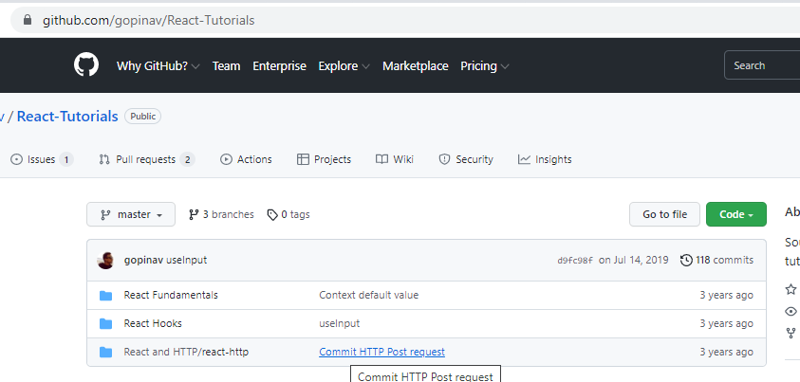

Other videos on full stack react+springboot

<https://github.com/RameshMF/ReactJS-Spring-Boot-CRUD-Full-Stack-App>

<https://www.javaguides.net/2020/07/spring-boot-react-js-crud-example-tutorial.html>

link for the react+boot full video

<https://www.youtube.com/watch?v=5RA5NpxbioI>

<https://www.javaguides.net/2021/07/react-js-react-hooks-spring-boot.html>

<https://www.javaguides.net/2021/08/react-spring-boot-postgresql-crud.html>

<https://www.javaguides.net/2021/01/angular-spring-boot-rest-api-example.html>

check code

<https://www.pluralsight.com/guides/using-react-with-the-history-api>

vidoes

<https://www.youtube.com/watch?v=_rMAnZIcRiU&feature=youtu.be>

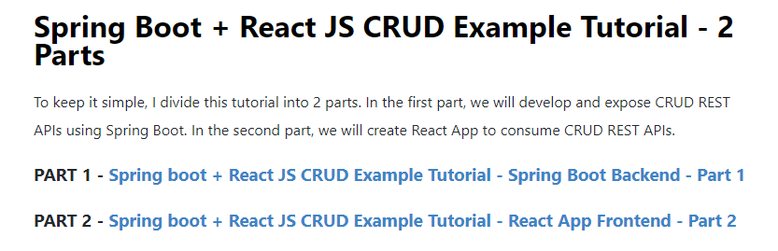

<https://www.javaguides.net/2020/07/spring-boot-react-js-crud-example-tutorial-spring-boot-backend-part1.html>

<https://www.javaguides.net/2020/07/spring-boot-react-js-crud-example-tutorial-react-app-frontend-part2.html>

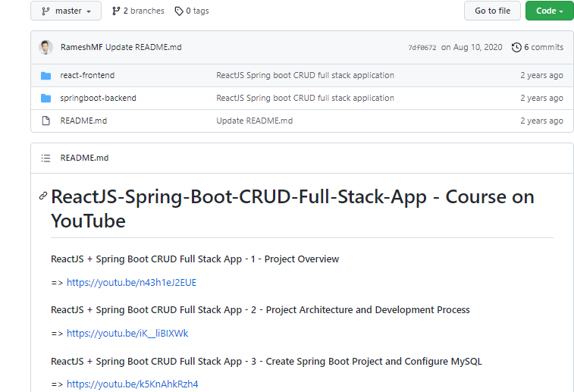

<https://www.youtube.com/watch?v=9hb_0TZ_MVI&list=PLC3y8-rFHvwgg3vaYJgHGnModB54rxOk3&index=2>

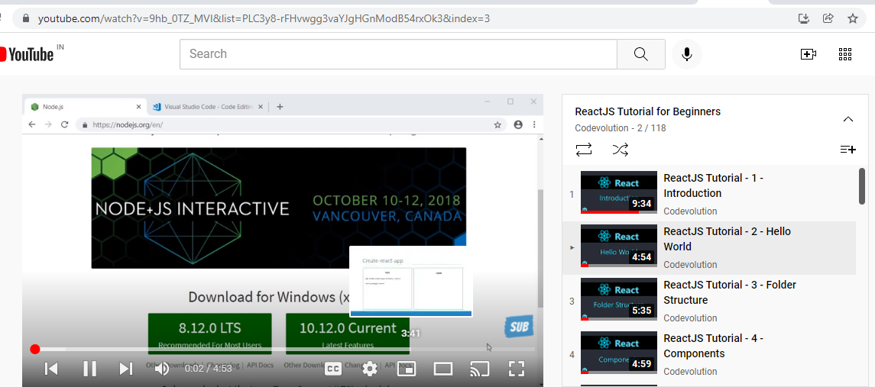

how to create the first react application,

s1-create a folder React- navigate the vscode and open terminal

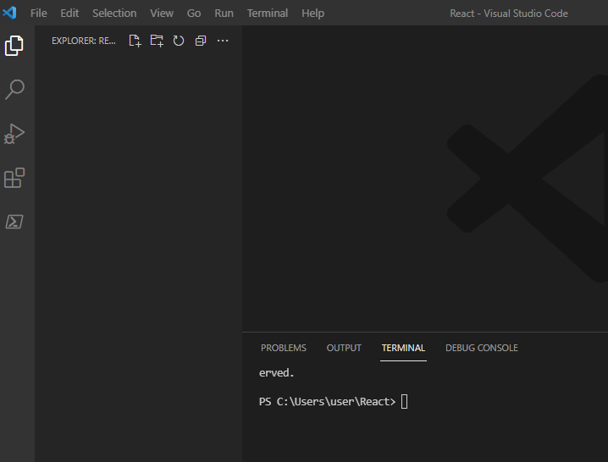

**Create the first app-**

* **npx create-react-app hello-world**

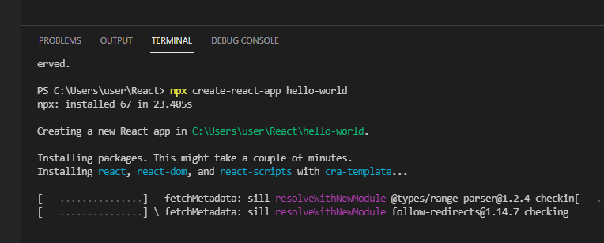

We got the folder

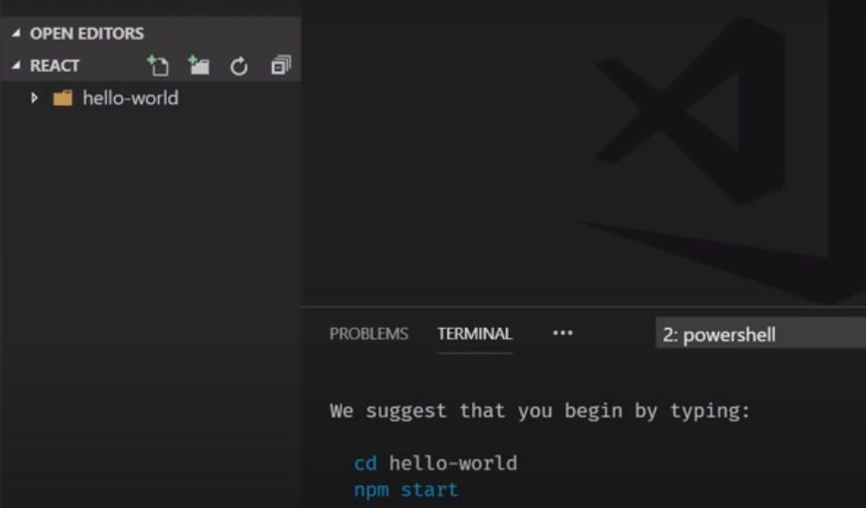

Naviage to cd. Hello-world

Give command **npm-start**

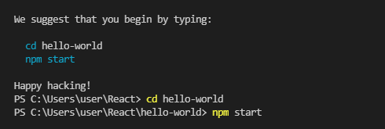

At localhost –its up and running.

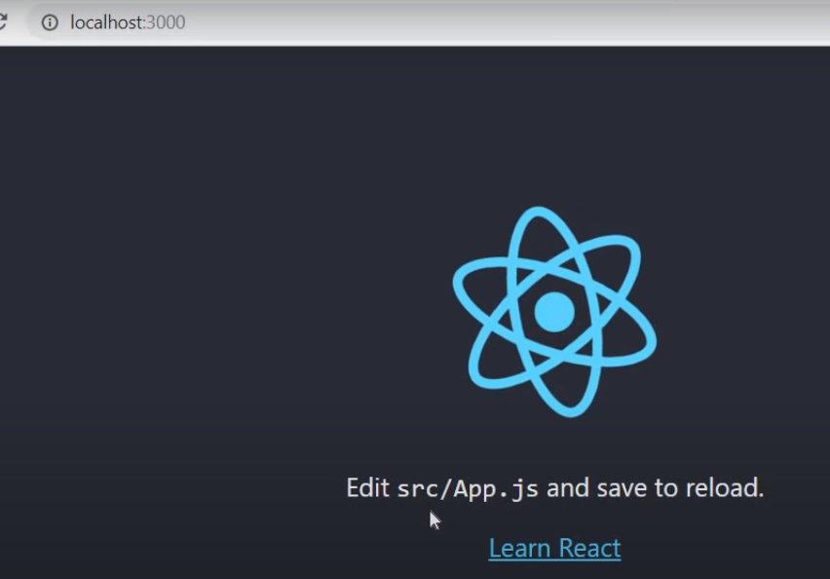

You can edit the content.

Lets go back to the code and edit the content.. expand Helloworld

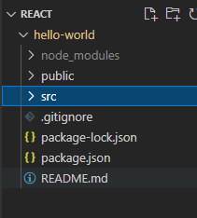

Expand Src-

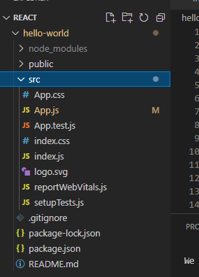

Edit App. Js

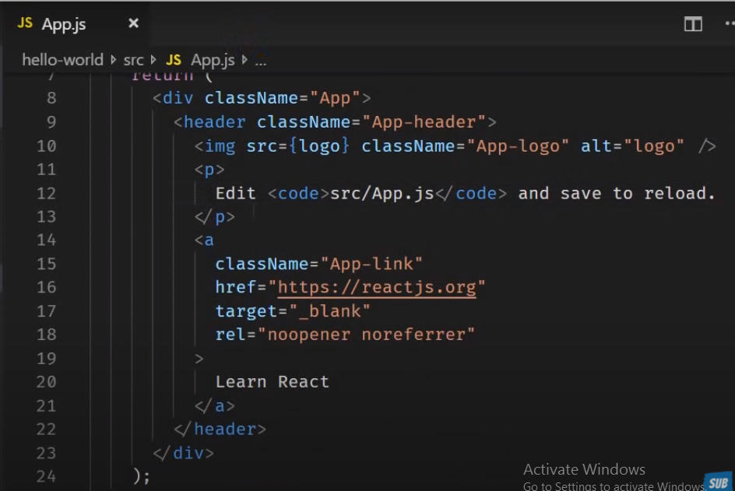

Content is changed

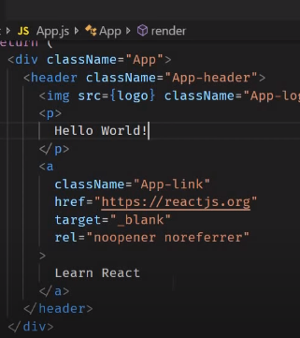

Local host:3000

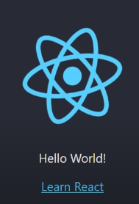

Two ways to create the application

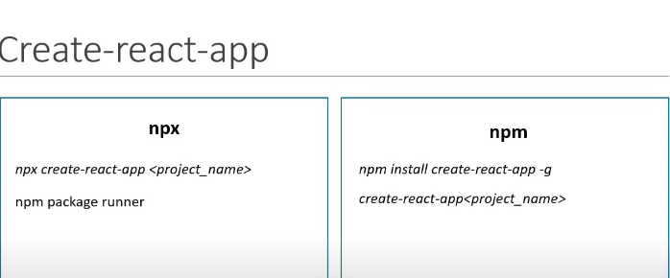

S1- is good approach and required to install package globally –npx will take care

S2-npm is global set up.. need to install package globally and need to update.

Prefer to go s1.

**File Structure : -**

<https://www.youtube.com/watch?v=9VIiLJL0H4Y&list=PLC3y8-rFHvwgg3vaYJgHGnModB54rxOk3&index=3>

**Flow of the Code:-**

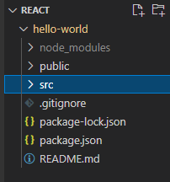

**Package.json**

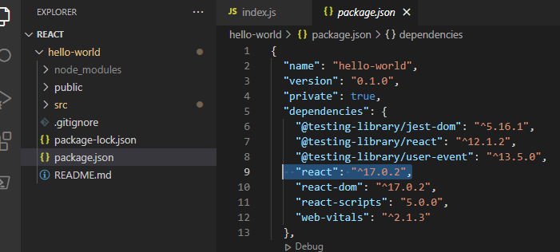

**As we are using the 16.5 version.. react ..**

**We have scripts to run**

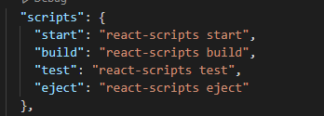

**Package-lock-json- not required to worry- maintain the dependencies.**

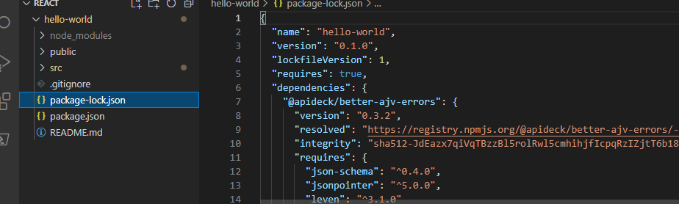

**Gitignore**

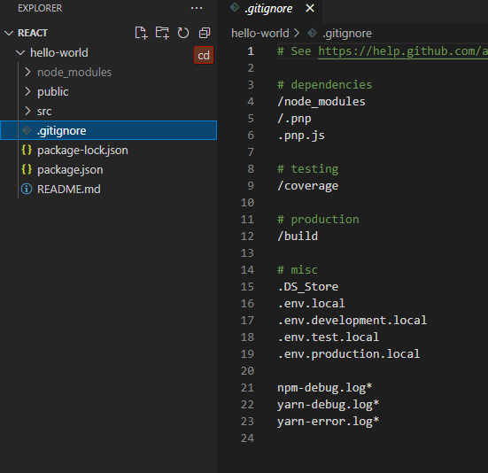

**Coming to node module – all dependencies are install when create–react-app cmd or npm install**

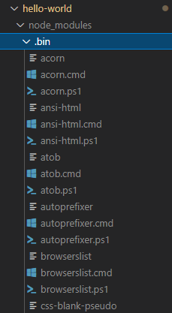

**Public folder**

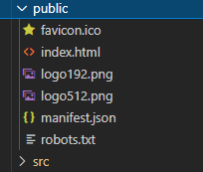

**As beginner we have to concentrate on index.html- its only html file we have in the application**

**We can build the single page application i.e the view can change dynamical in the browser.**

**Typicaly we are not change any code in the html life – that too only head tag not in the body tag.**

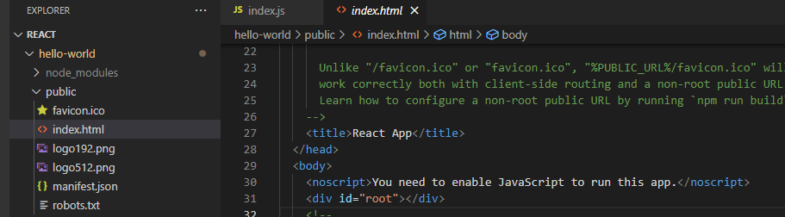

**You want the react –to control the ui ? –**

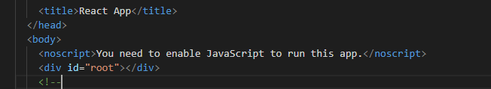

**We will proceeding will learn this root tag.**

**Starting point of the react application is the index.html >> index.js >> App.js>>**

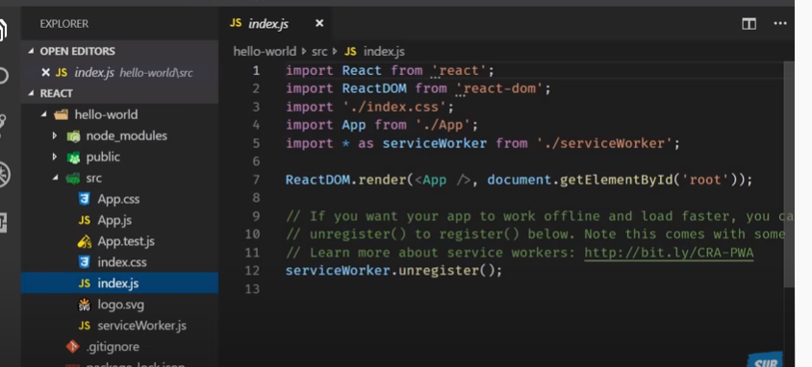

**In new version**

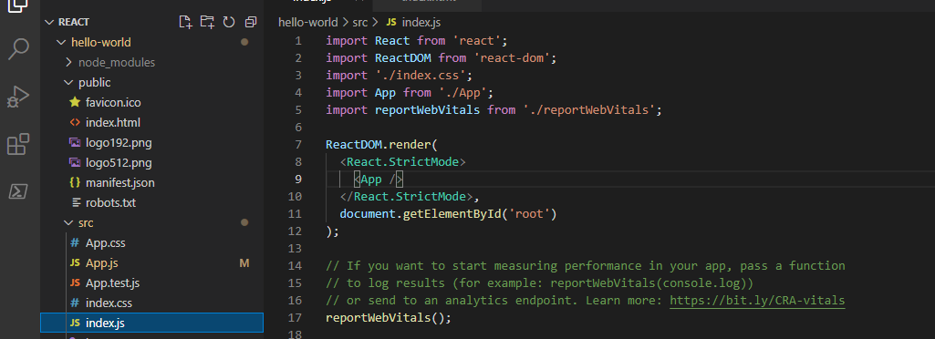

**Where you can see the id is root- this element in the index.html**

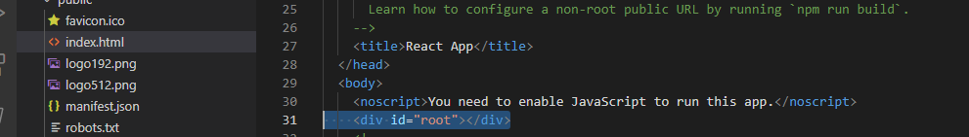

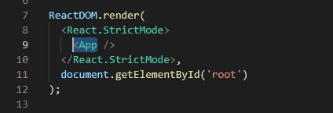

**App.js**

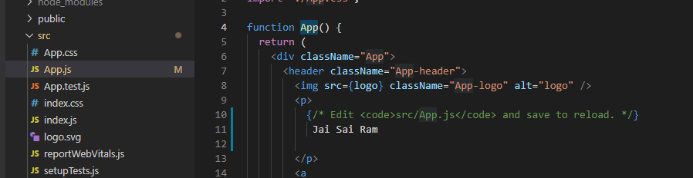

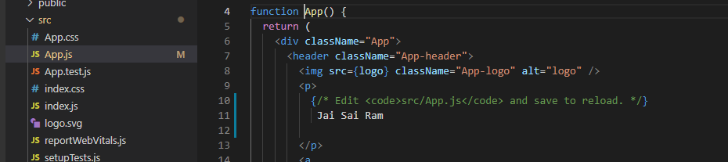

* **App.css- for styling the app.js**
* **App.test.js-simple test case**
* **Index.css- for styling body tag**
* **Logo.svg-for logo.**
* **ServiceWorker.js- progressive web app**

**Component : -**

[**https://www.youtube.com/watch?v=Y2hgEGPzTZY&list=PLC3y8-rFHvwgg3vaYJgHGnModB54rxOk3&index=4**](https://www.youtube.com/watch?v=Y2hgEGPzTZY&list=PLC3y8-rFHvwgg3vaYJgHGnModB54rxOk3&index=4)

**components are re-usable**

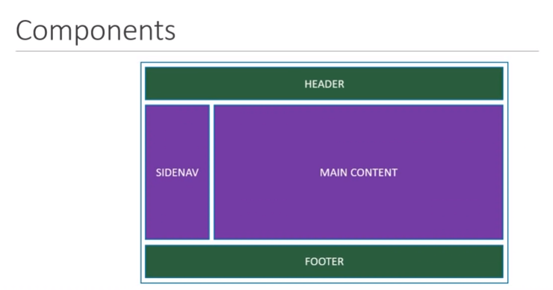

**same component can use different property and display different info.**

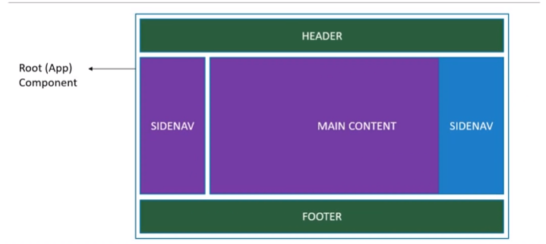

**Component usally placed in the java script.**

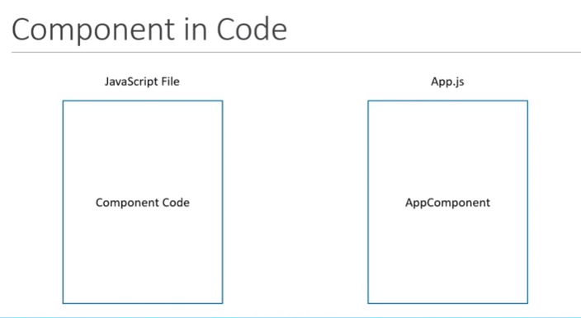

**Also we can define the jsx extention – will read in other sessions.**

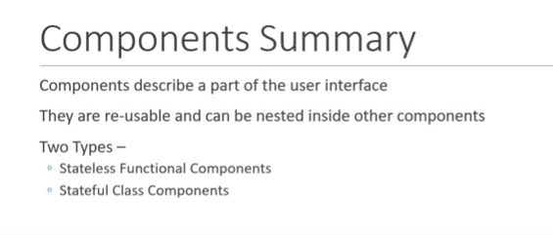

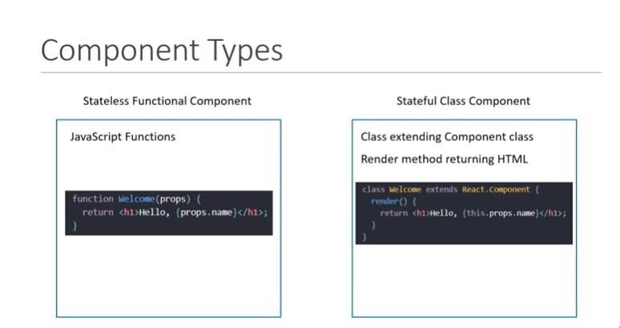

**Two types of extensions.**

* **Stateless functional compnent**
* **Stateful class component .**

**Stateful class component- App.js**

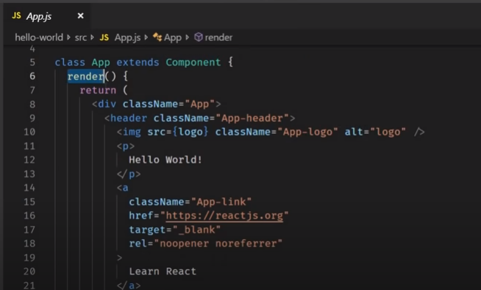

**Like these we can any no of components (10 or 100 or 1000) . like extends to component and render().**

**Components are building blocks of the any react application..**

[**https://www.youtube.com/watch?v=Cla1WwguArA&list=PLC3y8-rFHvwgg3vaYJgHGnModB54rxOk3&index=5**](https://www.youtube.com/watch?v=Cla1WwguArA&list=PLC3y8-rFHvwgg3vaYJgHGnModB54rxOk3&index=5)

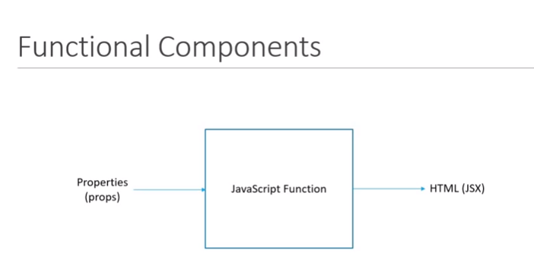

**Lets edit the previous application –header section**

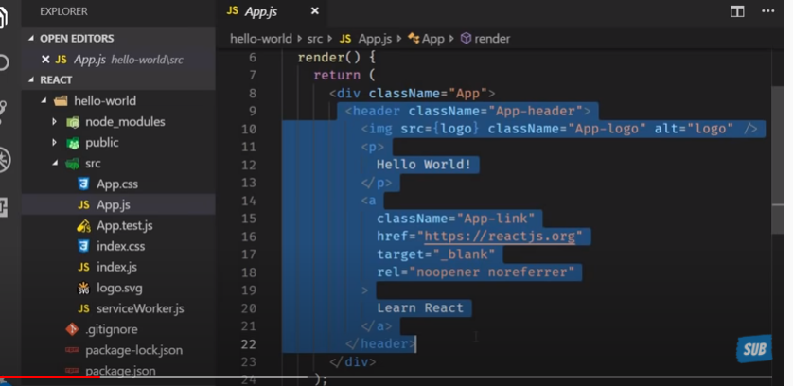

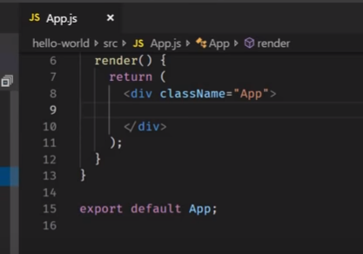

**Lets create the folder component and create the file in it.**

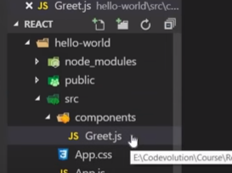

**Lets create the component :-**

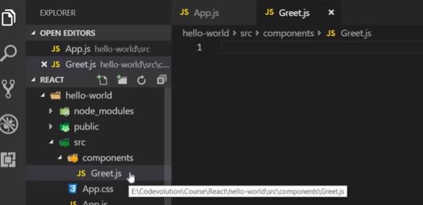

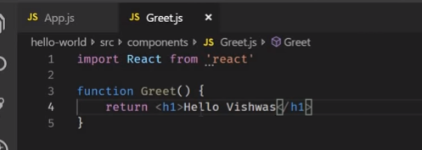

**This code is not render on the browser.**

**Need to export and import in the app.js and render.**

**How.. ?**

**S1- Export :-**

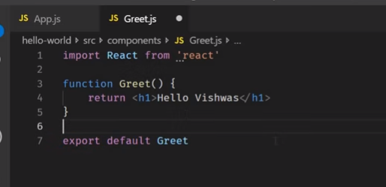

**In app.js.. import and render() {<Greet>}**

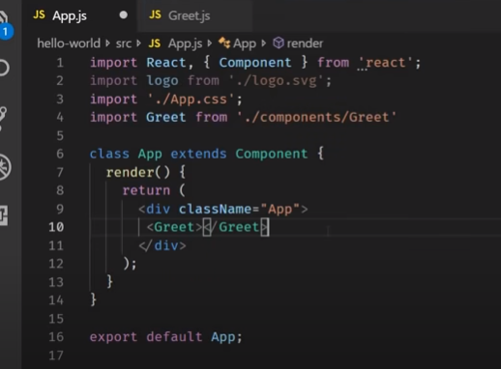

**Output:- Functional Component:-**

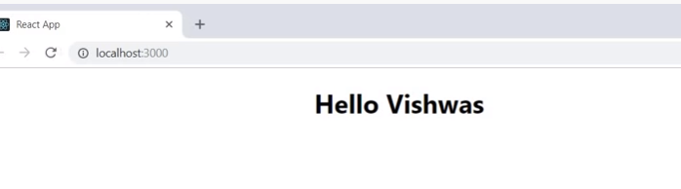

**However other changes –code is updated as export contest Greet() =>**

**Convention and preference is to define the array function with E6**

**MORE EASY… - its add more additional features.. will discuss on the further tutorials.**

**If we define the My component in App.js it will work to render**

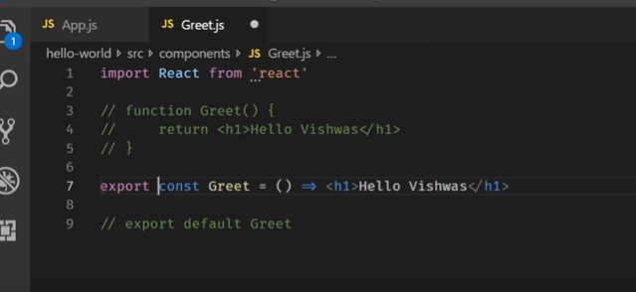

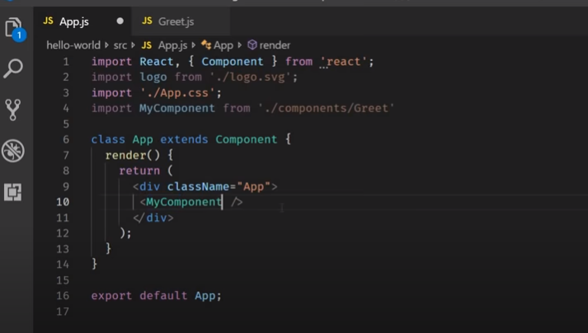

**Still out put works – as we can import the component with any name**



**But when you change the as export**

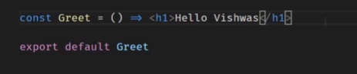

**In below error asking for the exact the same name of the component when we define the xport default Greet**

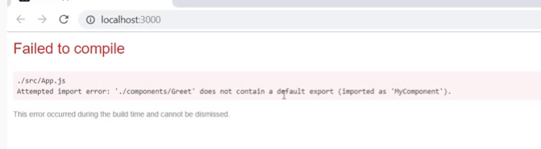

**As we have to define the {Greet} from ./component/Greet’**

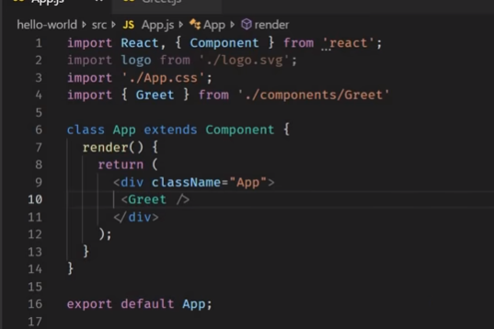

**Output**

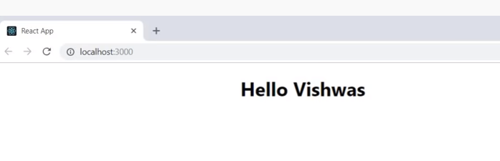

**However, suggested to define the default export**

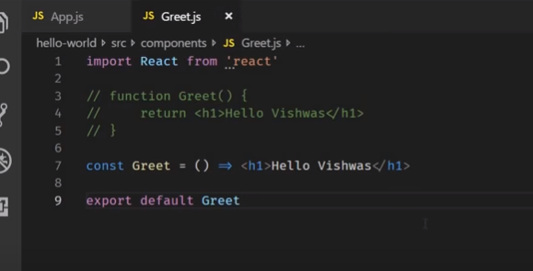

# ReactJS Tutorial - 6 - Class Components

[**https://www.youtube.com/watch?v=lnV34uLEzis&list=PLC3y8-rFHvwgg3vaYJgHGnModB54rxOk3&index=6**](https://www.youtube.com/watch?v=lnV34uLEzis&list=PLC3y8-rFHvwgg3vaYJgHGnModB54rxOk3&index=6)

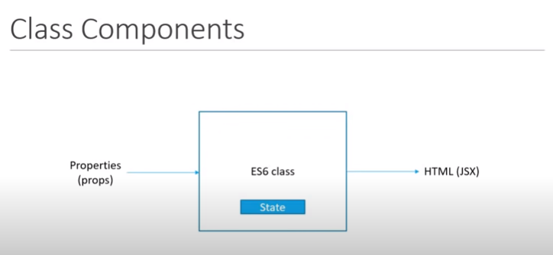

**Lets create the two classes Greet.js and Welcome.js**

**Note: we can not two files with the same name**

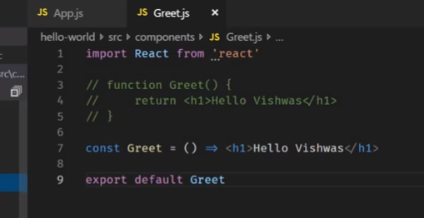

**Define welcome.js as class level and export default to integrate with App.js to render output**

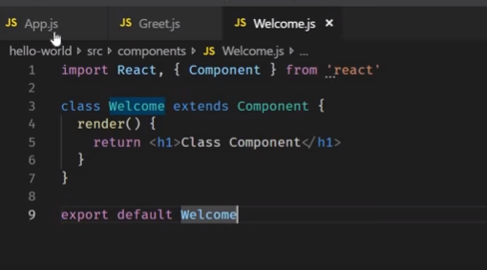

**Define the Greet and Welcome class in App.js**

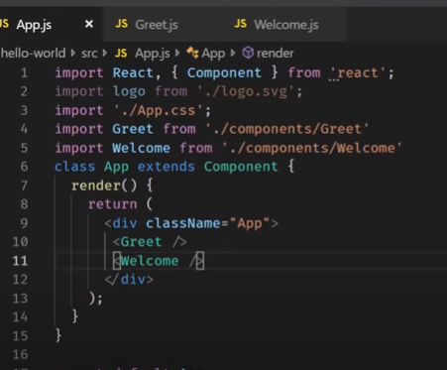

**Output:-**

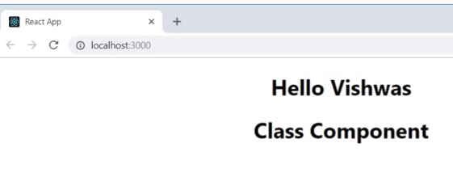

**Now we have to understand when we have to use the class level component and functional level component or const with array function .**

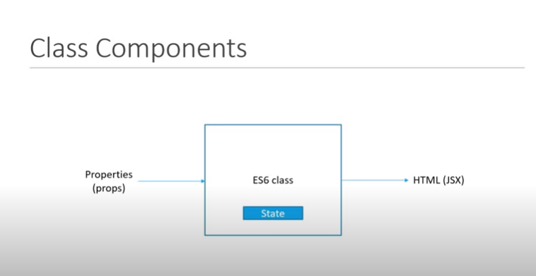

[**https://www.geeksforgeeks.org/differences-between-functional-components-and-class-components-in-react/**](https://www.geeksforgeeks.org/differences-between-functional-components-and-class-components-in-react/)

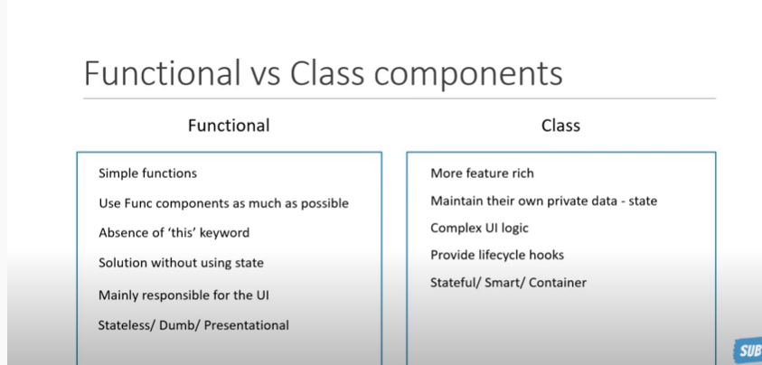

**F – easy to debug , can use hooks concepts**

**C – complex in ui logic, have its own life cycle methods like componentdintMount().**

**As we have App.js, Greet.js and Welcome.js- All three components we return some html**

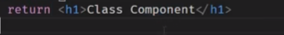

**Its not regular html and its JSX..**

**WILL DIScuss on the JSX in the next tutorial**

[**https://www.youtube.com/watch?v=oecI26cWqzk&list=PLC3y8-rFHvwgg3vaYJgHGnModB54rxOk3&index=7**](https://www.youtube.com/watch?v=oecI26cWqzk&list=PLC3y8-rFHvwgg3vaYJgHGnModB54rxOk3&index=7)

# ReactJS Tutorial - 7 - Hooks Update

**In last video**

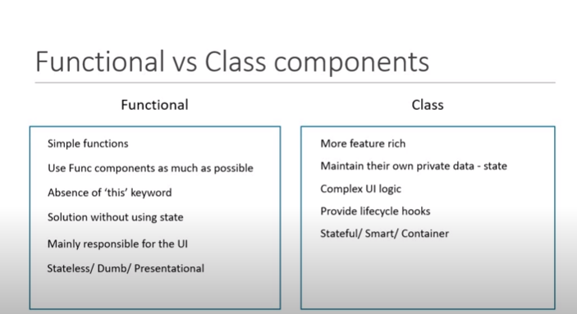

**As defined that.. functional component is statless - but not its changed.. updated**

**Hooks concepts like useState and other react features.**

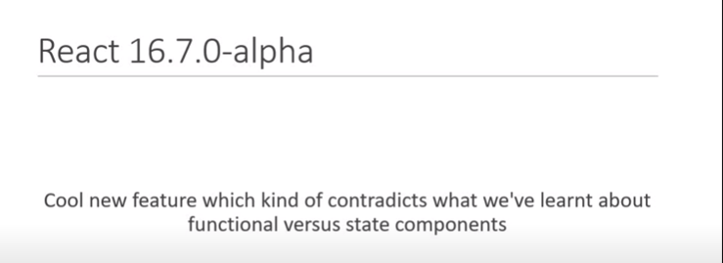

[**https://reactjs.org/versions**](https://reactjs.org/versions)

**if we add the hooks concepts it will effect other code and backward compatible**

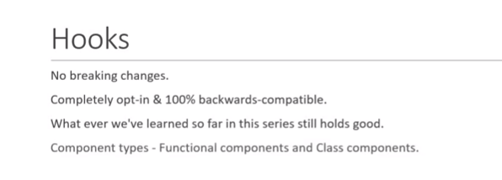

**By using the hooks we can implement the cycle methods in the functional components.**

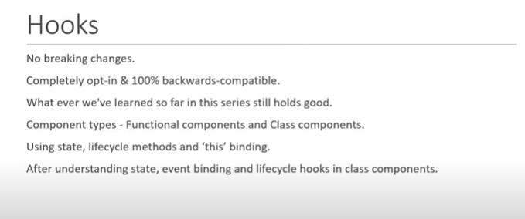

**Can avoid this binding in the hooks.**

**After all concepts state, event binding and lifecycle hooks then we will explain how to bind with th class components**

[**https://www.youtube.com/watch?v=7fPXI_MnBOY&list=PLC3y8-rFHvwgg3vaYJgHGnModB54rxOk3&index=8**](https://www.youtube.com/watch?v=7fPXI_MnBOY&list=PLC3y8-rFHvwgg3vaYJgHGnModB54rxOk3&index=8)

# ReactJS Tutorial - 8 - JSX

**About the JSX component : -**

**What is the jsx and why it is used ?**

**With out jsx you can write the react application but however, using the jsx it’s easy to i.e react code simpler and elegant.**

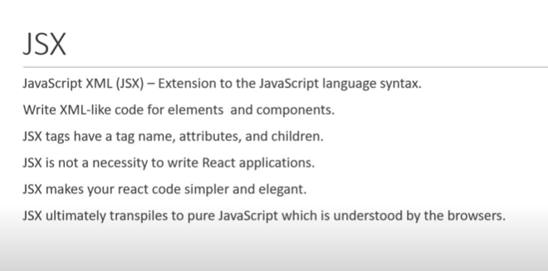

**With jsx : -**

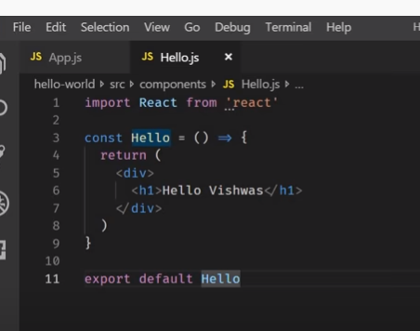

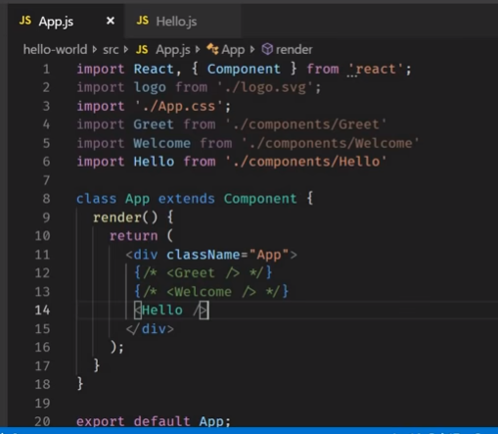

**Output :-**

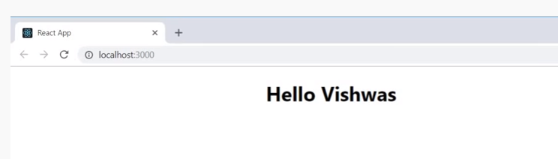

**Without using the jsx : -**

**React provide create element i.e React.createElement(‘div’, null, ‘hello viswhas)**

1. **Param - to reflect on the page.. using the div tag**
2. **Param - is optional to use. So define null.**
3. **Param – children for the html element. Ie. Children for the div tag.**

**Code changes**

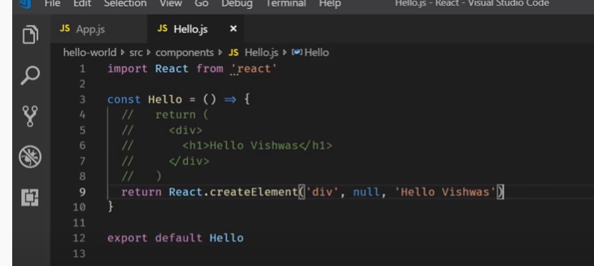

**Output**

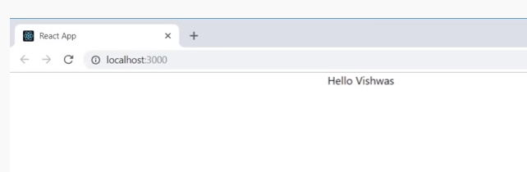

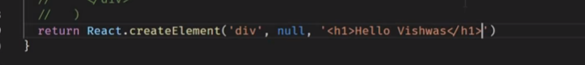

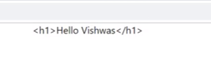

**Inpsect element .. you can find its just text what ever you define in children- 3rd parameter**

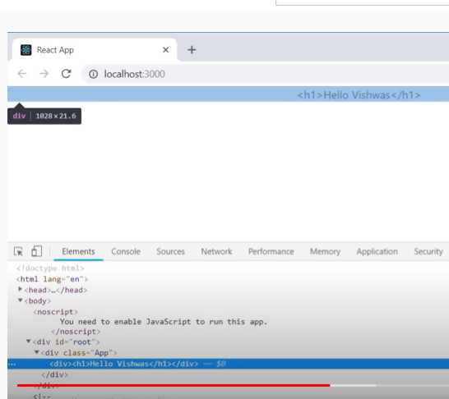



**Out put is same.. not considering the h1 tag**

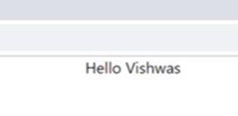

**Lets make the code changes :-**

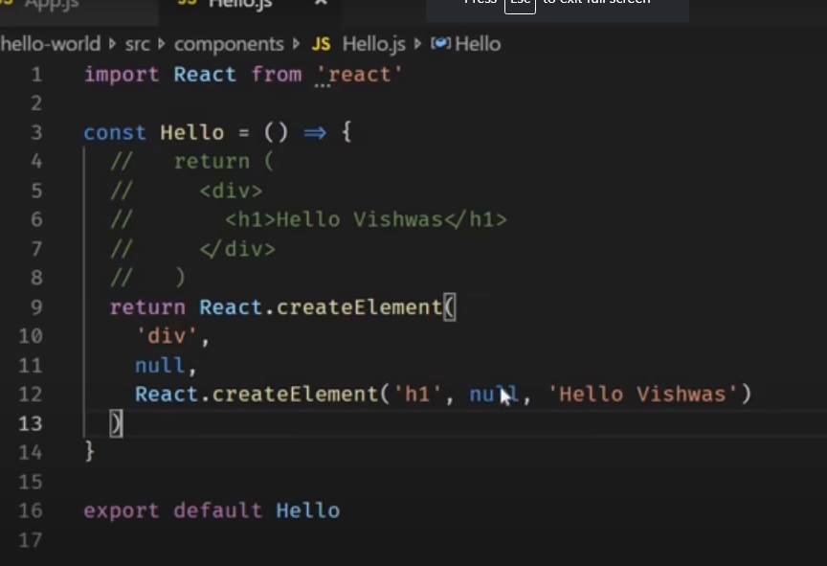

**Output: -**

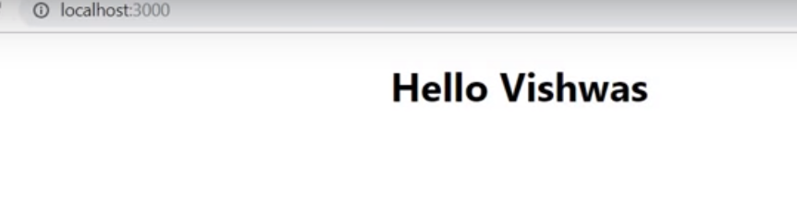

**Lets consider now the second parameter : -**

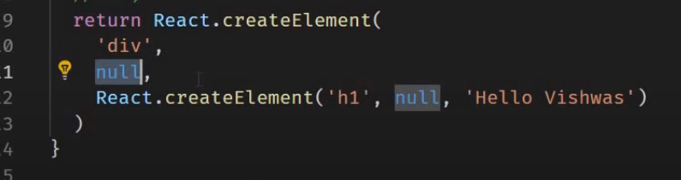

**We can consider the 2nd param is the object**

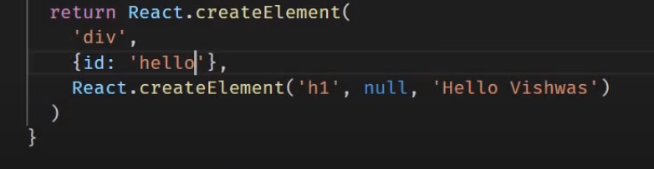

**Output - inspect the element.**

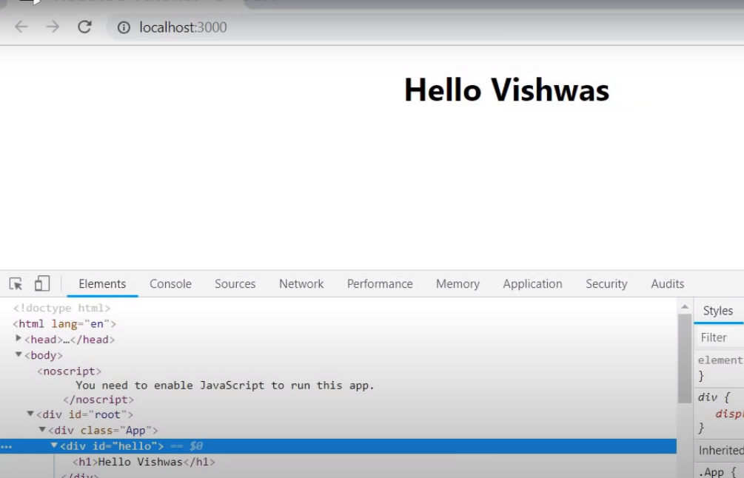

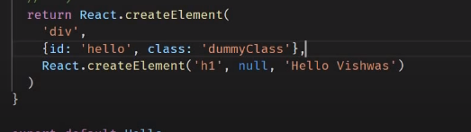

**Check in the console**

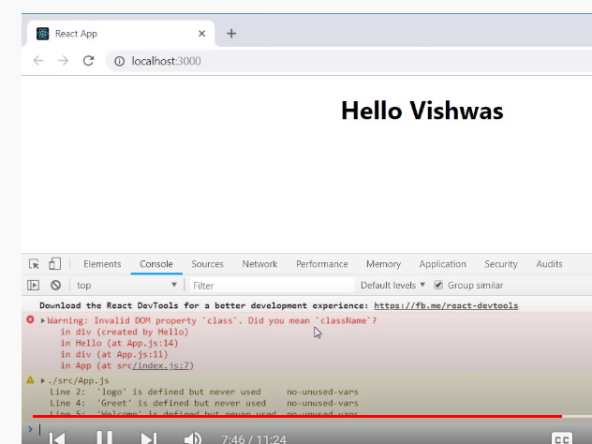

**Defined ClassName**

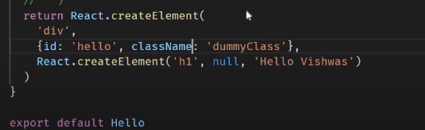

**Complete code : -**

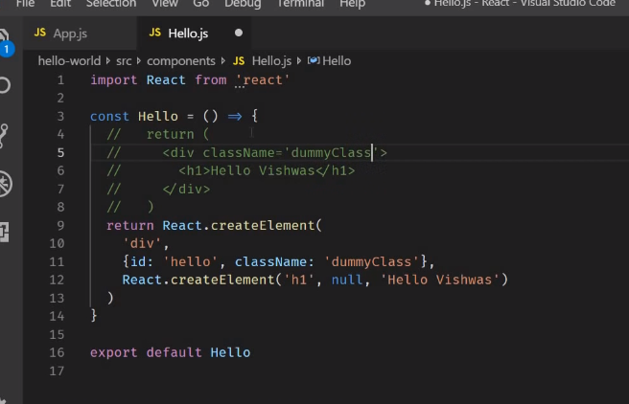

**With the jsx the code is more simpler**

**In the Greet class – jsx use the React lib hence, its import the React ..**

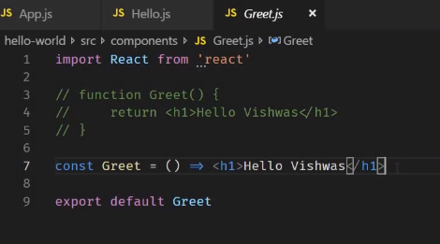

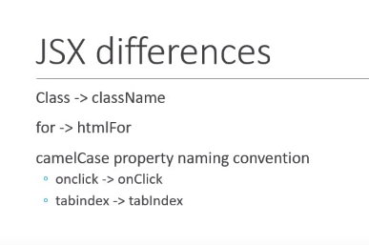

**More about the jsx**

[**https://www.javaguides.net/2020/08/reactjs-tutorial-for-beginners-7-jsx.html**](https://www.javaguides.net/2020/08/reactjs-tutorial-for-beginners-7-jsx.html)

[**https://www.youtube.com/watch?v=m7OWXtbiXX8&list=PLC3y8-rFHvwgg3vaYJgHGnModB54rxOk3&index=9**](https://www.youtube.com/watch?v=m7OWXtbiXX8&list=PLC3y8-rFHvwgg3vaYJgHGnModB54rxOk3&index=9)

# ReactJS Tutorial - 9 - Props

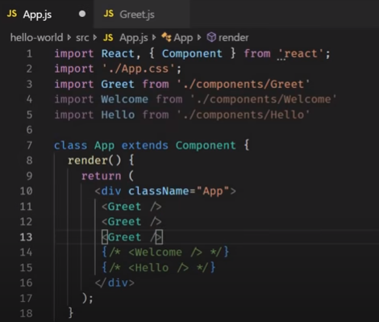

**Output:-**

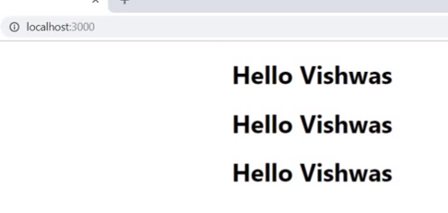

**Instead of defining the props for the 3 times. Props come in to picture to re-use it.**

**Lets define the props and it conventional to define –params we pass.**

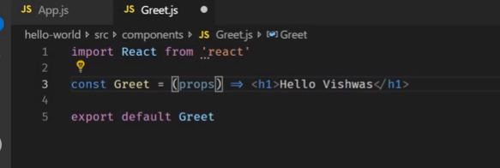

**Necessity of curely {} and return statement is ES6 concept**

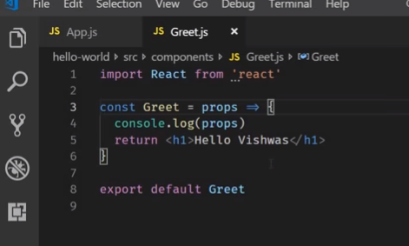

**On console : -**

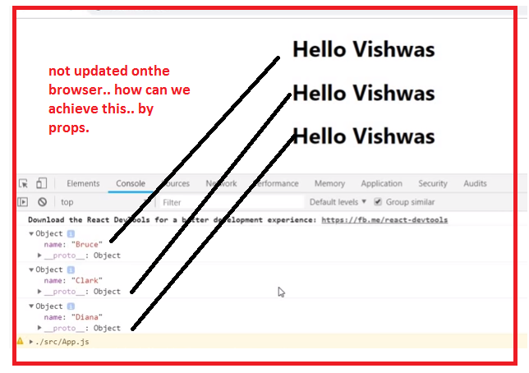

**If we make change in the code**

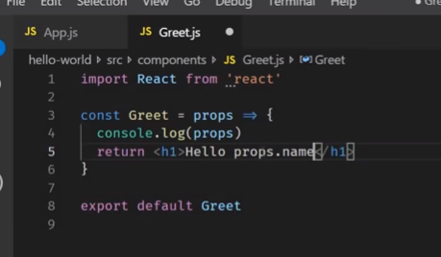

**On browser**

**Its treated as text**

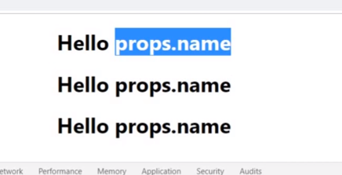

**So, to get the value of props.name we have to wrapping the element in the {props.name}**

**Its feature of the jsx**

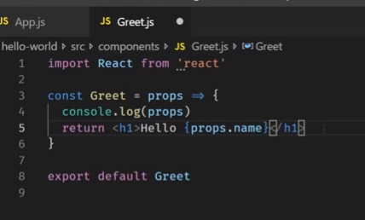

**Output – reusable – data pass the randomly**

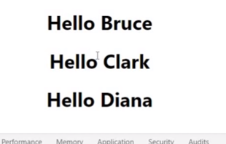

**Lets make the code changes App.js**

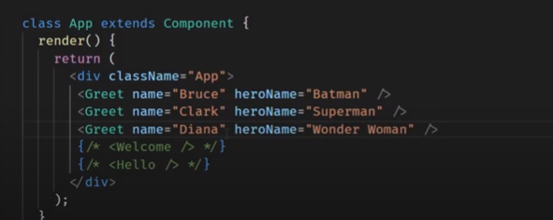

**In Greet.js – Make notice return <h1> tag.. there is no open bracke like return()- parenthesis**

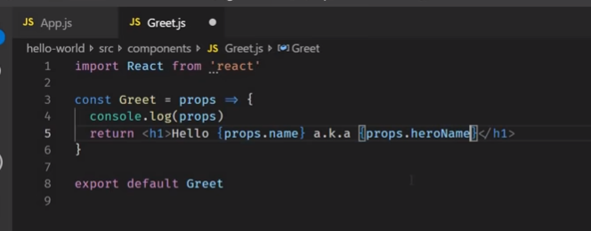

**Output**

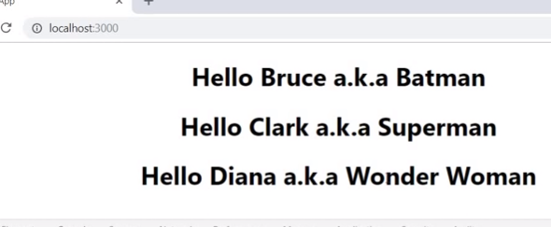

**Sometimes we don’t the what content is render on the browser… ? how can we achieve this.. ? open bracket like return()- parenthesis for multiple lines –**

**However, code throw error because.. ES6 Only one wrap element in h1 tag.**

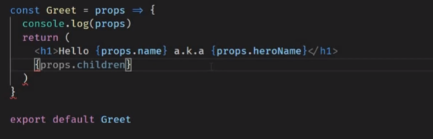

**However, we can over by defining the <div> tag – and we can return only one html element**

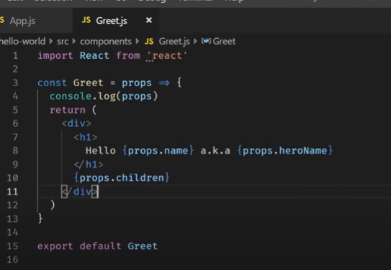

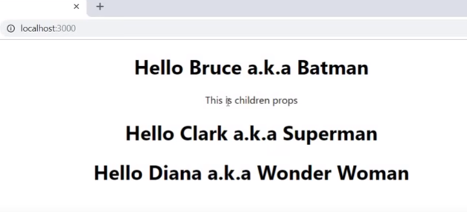

**In App.js**

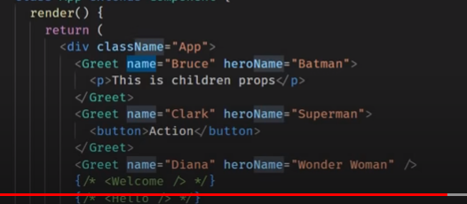

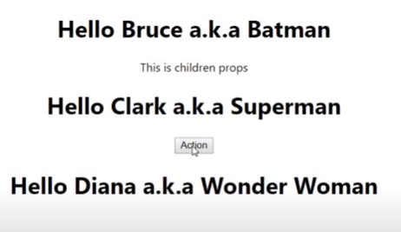

**Flow:-**

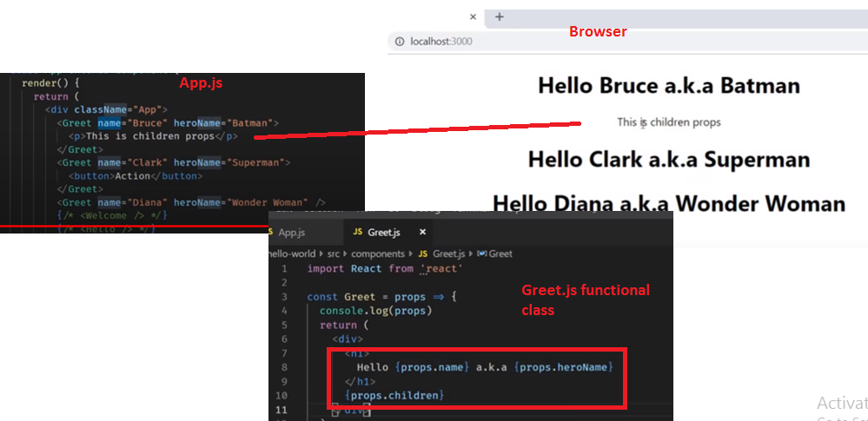

**How to use the props with the class component :**

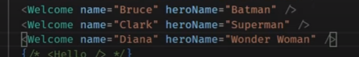

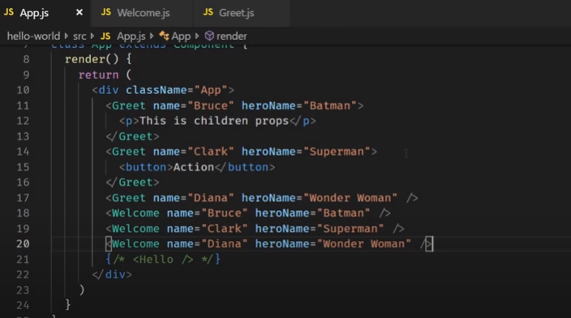

**Lets check in the class component : - as we have to use the this keyword**

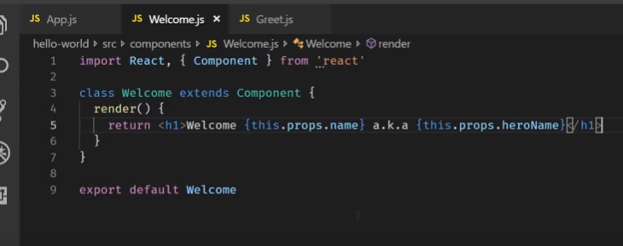

**Flow : props.flow**

**Props are immutable and value is can not be changed or modified.**

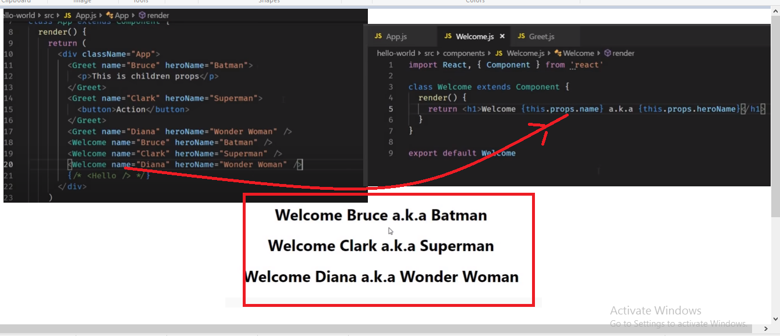

**If want to modified.. name attribute..**

**Like props.name = ‘vishwas’**

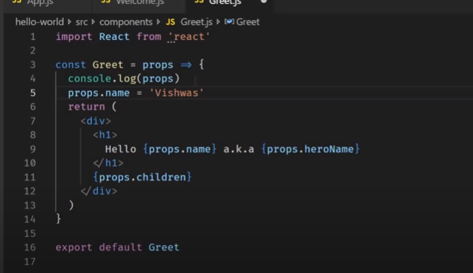

**Output:- application is break – we can change the props under any circumstances**

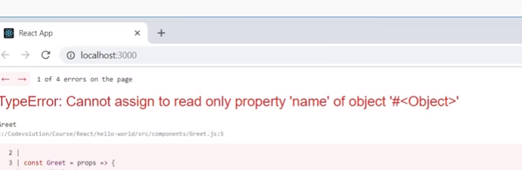

**If the props are immutable then how the components data changes overt time ?**

[**https://www.youtube.com/watch?v=4ORZ1GmjaMc&list=PLC3y8-rFHvwgg3vaYJgHGnModB54rxOk3&index=10**](https://www.youtube.com/watch?v=4ORZ1GmjaMc&list=PLC3y8-rFHvwgg3vaYJgHGnModB54rxOk3&index=10)

# ReactJS Tutorial - 10 - State

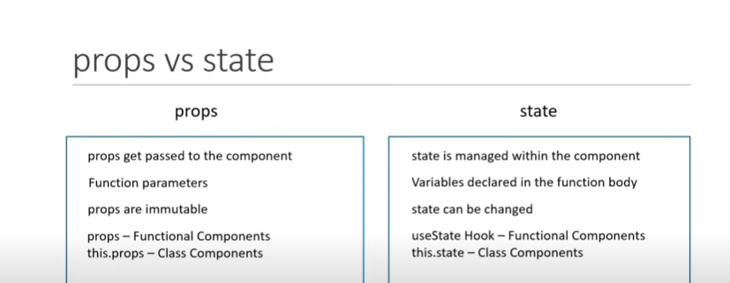

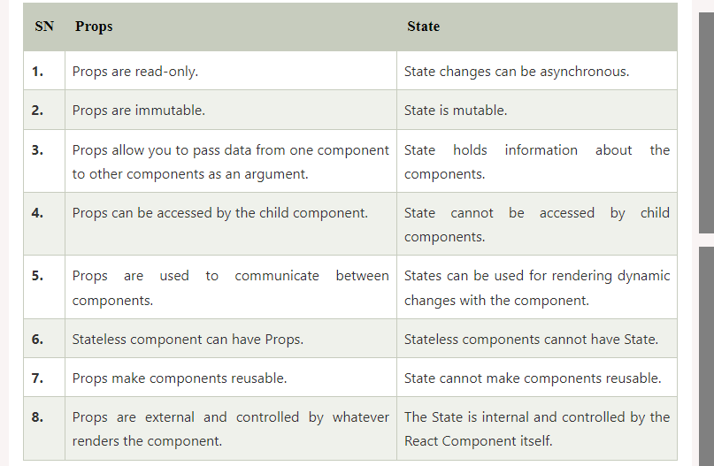

**How to use the state component in the class component : -**

**Message.js component**

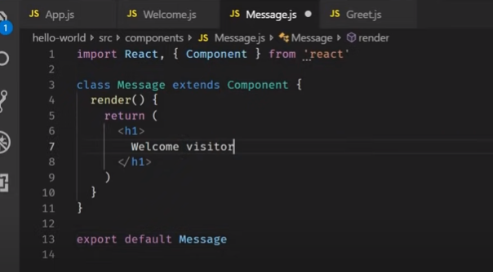

**App.js**

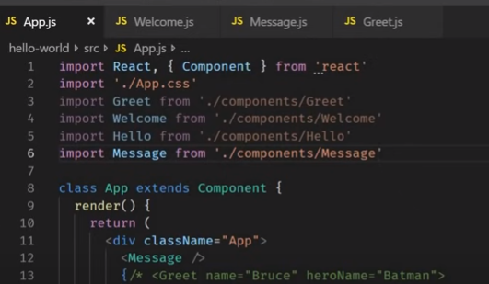

**Output:-**

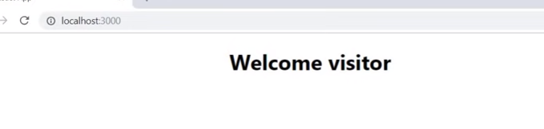

**We want to change the value on the browser .. Then it could be done by changing the code like : - as we props are immutable.. then how to achieve this ?**

**Then define the constructor() {}and super() with in the constructor**

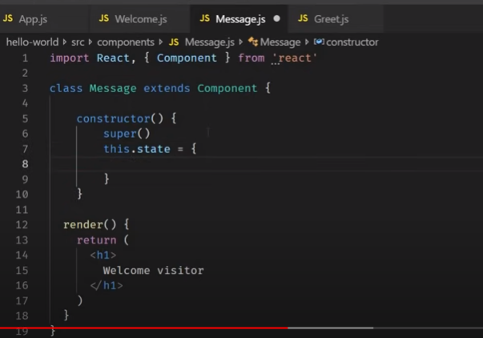

**Empty for time being**

**constructor() {**

**super();**

**this.state = {  };**

**}**

Step 1 – initial the value

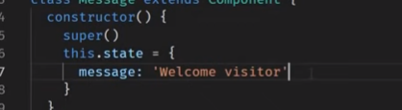

Ste 2- bind the state value in the render function

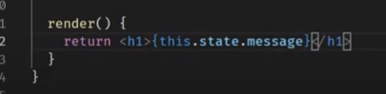

Complete code :-

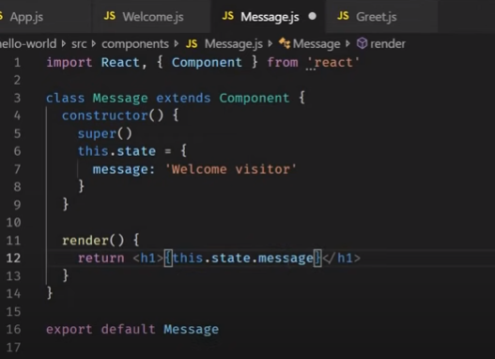

On browser : -

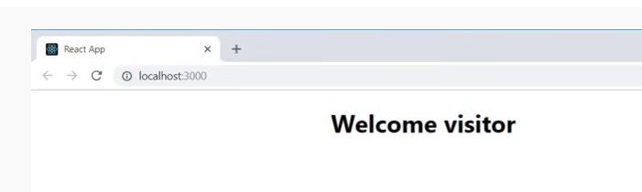

How to change the code on the browser?

By implementing the button:-

In return statement we are implementing multiples lines then need div tag

As defined below

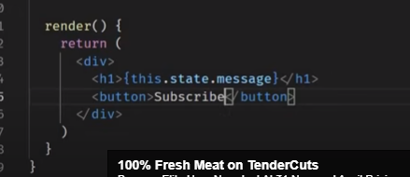

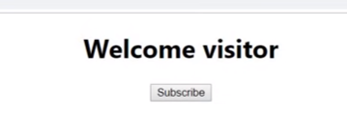

**Step 4- need to change the message when we click on the subscribe: -**

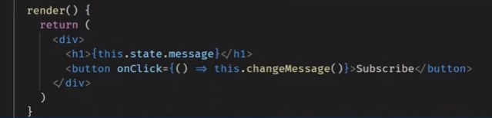

**onClick{ () onclick => this.changeMessage()}- define the changeMessage() and define the**

**set State({ statement})**

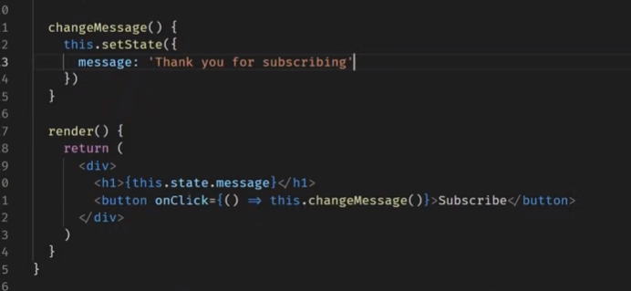

**setState –using to change the content**

**before click**



**After click**

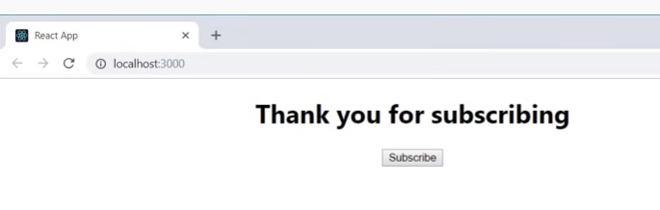

[**https://www.youtube.com/watch?v=uirRaVjRsf4&list=PLC3y8-rFHvwgg3vaYJgHGnModB54rxOk3&index=11**](https://www.youtube.com/watch?v=uirRaVjRsf4&list=PLC3y8-rFHvwgg3vaYJgHGnModB54rxOk3&index=11)

# ReactJS Tutorial - 11 - setState

**Lets add the extention for the code snipnet to save some time**

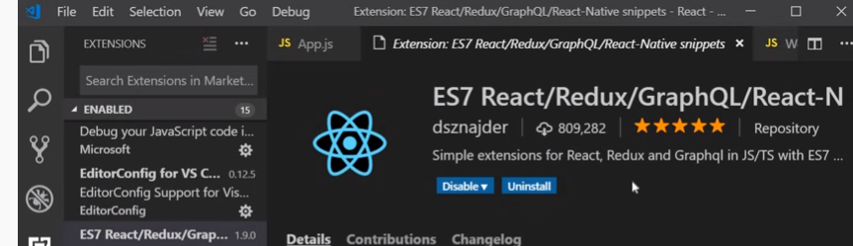

**Lets set the initial count =0 and let increment by +1 and render on the browser latest count.**

**How to achieve this..**

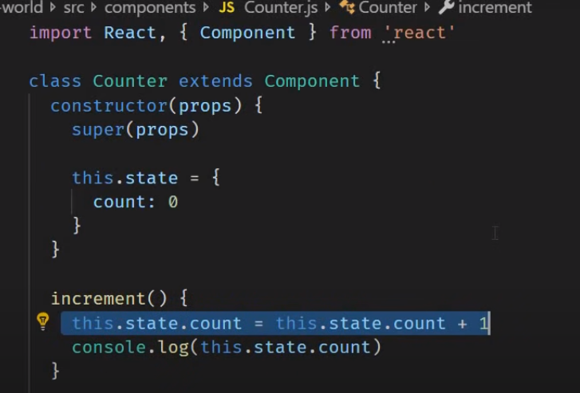

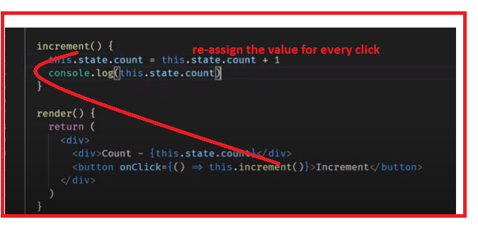

When you click on the increment button its value is not changed on the browser.. it can view on the console

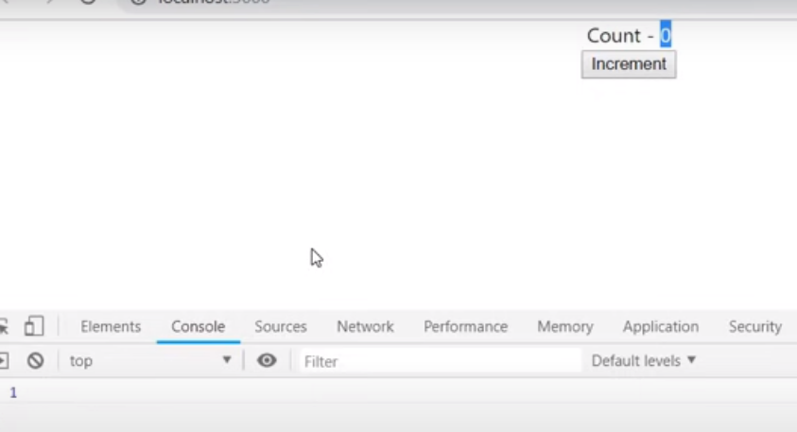

**this.state is constructor : - directly we can change the value of state..**

**As we have to define the this.setState{here change the value }**

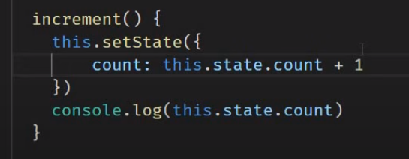

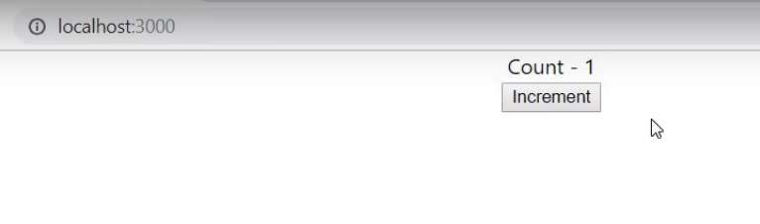

-this.setState() – have two methods- state object and call back function

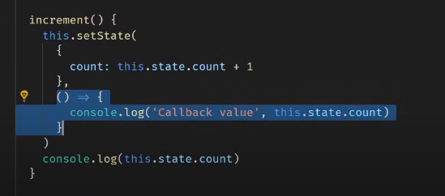

() => call back function.. with the set state method

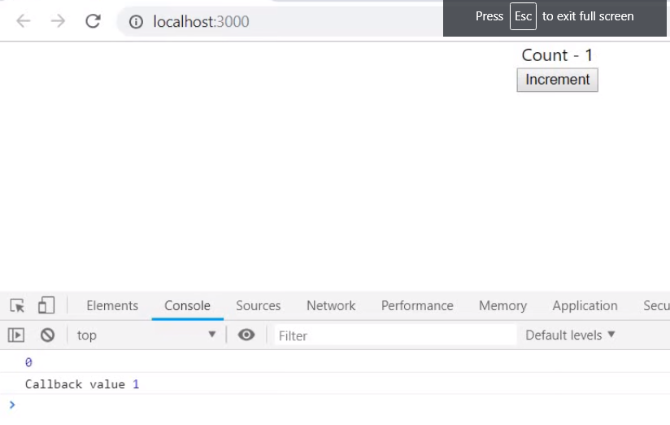

As you can see console 1- its outside the setmethod ..and console 2- from call back function from the set State().

If want to render the latest value on the console in the setMethod then define in the call back method.. instead of outside of the setmethod.

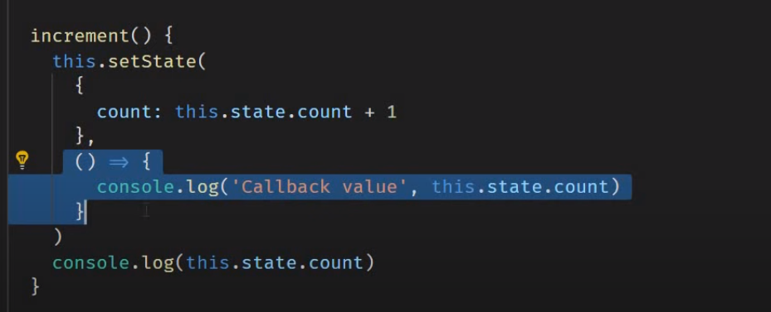

Lets make the code change

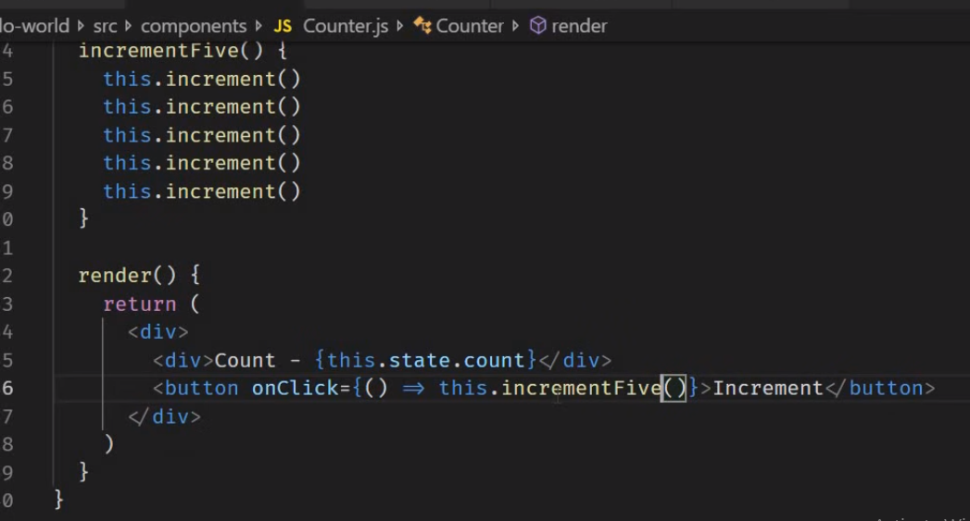

Output :- you can see this.setSate() is called 5 times for the call back method .. but the count is 1

* Why he this ?

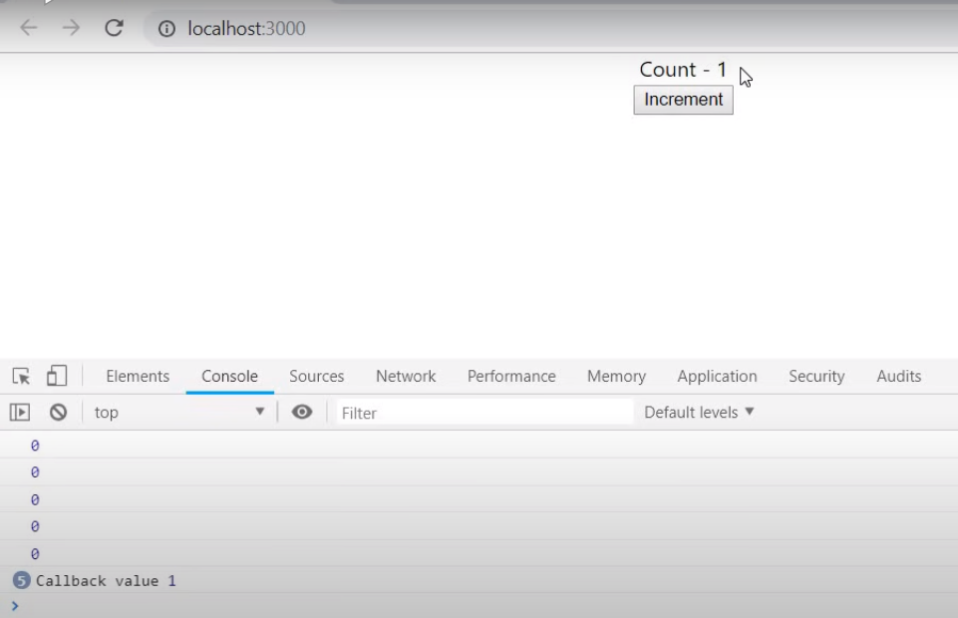

Why this.. -? React consider 5 updates as single go and using the current state..

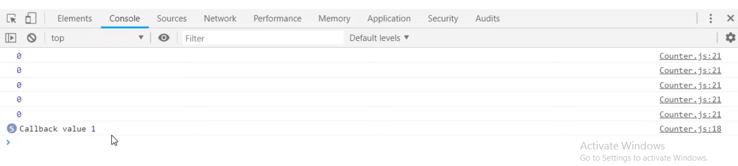

This.setState() – not passing the previous State.. consider only current state.

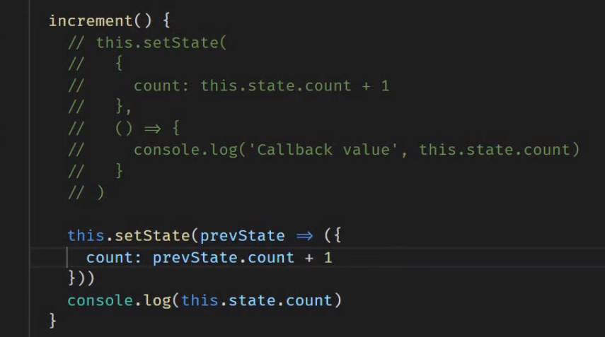

**How to consider the previous state.. pass the object in the this.setState(prevState =>)**

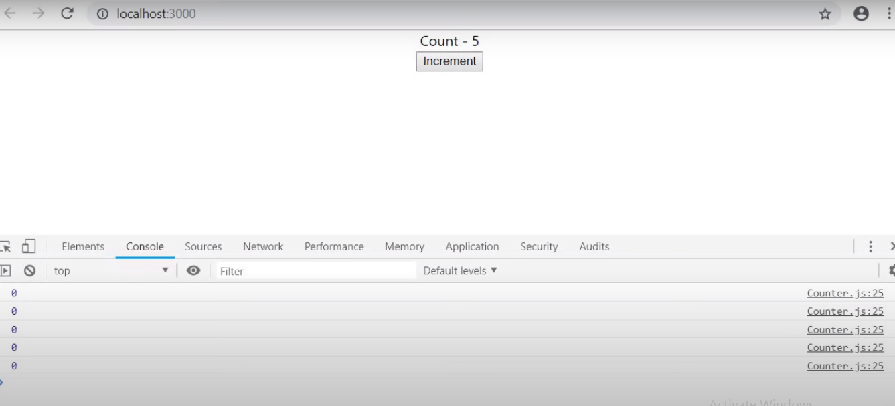

**Click on again**

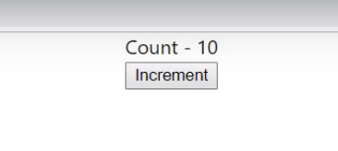

**Important**

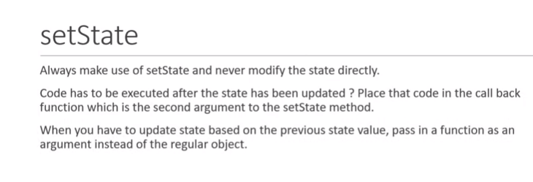

<https://www.youtube.com/watch?v=5_PdMS9CLLI&list=PLC3y8-rFHvwgg3vaYJgHGnModB54rxOk3&index=12>

# ReactJS Tutorial - 12 - Destructuring props and state

<https://www.javaguides.net/2020/08/reactjs-tutorial-for-beginners-10-destructuring-props-and-states.html>

<https://www.w3schools.com/REACT/react_es6_destructuring.asp>

Lets start in functional component - in Greek define App.js

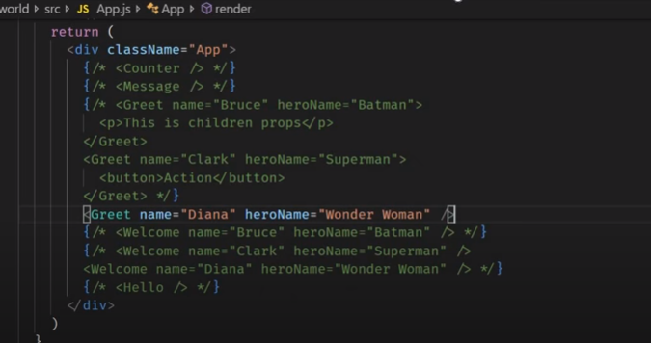

Calling as – props.name

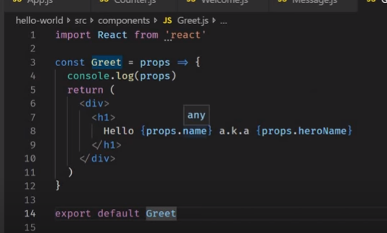

**Lets destructing inside the functional**

**1st way - in the parameter pass**

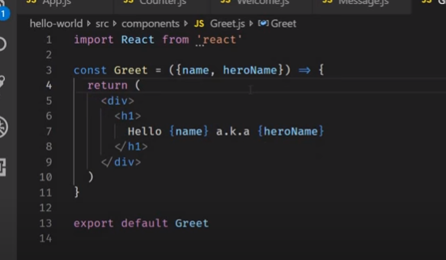

**Still works**

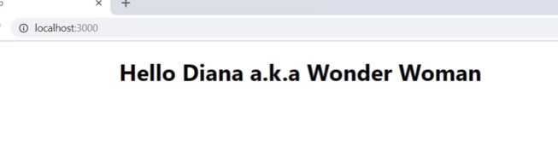

**2nd way :- Destructor in the functional body :-**

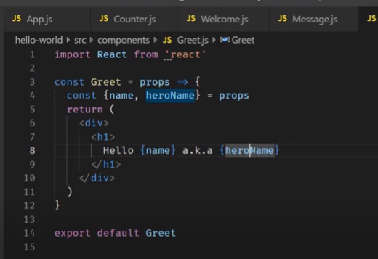

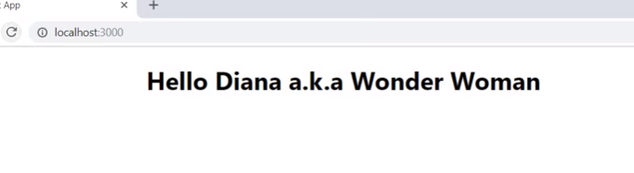

**Lets do in the class component :-**

**App.js**

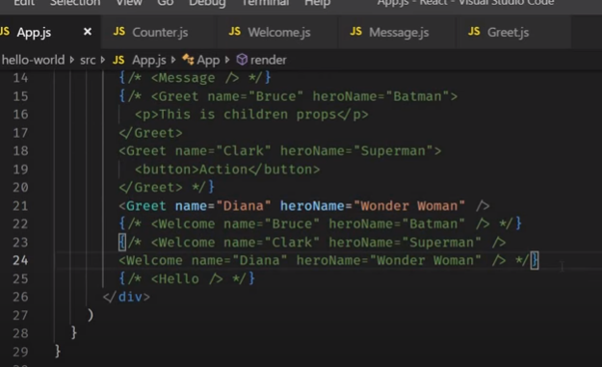

**Class component :-**

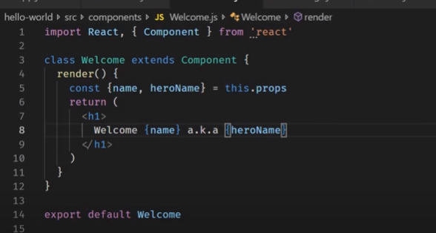

**Output**

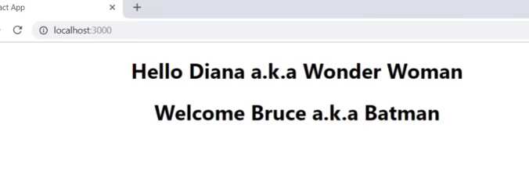

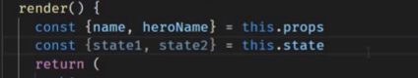

**We can come across the state also.. .. like props.**

[**https://www.youtube.com/watch?v=Znqv84xi8Vs&list=PLC3y8-rFHvwgg3vaYJgHGnModB54rxOk3&index=13**](https://www.youtube.com/watch?v=Znqv84xi8Vs&list=PLC3y8-rFHvwgg3vaYJgHGnModB54rxOk3&index=13)

# reactJS Tutorial - 13 - Event Handling

**Events –mouse click or button click or change value and so on…**

**Lets define button event**

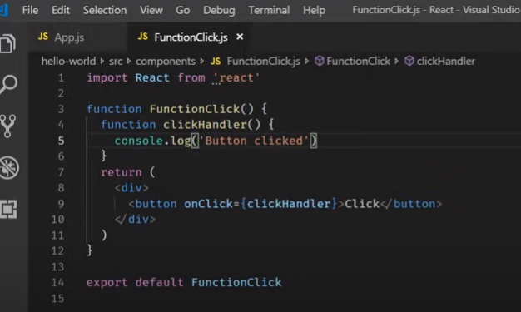

**On browser - when you click on it.. Button clicked on console**

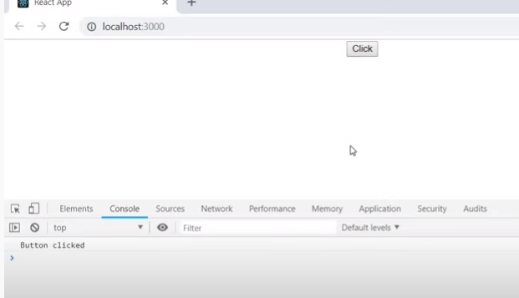

**There is difference**

**C1- onClick ={clickHandder}- it will trigger only when you click on the button to trigger**

**C2- onClick ={clickHandder()} –this functional called default when the application run**

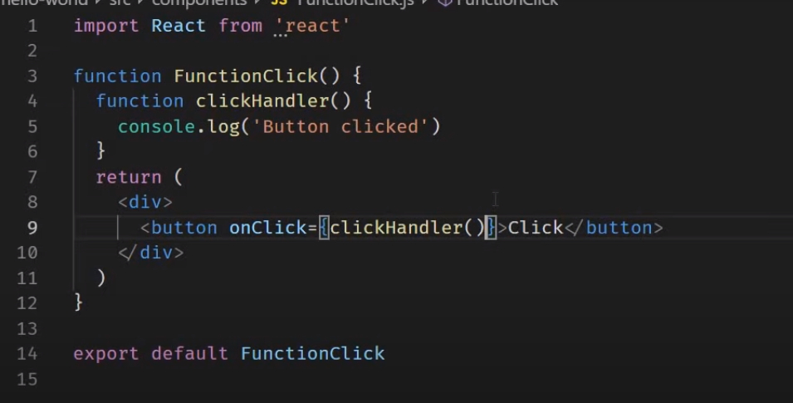

**Its already log**

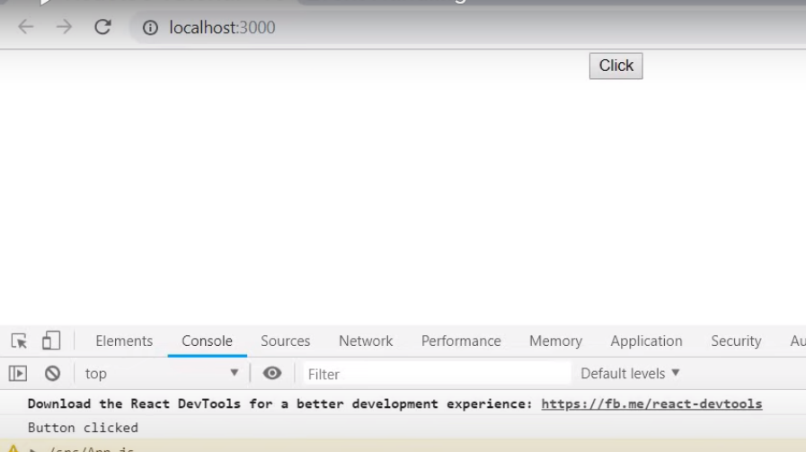

**When click on the button nothing will happen**

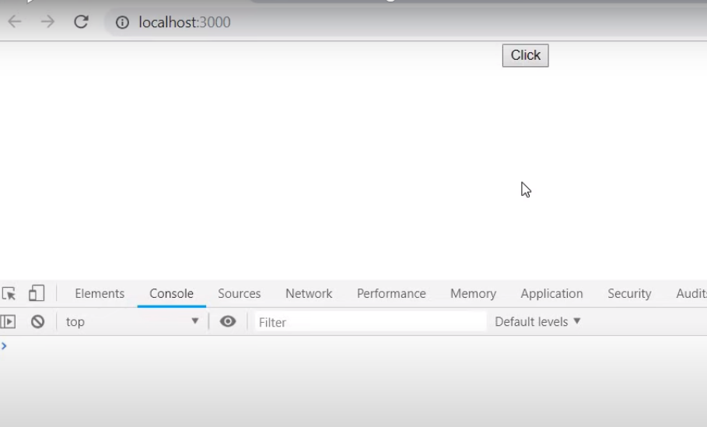

**When use this approach in the class level component.. its call infinity times (render**

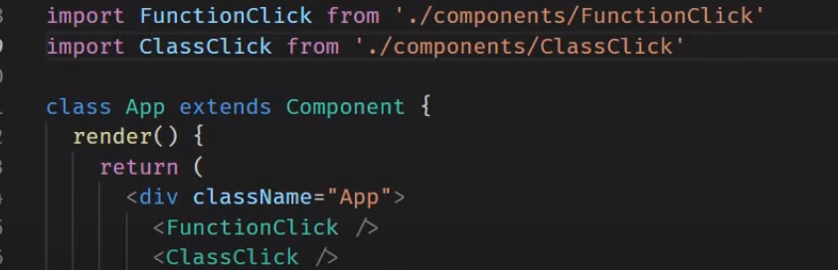

**Just define the function name in the {} in onClick**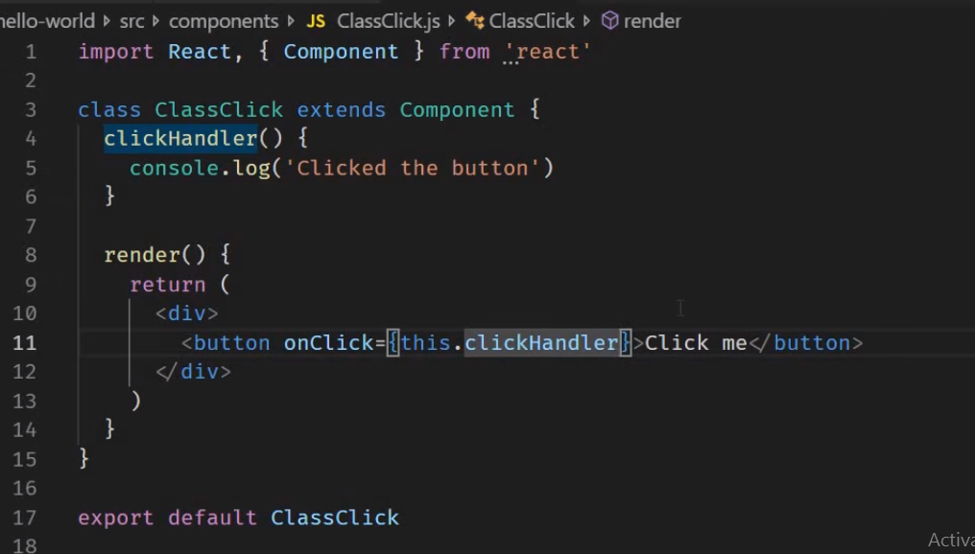

**On browser click on the button**

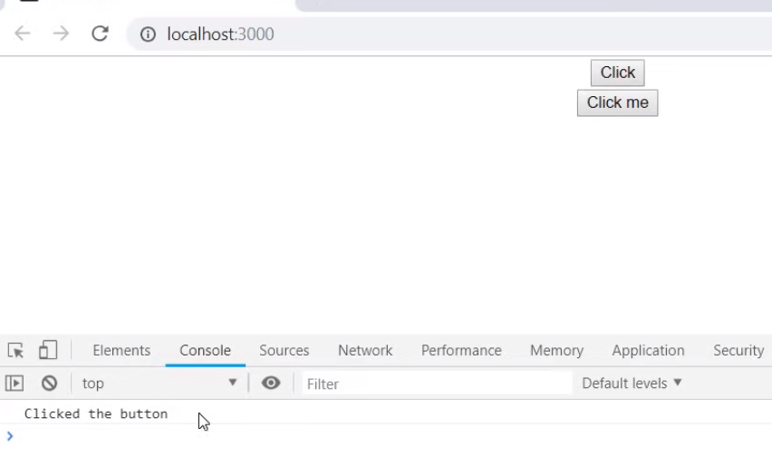

[**https://www.youtube.com/watch?v=kVWpBtRjkCk&list=PLC3y8-rFHvwgg3vaYJgHGnModB54rxOk3&index=14**](https://www.youtube.com/watch?v=kVWpBtRjkCk&list=PLC3y8-rFHvwgg3vaYJgHGnModB54rxOk3&index=14)0:12 / 11:55

ReactJS Tutorial - 14 - Binding Event Handlers

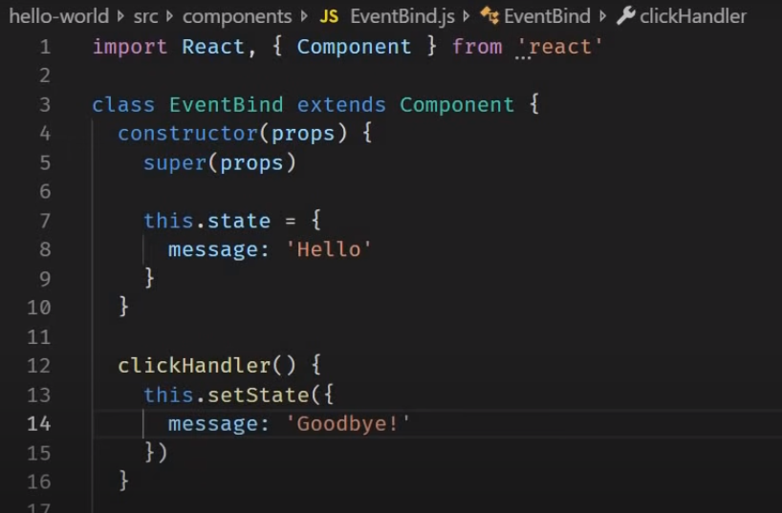

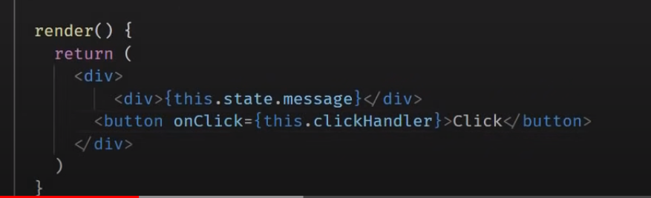

**Application breaks on the browser**

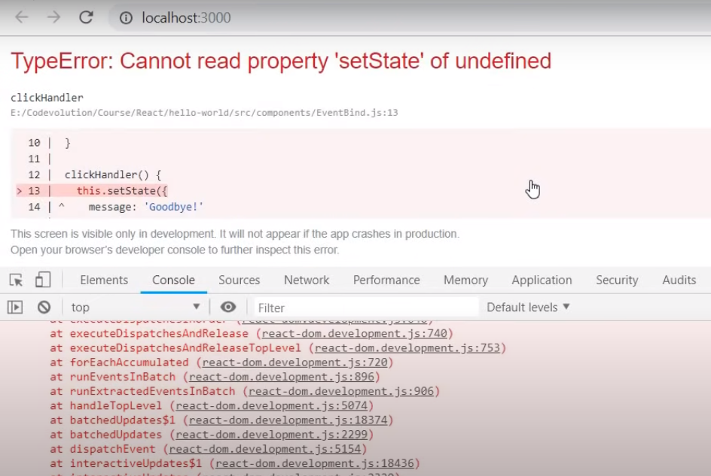

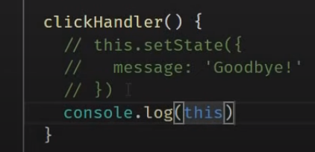

**On browser :- its undefined**

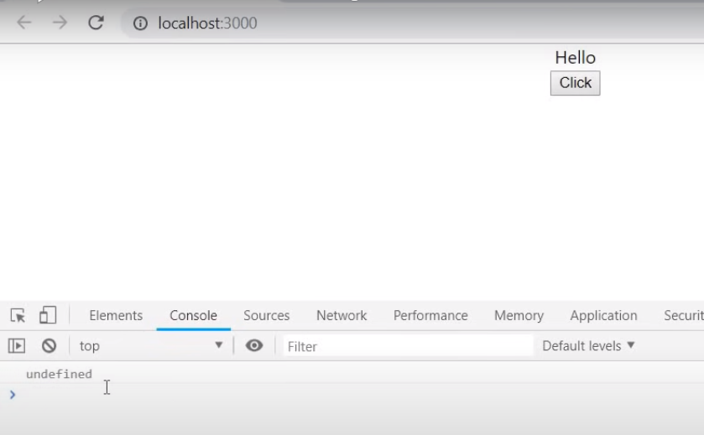

**This is keyword … undefined in the javascript..**

**How to avoid this in the react application by using the bind(this)**

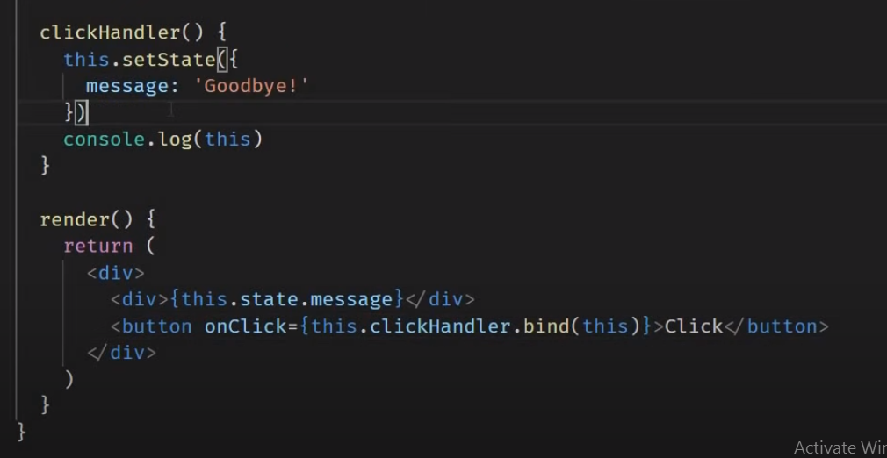

**Browser**

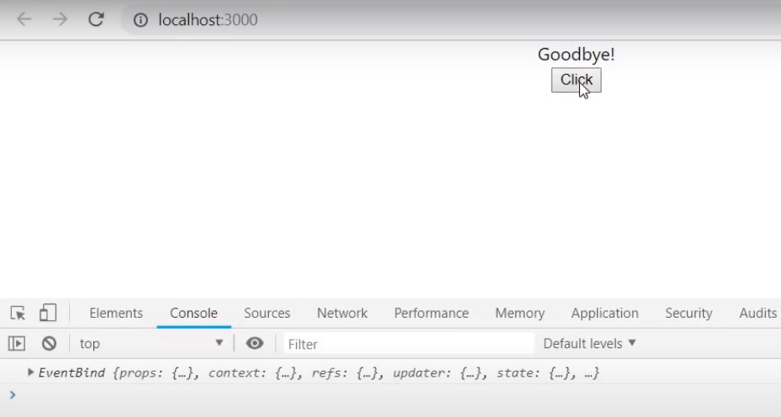

**Console - this keyword**

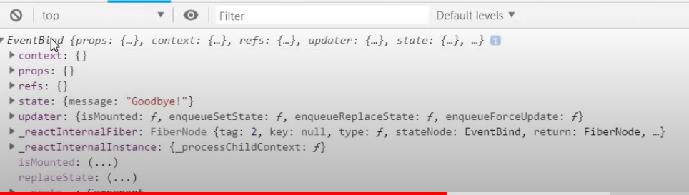

**Types of Bindings**

**Approach 1-**

**This bind is fine in the small applications but for big application some how trouble**

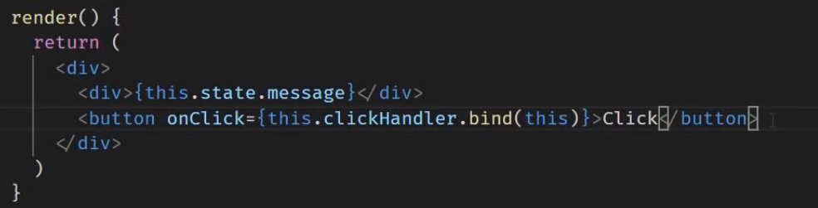

**Approach 2- Array function**

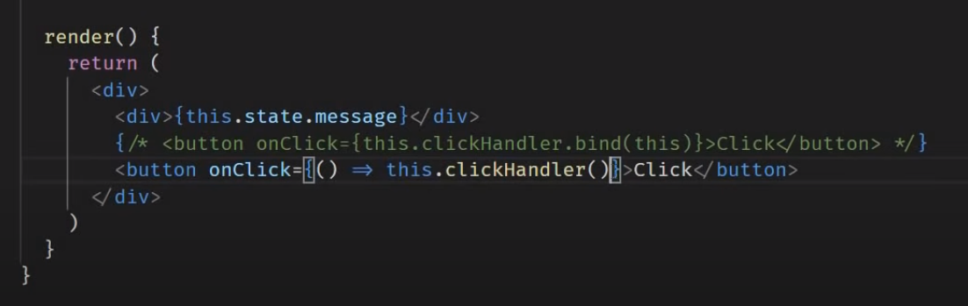

**Browser : - Perform issues like first Approach 1**

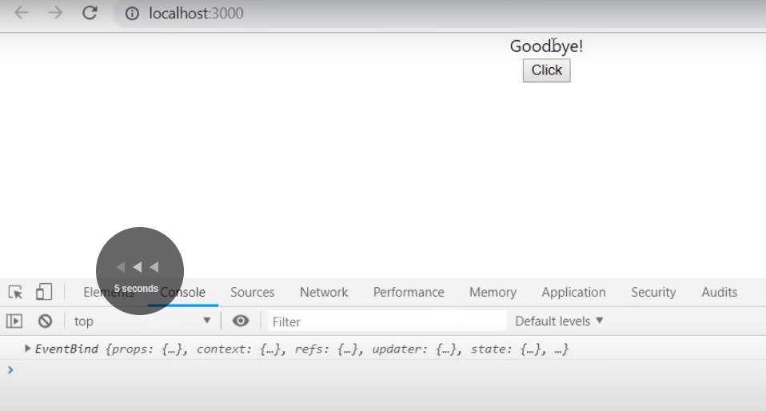

**3rd Approach of Binding in constructor**

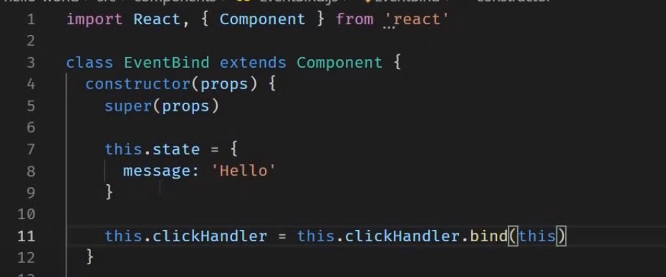

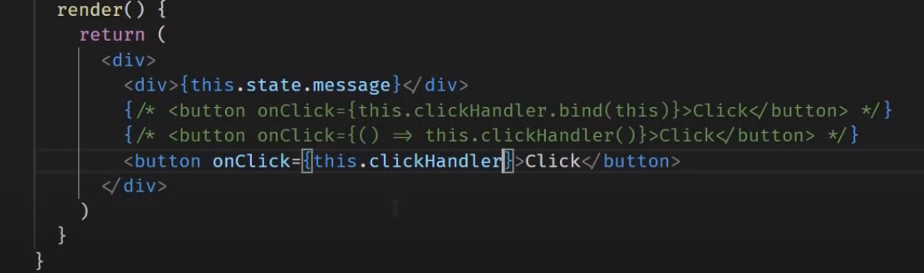

**Browser :-**

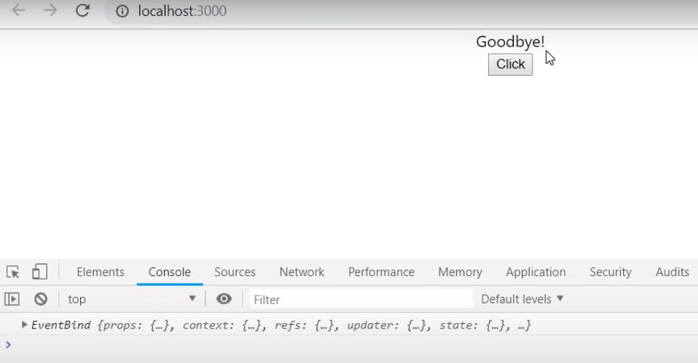

**Approach 4:-**

**Binding by the Array function :-**

**Comment in the previous code**

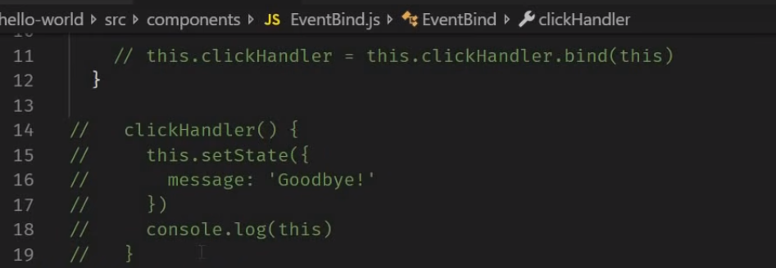

**Array function**

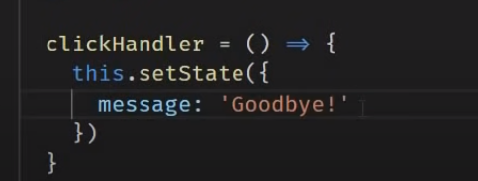



**1-binding in the render(not prefer to use perform issues )**

**2-array function in the render(not prefer to use perform issues ) – but easiet way to render.**

**3-binding in the class constructor (react either 3 and 4)**

**4-class property as array function (implement more.. )**



[**https://www.youtube.com/watch?v=QpfyjwhY9kg&list=PLC3y8-rFHvwgg3vaYJgHGnModB54rxOk3&index=15**](https://www.youtube.com/watch?v=QpfyjwhY9kg&list=PLC3y8-rFHvwgg3vaYJgHGnModB54rxOk3&index=15)

# ReactJS Tutorial - 15 - Methods as props

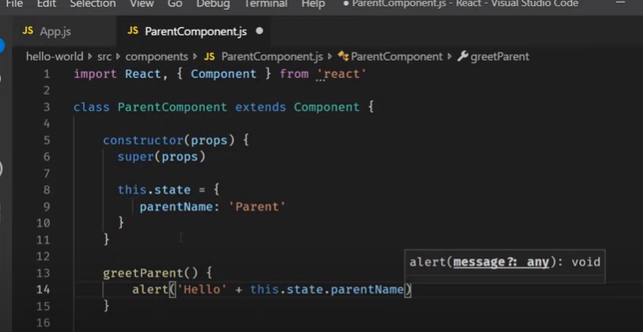

**We are define the method called greetParent() – which in defined as**

**Alert (‘hello’+ this.state.parentName) – regular contatination**

**patrix `` and doller symbol $ are feature of the ES6 not React.**

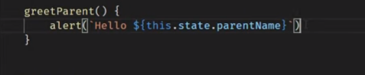

**Template ilterals – more..**

**Parent component :-**

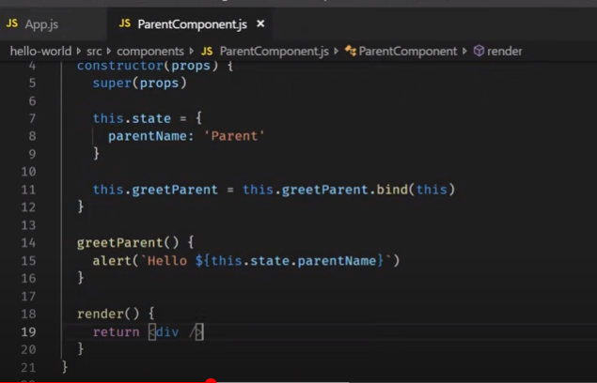

**Child component.js**

**If don’t want to make use of state then we can define simle component rfce**

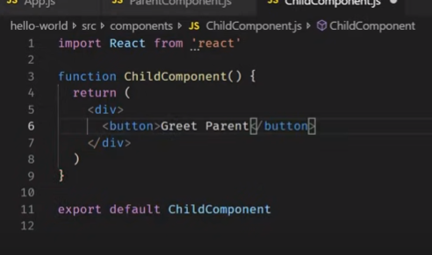

**In parent**



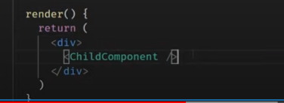

**In App.js**

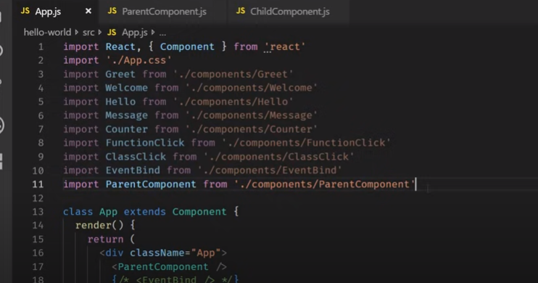

**Output :-**

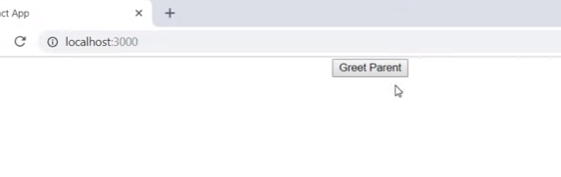

**Noting happens.**

**When click on the button on the child component .. I want to execute the method in the parent component**

**In parent component :-**

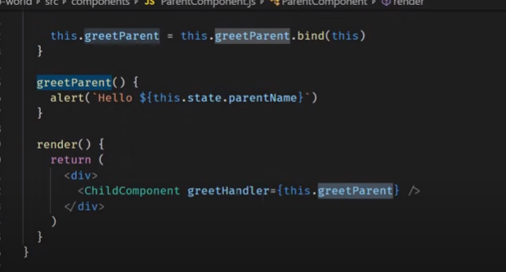

**Child component :-**

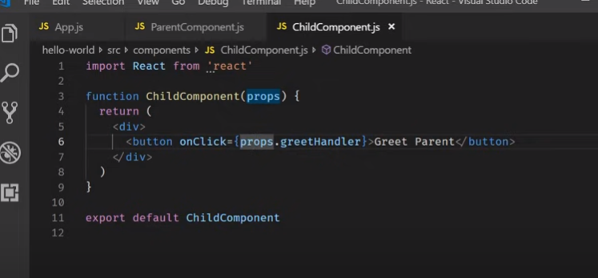

**Output**

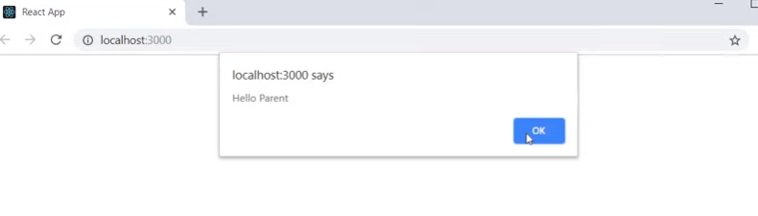

**Flow :-**

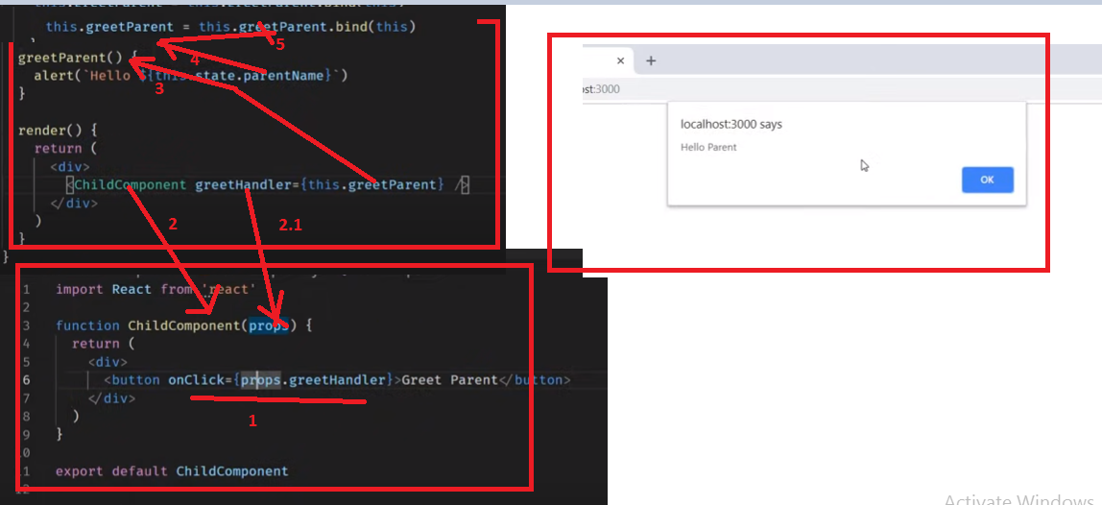

**In the child component we are passing the method called props. greetHandler**

**How to pass the parameter when calling the parent method in the child component**

**Array function is used for really here..**

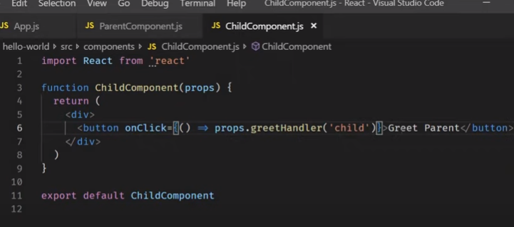

**From child param should be pass in the parent**

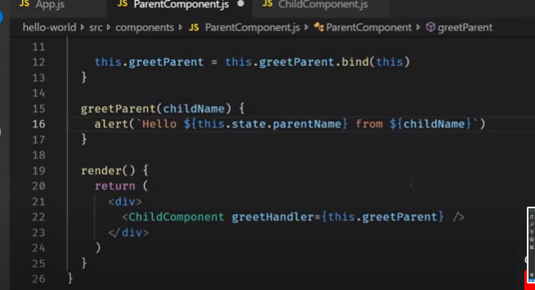

**Flow : parms flow child and parent**

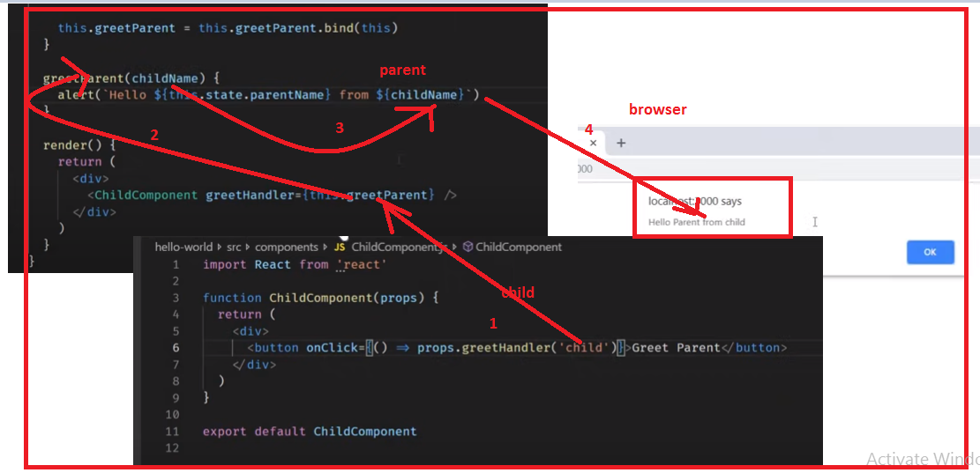

[**https://www.youtube.com/watch?v=7o5FPaVA9m0&list=PLC3y8-rFHvwgg3vaYJgHGnModB54rxOk3&index=16**](https://www.youtube.com/watch?v=7o5FPaVA9m0&list=PLC3y8-rFHvwgg3vaYJgHGnModB54rxOk3&index=16)

# ReactJS Tutorial - 16 - Conditional Rendering

# 

**Class component –rce**

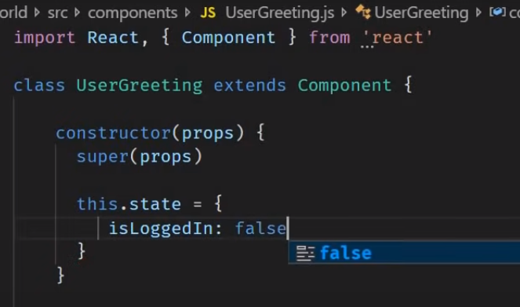

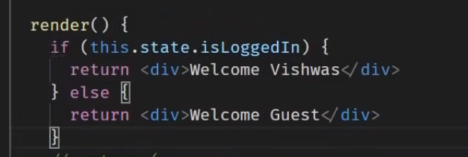

**Output:- initial value is false**

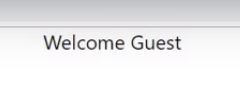

**Note : if else statements are not work in the JSX**

**Jsx is** syntactic **sugar for functional calls and object constructions.**

**Also we can define the conditional render entire the component or parital component aswell**

**How? -**

**2 Approach :- Element Variables**

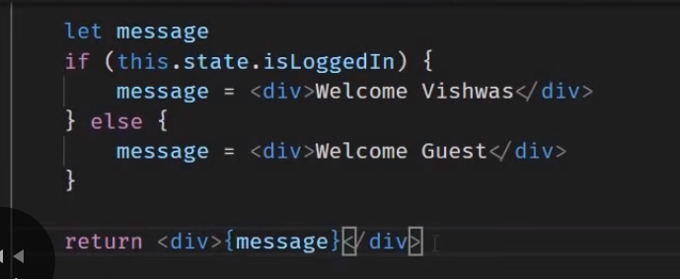

**Lets return in the jsx … return <div> {message}<div>**



**Lets use the Tentorary operation – can use the inside the jsx …**

**3rd Approach Tentorary operation:-**

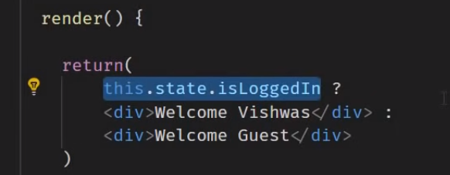

**Formatted the code – Most of the code use this approach**

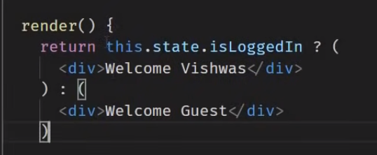

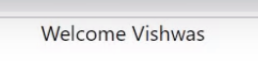

**4th Approach :- Short Circuit Operator- specific case.**

**If condition is true only it should render if not nothing to render ..**

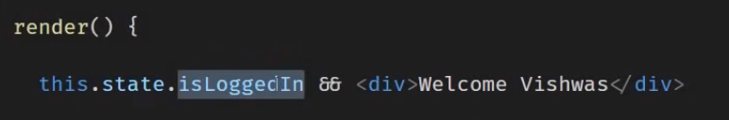

**If true…**

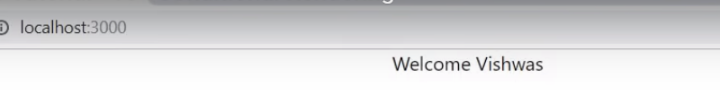

**Preferred to go with the conditional operator or short circuit operator**

[**https://www.youtube.com/watch?v=5s8Ol9uw-yM&list=PLC3y8-rFHvwgg3vaYJgHGnModB54rxOk3&index=17**](https://www.youtube.com/watch?v=5s8Ol9uw-yM&list=PLC3y8-rFHvwgg3vaYJgHGnModB54rxOk3&index=17)

# ReactJS Tutorial - 17 - List Rendering

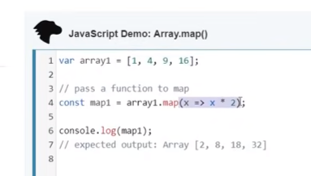

**Name list component**

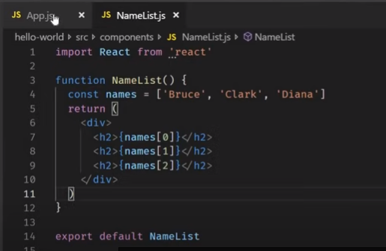

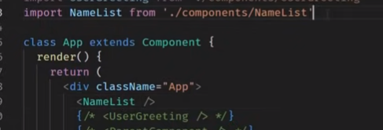

**Output:-**

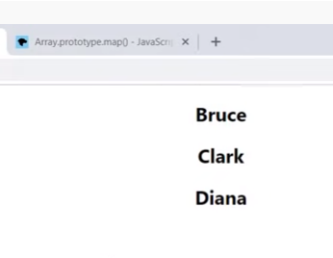

Instead of defing the multiple times based on index value.

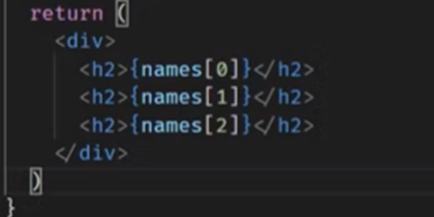

Lets define the map and render on the page

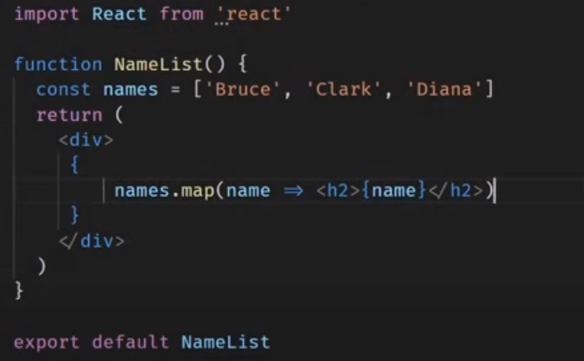

As we want to define the {} curly bases in the map in <h2> tag.. to express the value..

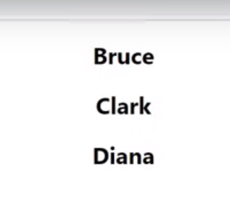

Simple format – preferred.. List

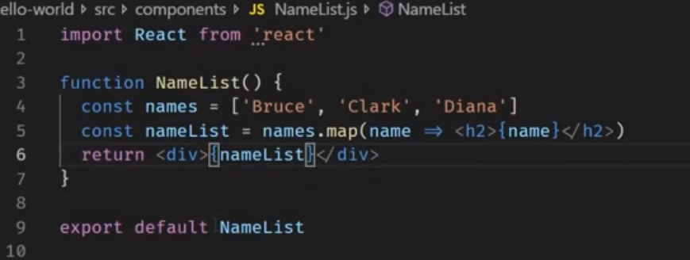

Lets define another component

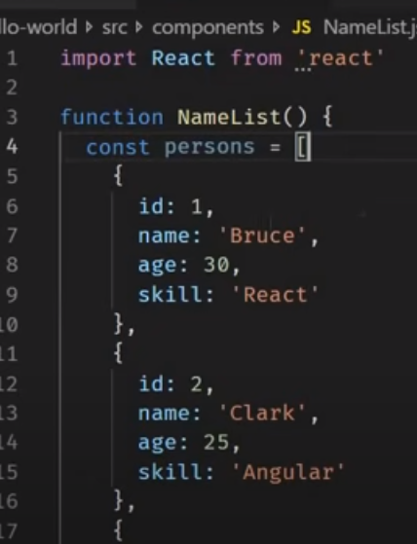

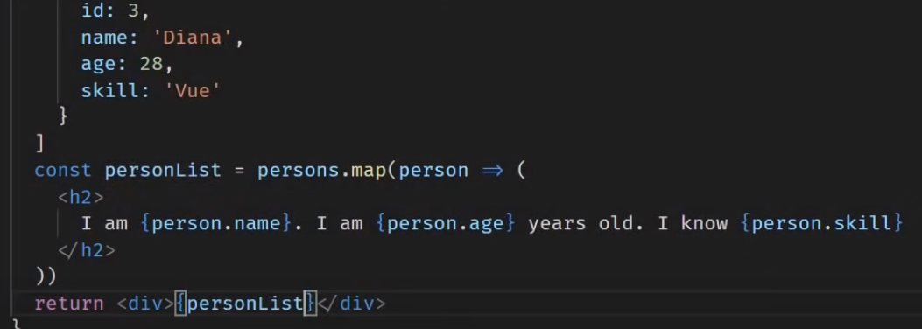

Output :-

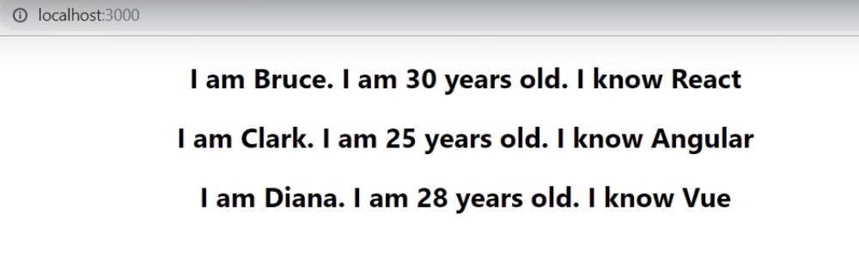

Changes in the code…

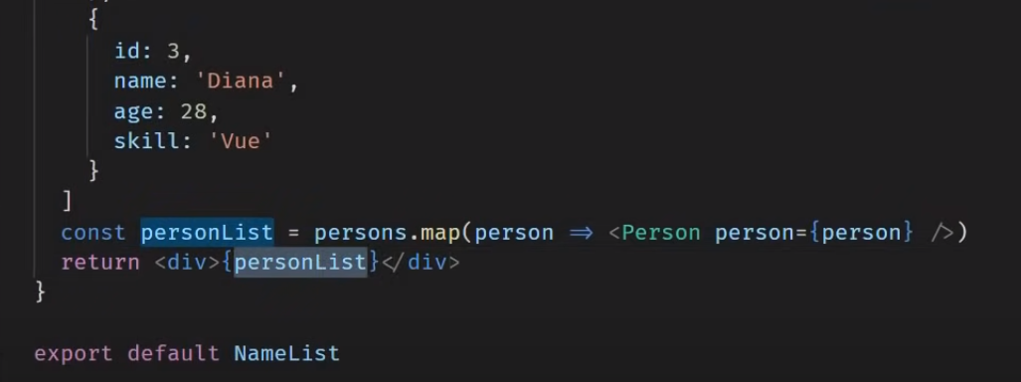

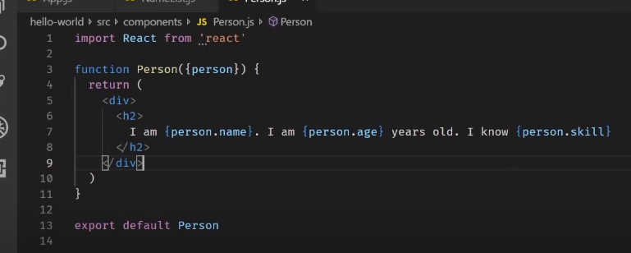

Flow

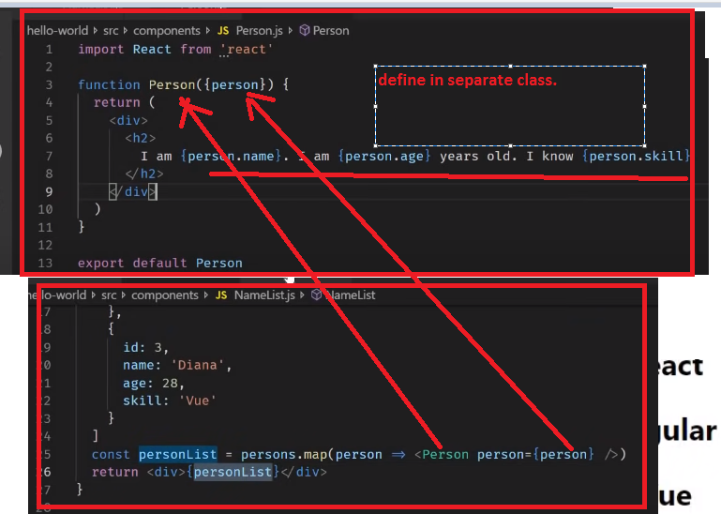

But in the same class is



However, we are getting error on cconsle

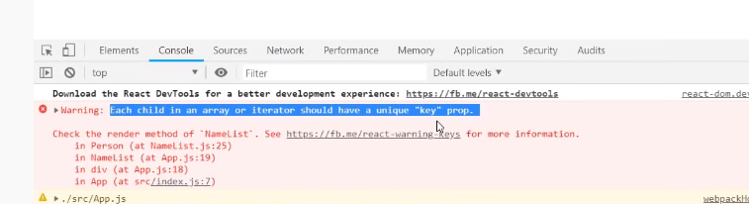

<https://www.youtube.com/watch?v=0sasRxl35_8&list=PLC3y8-rFHvwgg3vaYJgHGnModB54rxOk3&index=18>



We have to add the key for the list of content and key should be unique in the list..

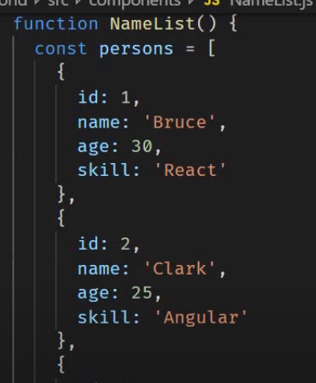

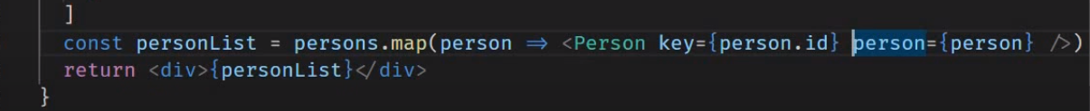

Key is unique it cant be id all the time or it could name also

Even name also **unquie**

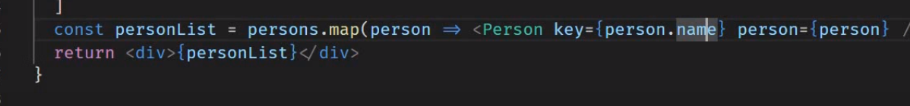

Key components are not accessible in the child components

Define the key as props in the Person/ child component..

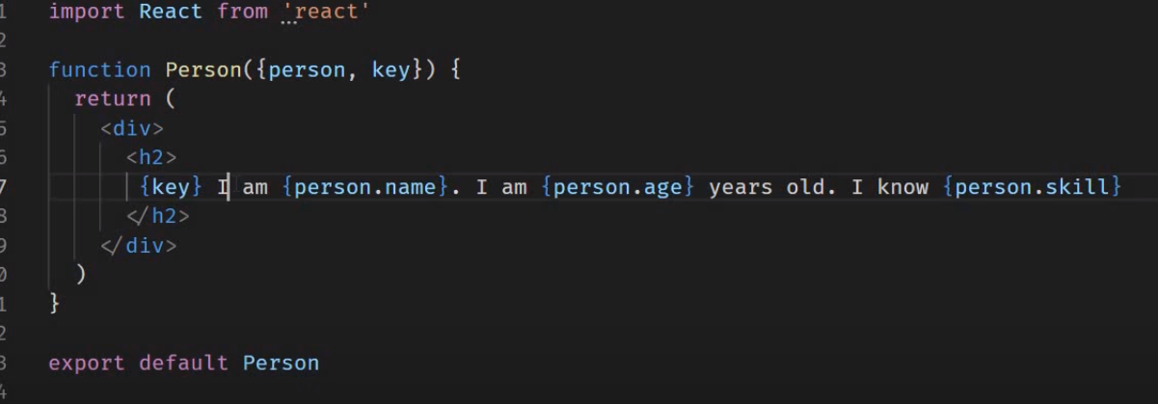

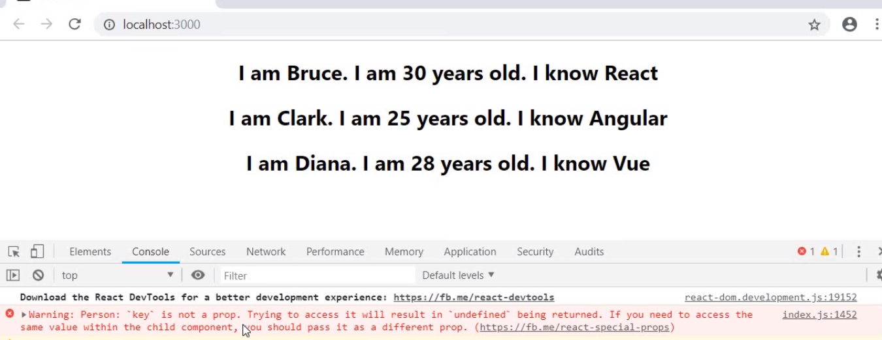

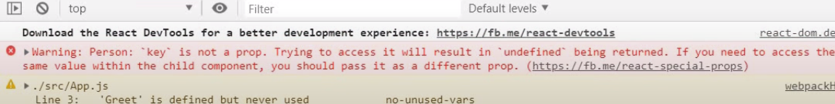

**Key** – don’t render the key props any data.

What we do we need it- key is used get information which is used to to **add/update/remove**

Its play crucial roll in the ui updates

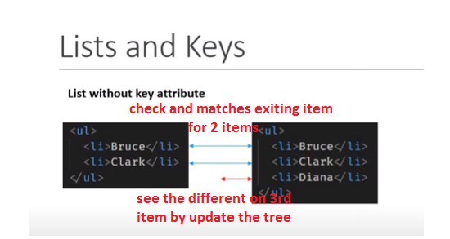

**Why do we need key :-**

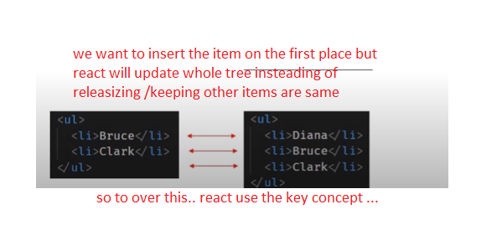

Now react know the elementes position by keys

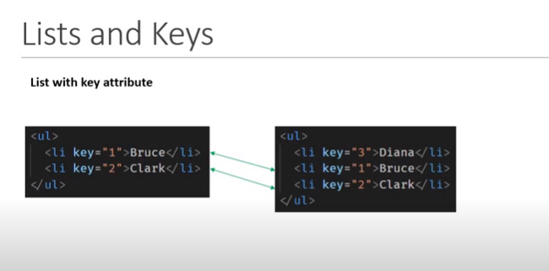

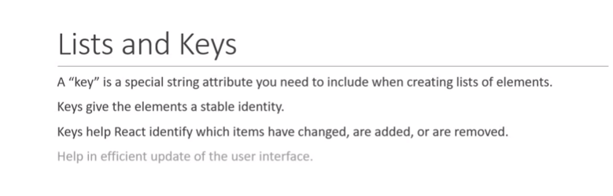

What is some case.. key is unable to indentiifed.. ? how to proceed with that concepts

<https://www.youtube.com/watch?v=xlPxnc5uUPQ&list=PLC3y8-rFHvwgg3vaYJgHGnModB54rxOk3&index=19>

# Index as Key Anti-pattern

As we are passing only names instead of person data in the namelist.

Where in names.map(name =>)

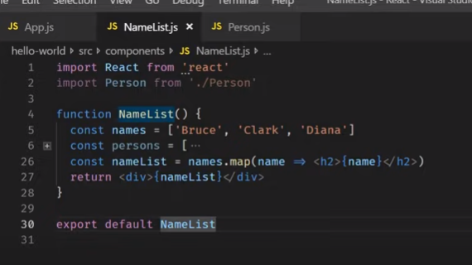

Output: simple output

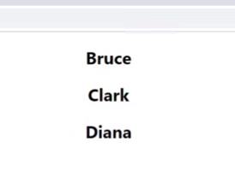

As don’t define key attribute in the code. 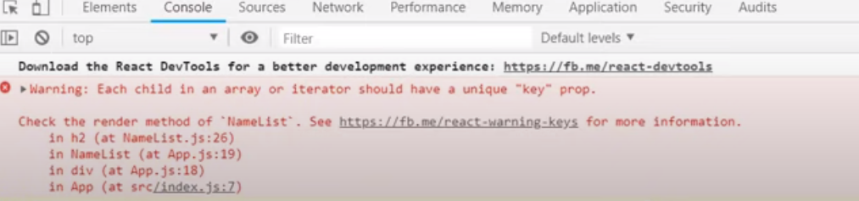

But we don’t have key value in the list.. how to achieve or over come this.. ?

Now in the below code we can consider names are unique

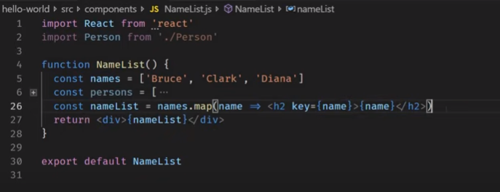

Output - here name are unique not a issue.. But what if have duplicates names… ?

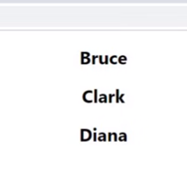

If duplicates names in the code

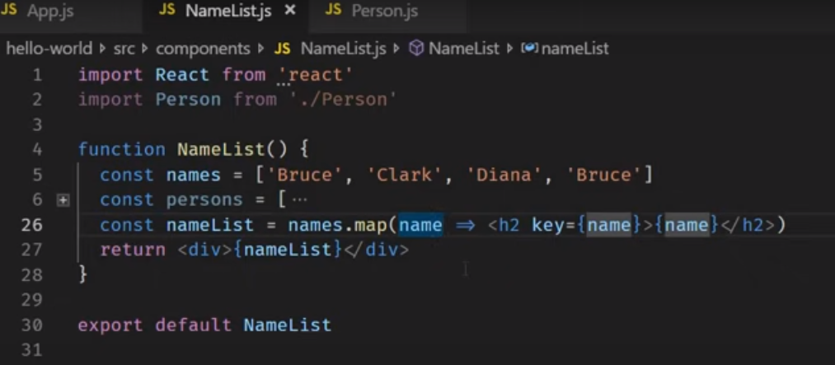

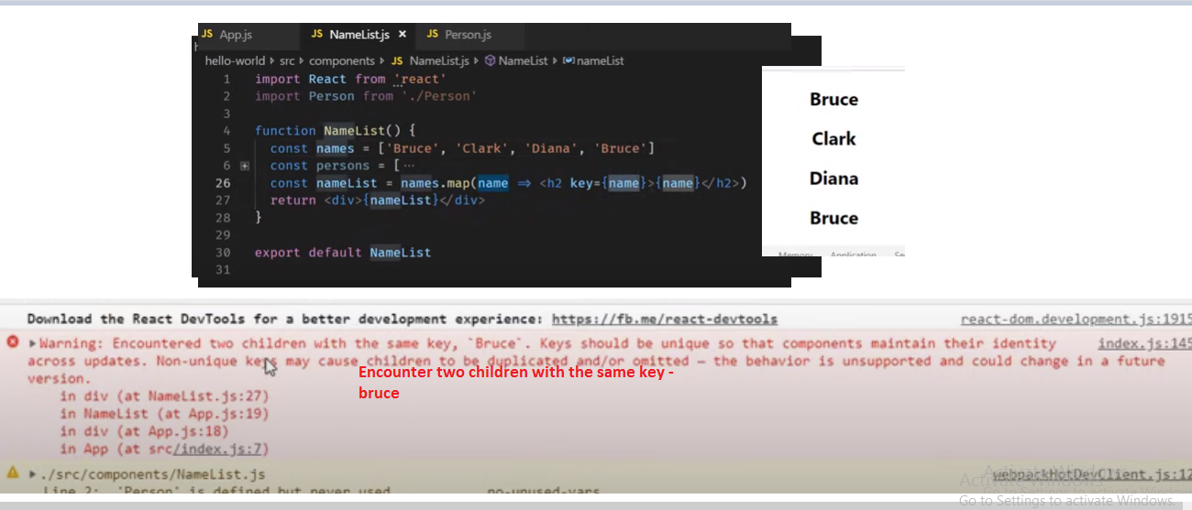

Lets make code changes

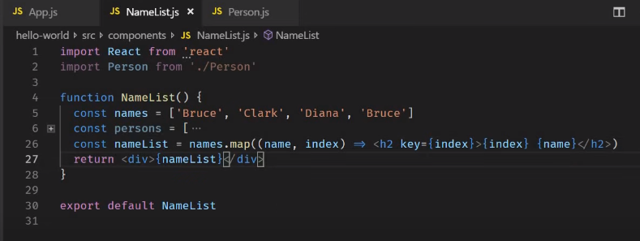

Output :-

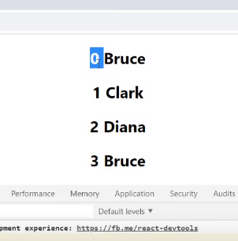

Flow :-

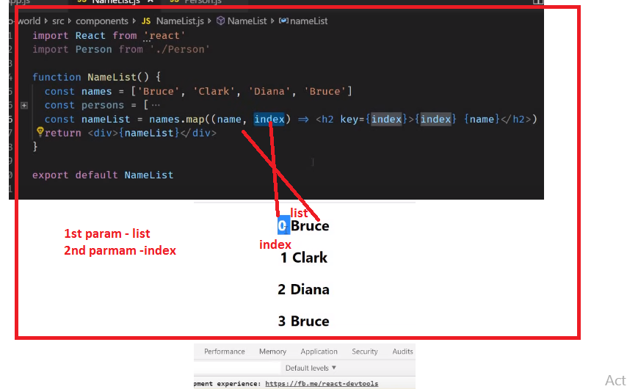

Some cases the index value make issues.

Example

Case1- here index value starts 0, 1 and 2.. for first entry…

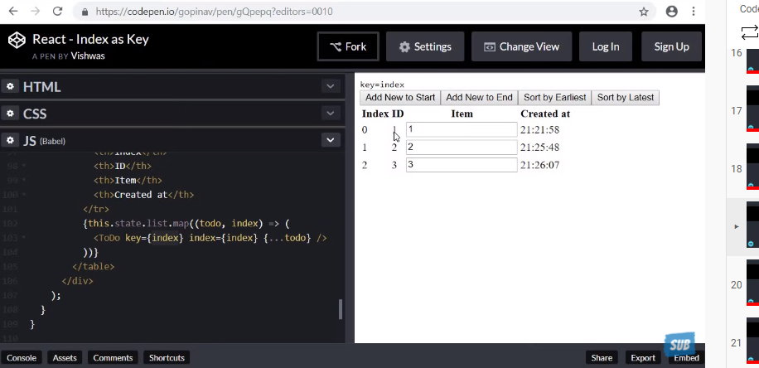

When we add the 4th id value in the code.. at the index 0 but is empty..

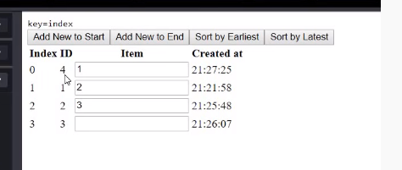

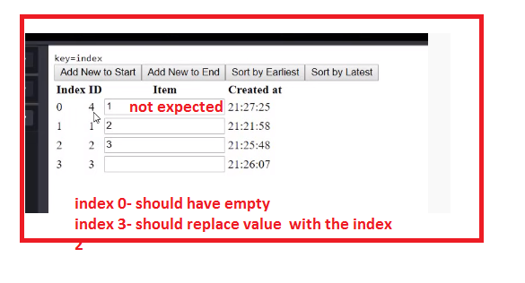.

**So we added the new value at first index 0 .. buts create the at last index x**

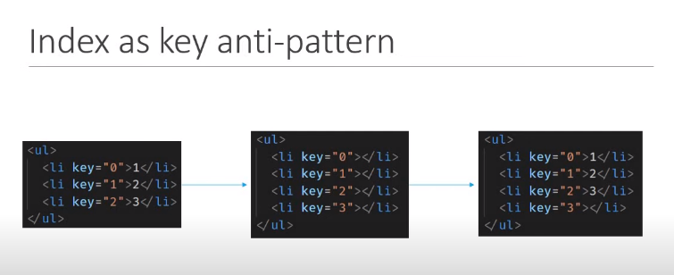

**Flow:-**

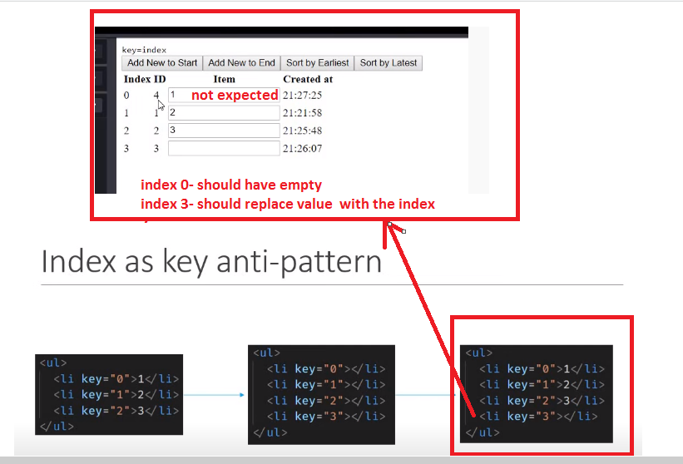

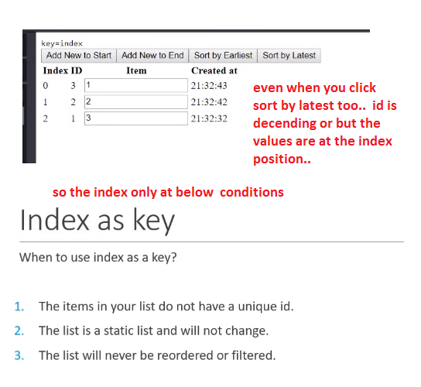

[**https://www.youtube.com/watch?v=7Vo_VCcWupQ&list=PLC3y8-rFHvwgg3vaYJgHGnModB54rxOk3&index=21**](https://www.youtube.com/watch?v=7Vo_VCcWupQ&list=PLC3y8-rFHvwgg3vaYJgHGnModB54rxOk3&index=21)

# ReactJS Tutorial - 21 - Basics of Form Handling

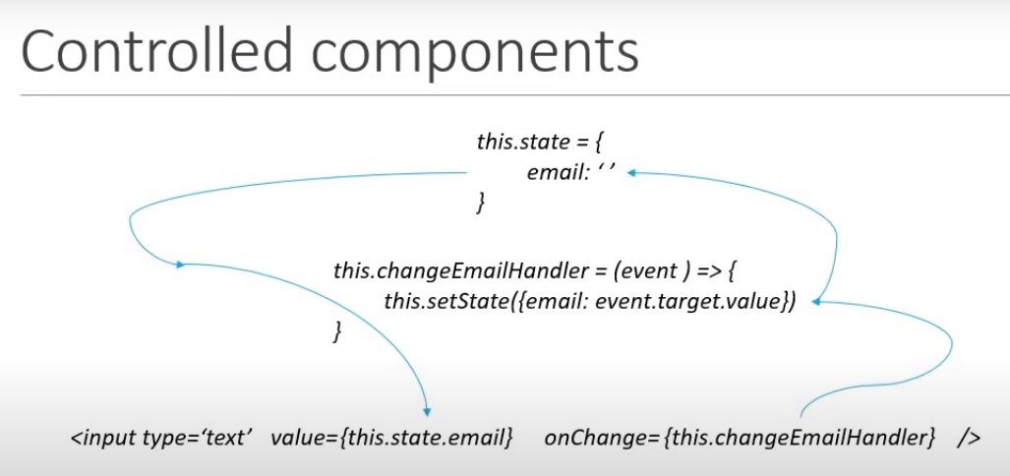

**Just sample form lable..**

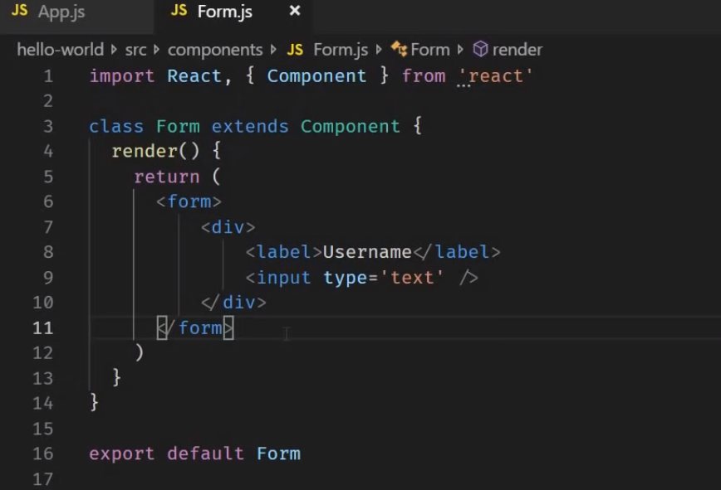

**Output:-**

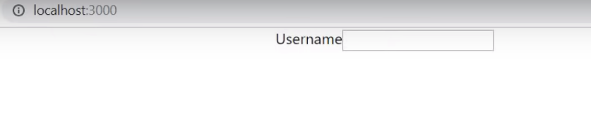

**Lets defined controlled form**

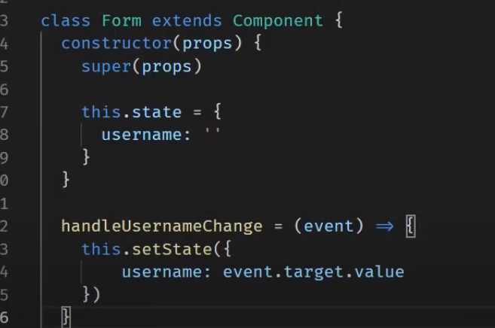

**Define the event – for current updated value…**

[**https://www.javatpoint.com/react-events**](https://www.javatpoint.com/react-events)

[**https://www.w3schools.com/REACT/react_events.asp**](https://www.w3schools.com/REACT/react_events.asp)

**Below code is different for the button and form tags..**

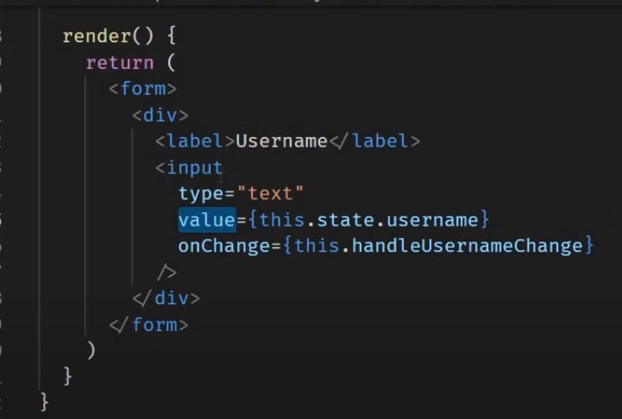

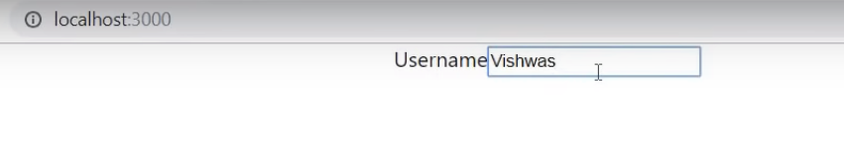

**Flow :-**

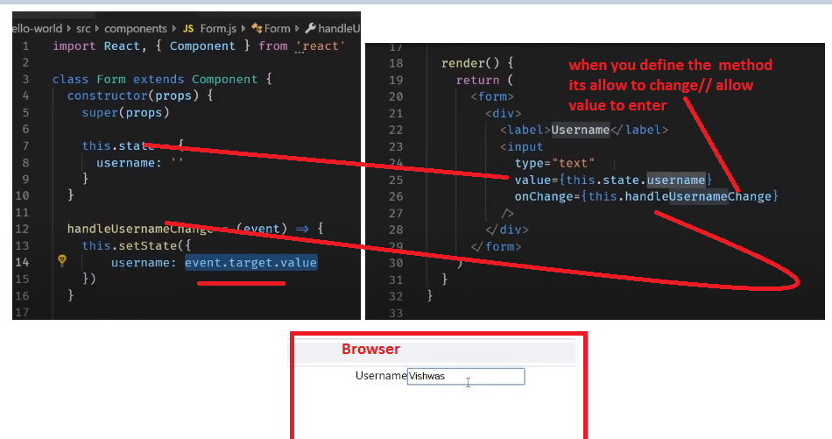

**Code update three variables like username, comments and topic for select and default value is react.**

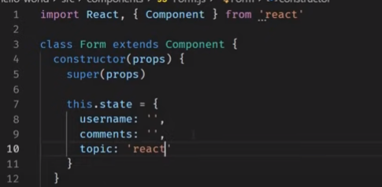

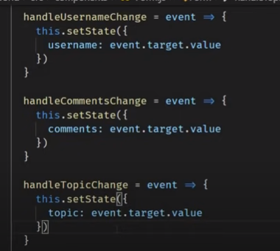

**For form tag**

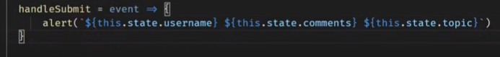

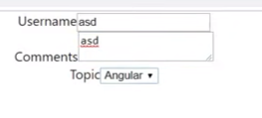

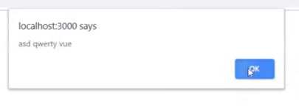

**After close this alter button data will be vanish.. so how to preserve the data ?**

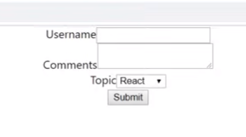

**Define the event.preventDefault()**

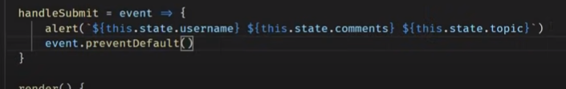

**After refresh – data exist**

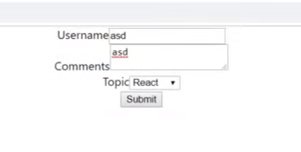

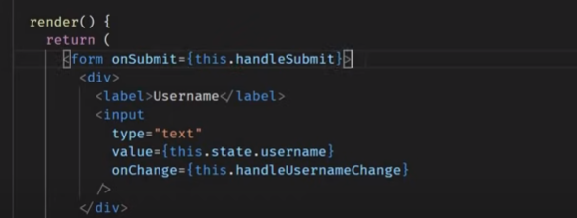

**Submit button.. and select tag**

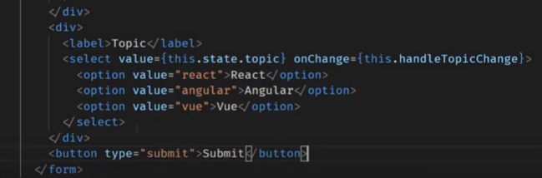

**Flow for only.. Select tag and Submit tag**

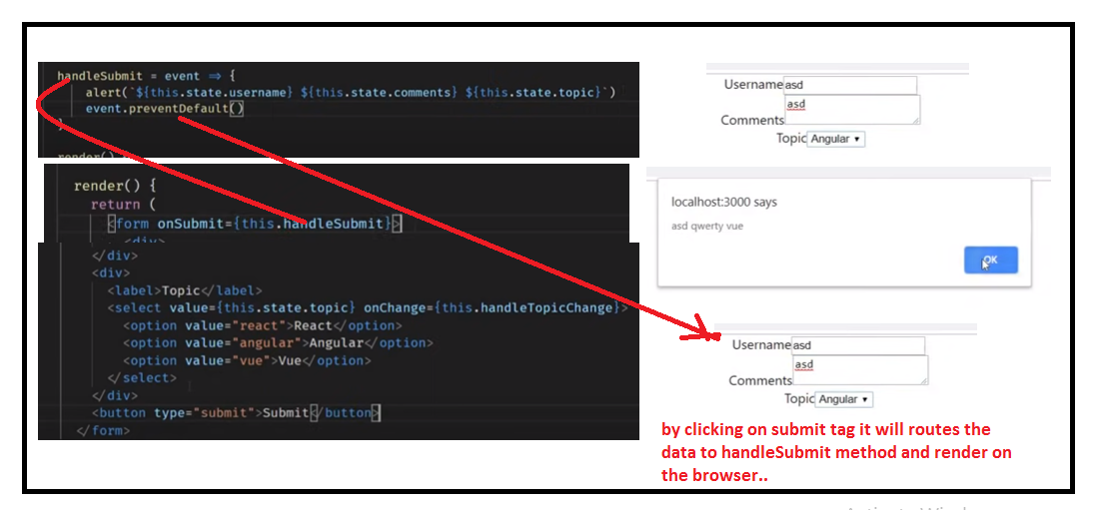

[**https://www.youtube.com/watch?v=qnN_FuFNq2g&list=PLC3y8-rFHvwgg3vaYJgHGnModB54rxOk3&index=22**](https://www.youtube.com/watch?v=qnN_FuFNq2g&list=PLC3y8-rFHvwgg3vaYJgHGnModB54rxOk3&index=22)

# ReactJS Tutorial - 22 - Component Lifecycle Methods

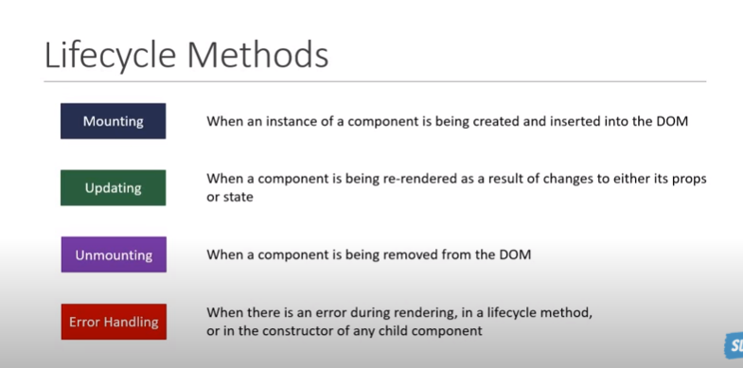

**Life cycle methods…**

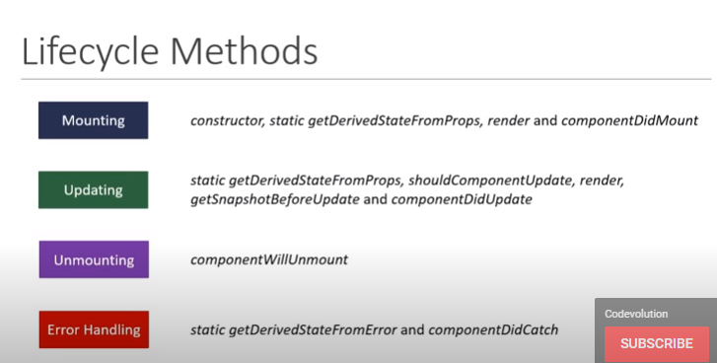

**Its depends on the developer to when to use the which method… and need to understand the each function.**

[**https://www.youtube.com/watch?v=KDXZibVdiEI&list=PLC3y8-rFHvwgg3vaYJgHGnModB54rxOk3&index=23**](https://www.youtube.com/watch?v=KDXZibVdiEI&list=PLC3y8-rFHvwgg3vaYJgHGnModB54rxOk3&index=23)

# ReactJS Tutorial - 23 - Component Mounting Lifecycle Methods

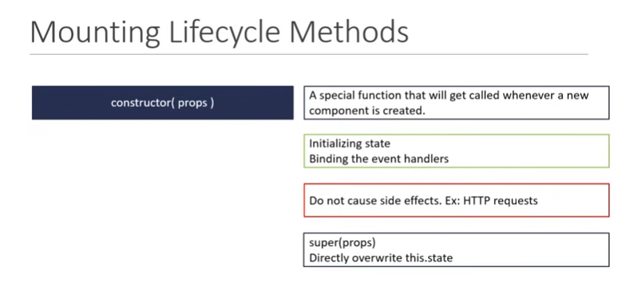

**1-constructor**

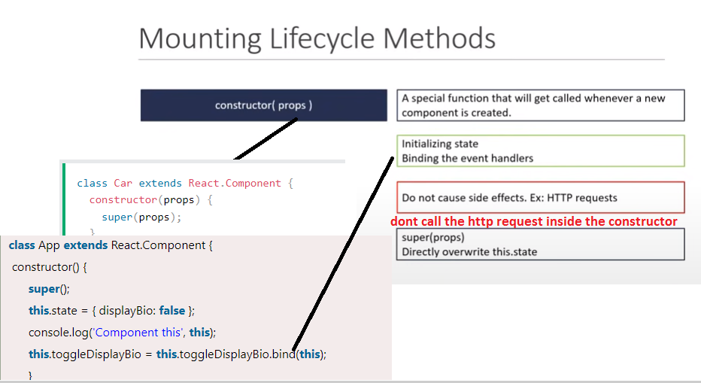

**2nd – getDerviedStateFromProps() – rarely used its static method and can’t use this. setSate**

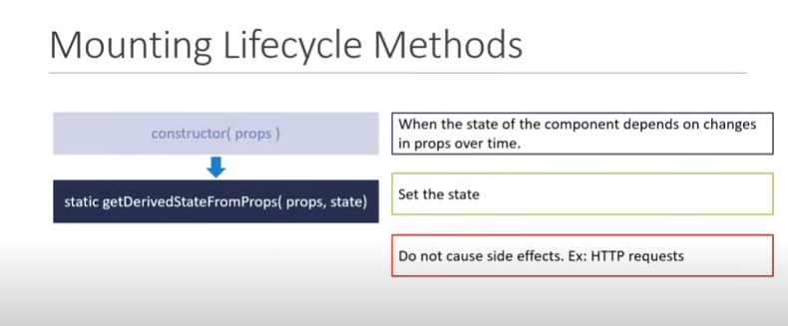

**Render: -**

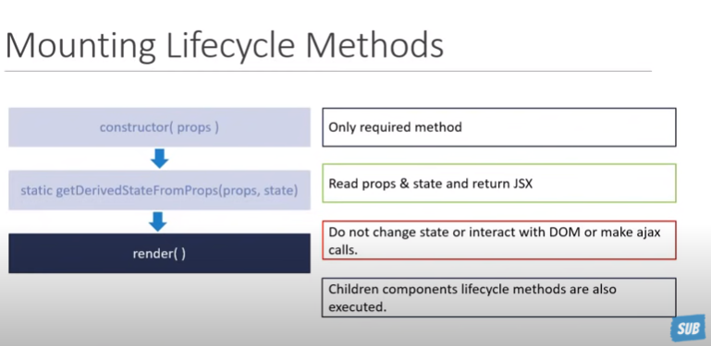

**Example for children component in the parent render().**



**Component did mount – used for only initial the data at once.. whole life cycle..**

**Can’t call the ajax calls to load data..**

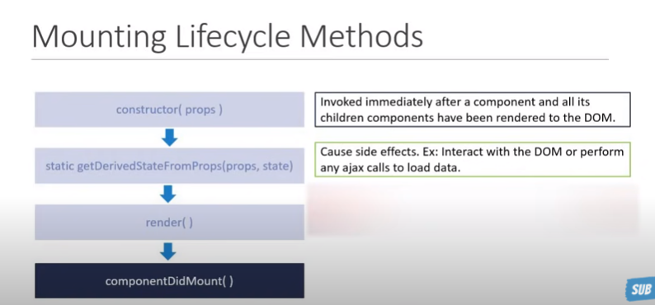

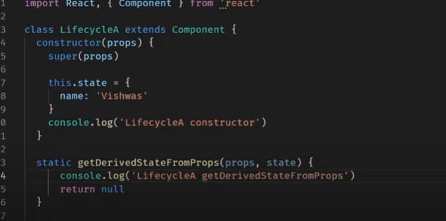

**getDerivedStateFromProps( )- accepts the props and state**

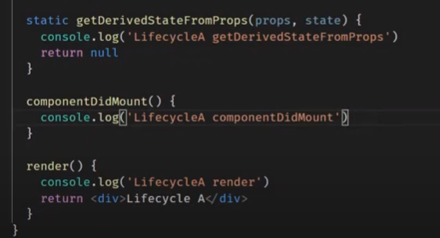

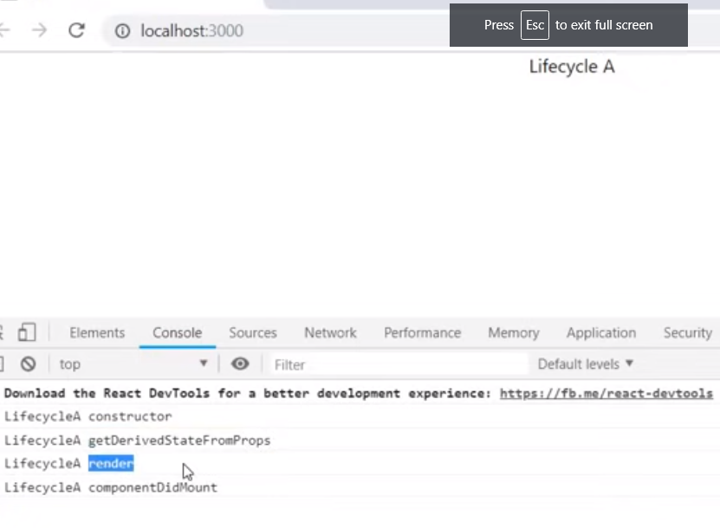

**Flow –order of executing state during the mounting face**

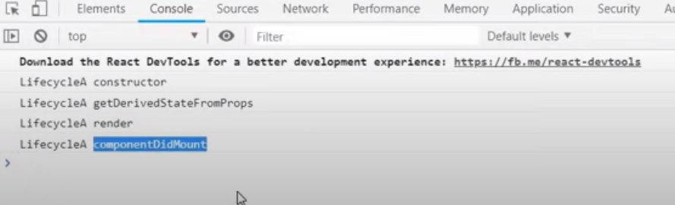

**Now lets call the child component in the render method.. in the parent component.**

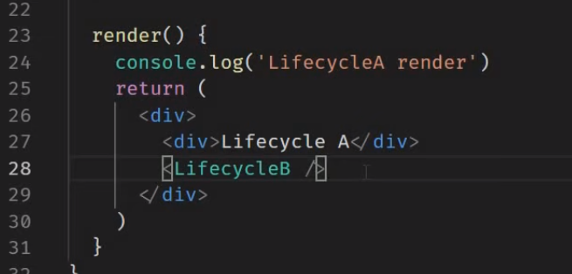

**Where as in child component : -**

**Flow**

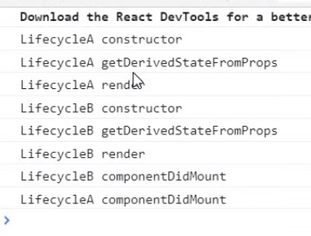

[**https://www.youtube.com/watch?v=DyPkojd1fas&list=PLC3y8-rFHvwgg3vaYJgHGnModB54rxOk3&index=24**](https://www.youtube.com/watch?v=DyPkojd1fas&list=PLC3y8-rFHvwgg3vaYJgHGnModB54rxOk3&index=24)

# ReactJS Tutorial - 24 - Component Updating Lifecycle Methods

**Changes in the state / re render the code..**

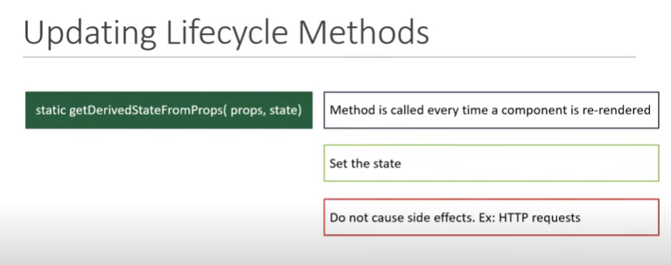

[**https://www.javatpoint.com/react-component-life-cycle**](https://www.javatpoint.com/react-component-life-cycle)

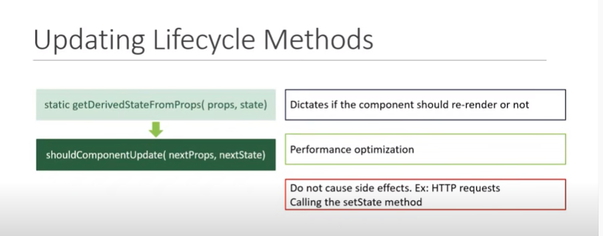

**This method used for the performance optimization – return the true or false to react application to execute or not based on the nextprops, next state.. if you true its re-render for false it not render.**

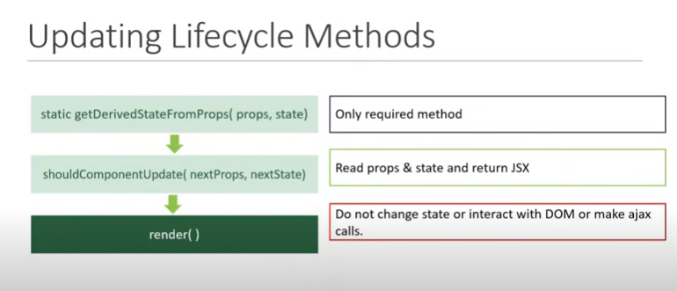

**getSnapShot : -**

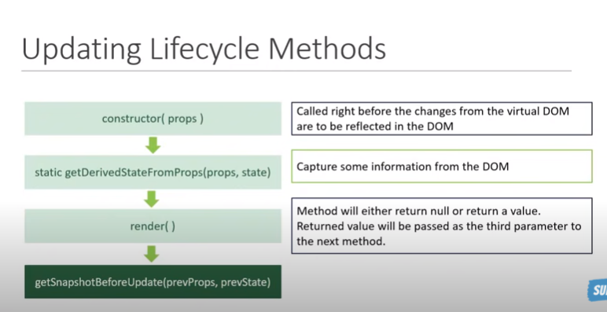

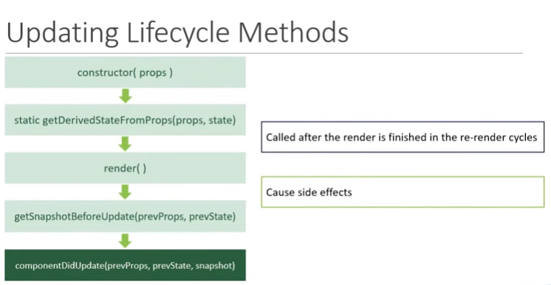

**This componentDidUpdate – suitable for the ajax calls for load data/fetch data**

**componentDidUpdate()**  
It is invoked immediately after the component updating occurs. In this method, you can put any code inside this which you want to execute once the updating occurs. This method is not invoked for the initial render.

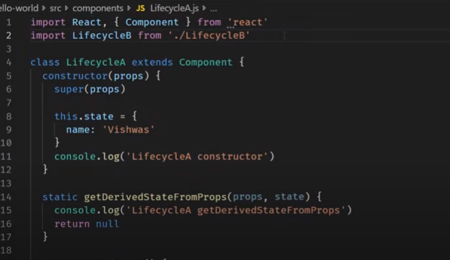

**Update methods.. : in snapshot method return the value is null**

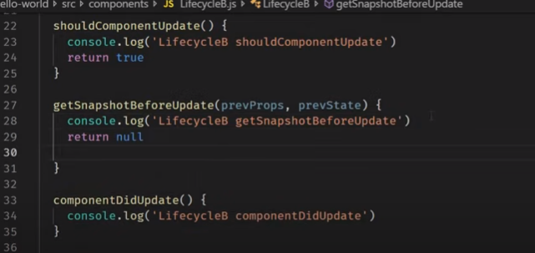

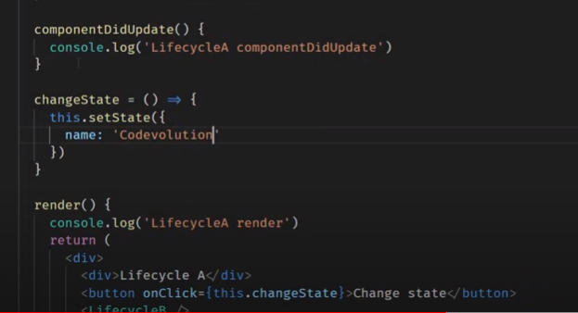

**Define the same code in the child component**

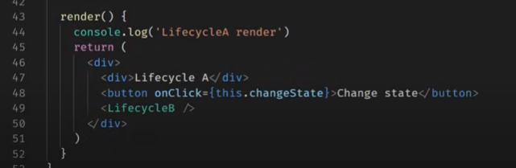

**On browser before we click on it..**

**No update and snapshot methods are triggered**

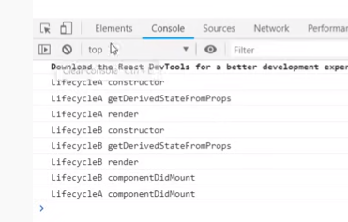

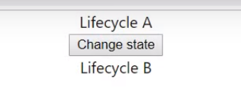

**After click on the change state**

**Flow the methods**

**update and snapshot methods are triggered**

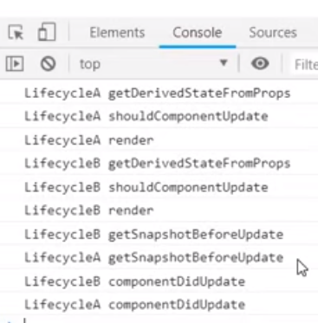

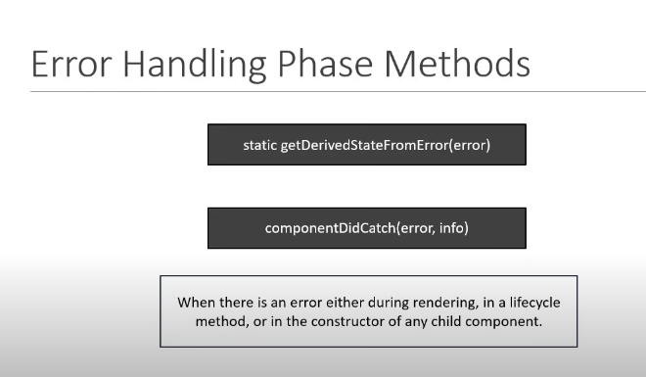 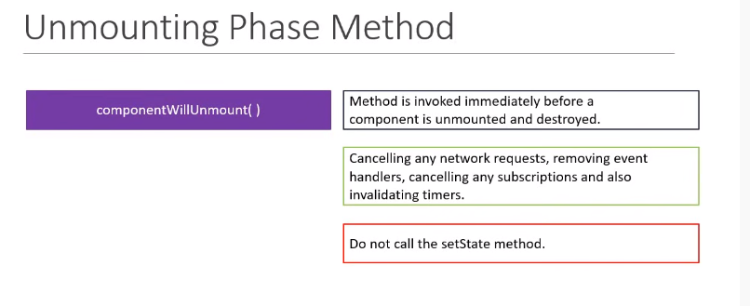

Error methods will discuss on the **further tutorials**

[**https://www.youtube.com/watch?v=bHdh1T0-US4&list=PLC3y8-rFHvwgg3vaYJgHGnModB54rxOk3&index=25**](https://www.youtube.com/watch?v=bHdh1T0-US4&list=PLC3y8-rFHvwgg3vaYJgHGnModB54rxOk3&index=25)

# ReactJS Tutorial - 25 - Fragments

**Framments :-**

**Wrong code :-**

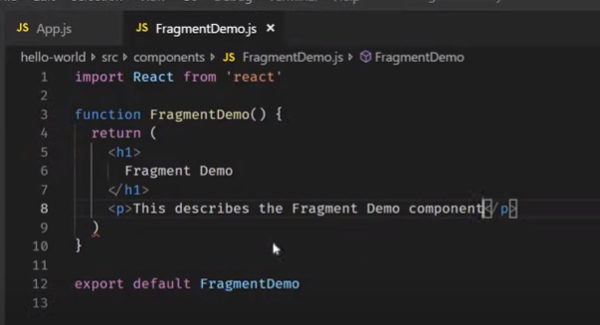

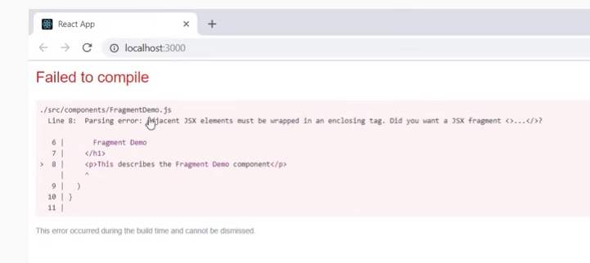

**Son wrapping the parent by the <div> tag**

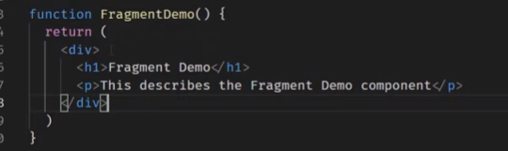

**Flow**

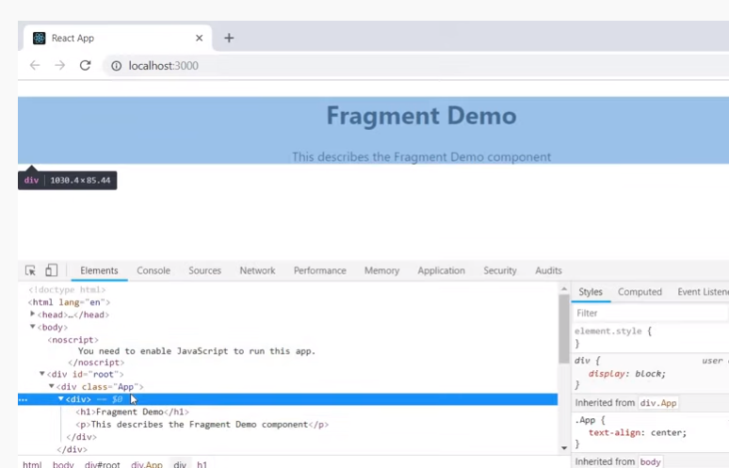

**Another way <React.Fragment > tag**

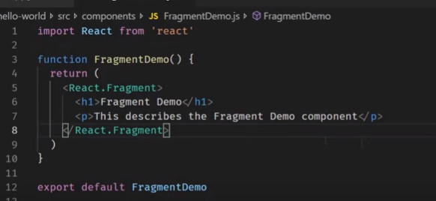

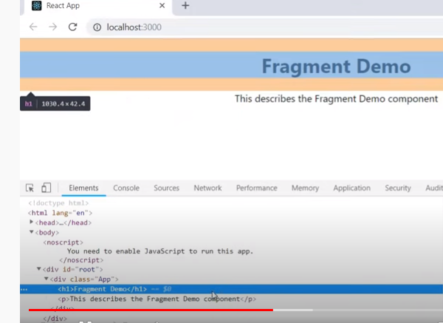

**Now lets create the Table and Columns js files.**

**Table :-**

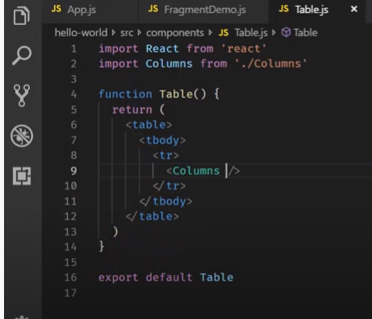

**For multiple elements we use the <div> tag..**

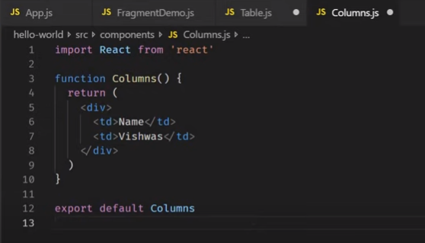

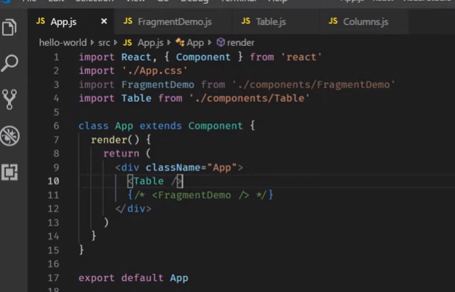

**Output:- warning on console – its wrong having the td element in the child component**

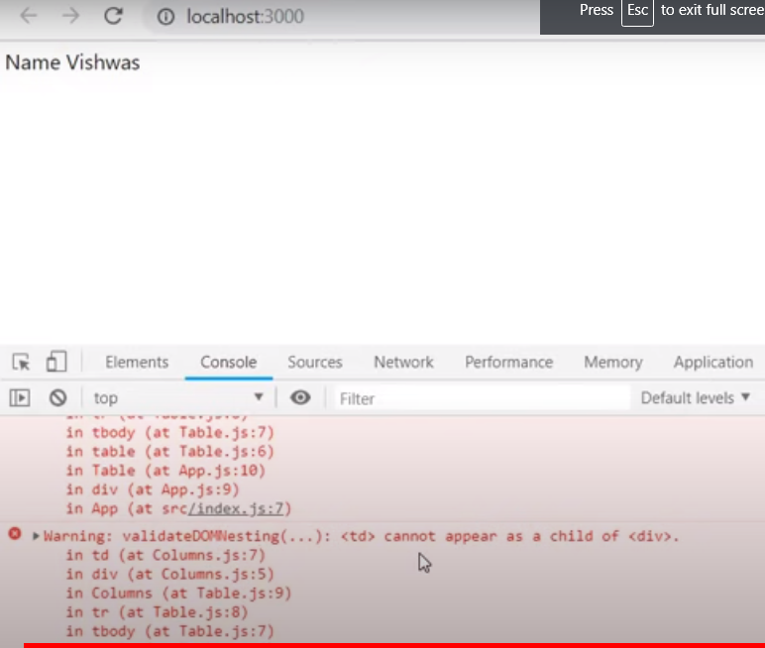

**So define the <React.Fragement>**

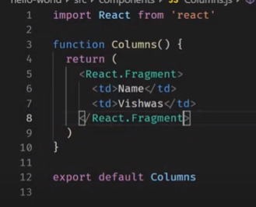

**No issue on the output**

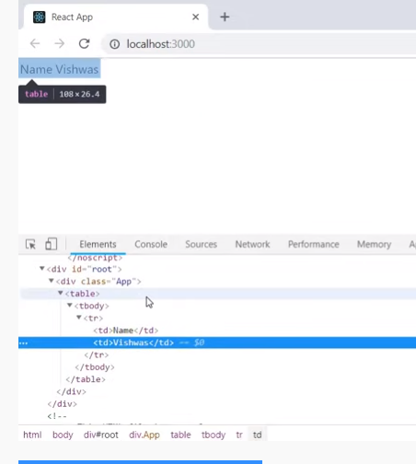

**For list of elements :-**

**Key can pass with the <React.Fragment key = {item.id}**

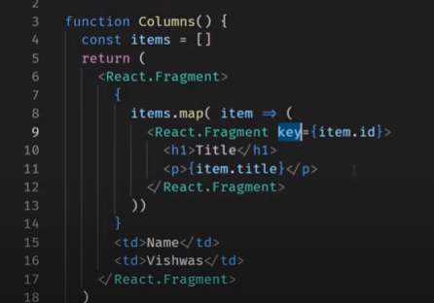

**However, we can define the multiple elements in the <> <\>**

**But there is limitation like.. you can pass the key attribute**

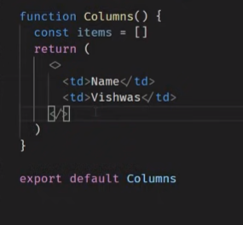

**No issue in the code**

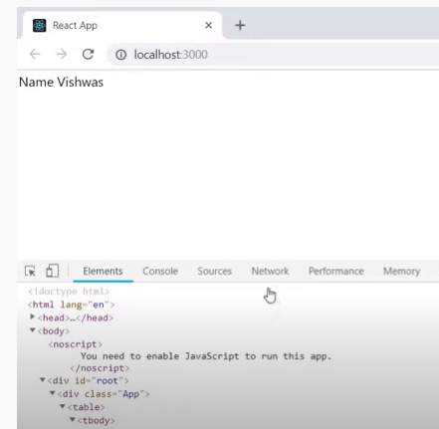

[**https://www.youtube.com/watch?v=YCRuTT31qR0&list=PLC3y8-rFHvwgg3vaYJgHGnModB54rxOk3&index=26**](https://www.youtube.com/watch?v=YCRuTT31qR0&list=PLC3y8-rFHvwgg3vaYJgHGnModB54rxOk3&index=26)

# ReactJS Tutorial - 26 - Pure Components

**What is the difference between component class and pure components class and when to use.. ?**

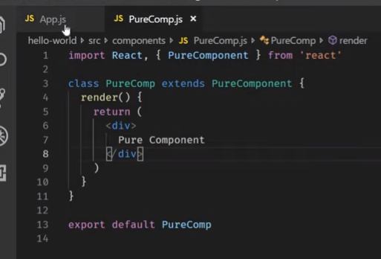

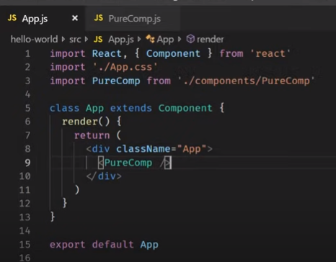

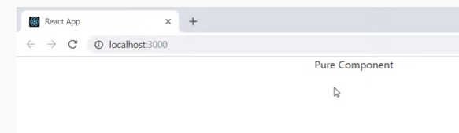

**What is the difference between component class and pure components class and when to use.. ?**

**Regular component :-**

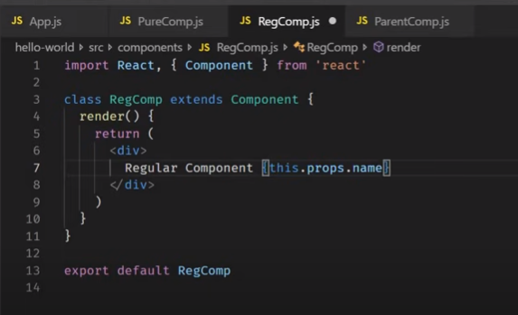

**Pure component :-**

**As we are not setting any state just getting the props value**

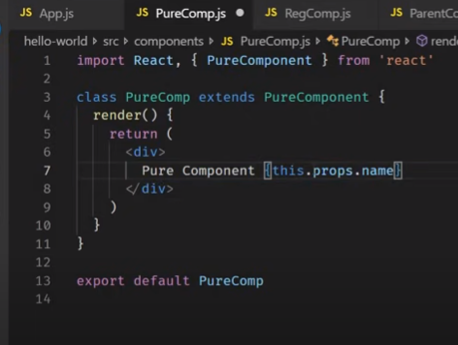

**Parent component :-**

**As we are passing define initial value and set value is same..**

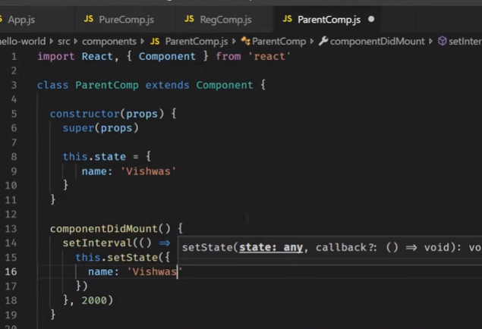**define the child components and passing the params like name = {this.state.name} to child components**

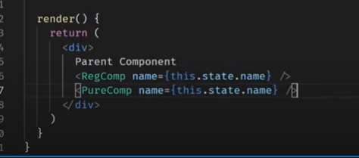

**App.js**

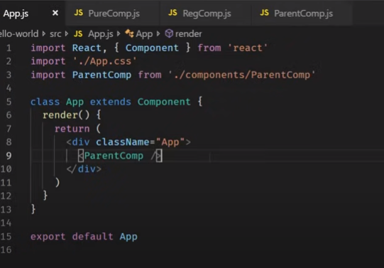

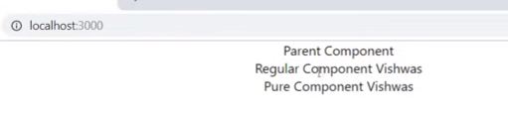

**We have to analysis when the render method is called each of the component :-**

**On parent –define the console.log()**

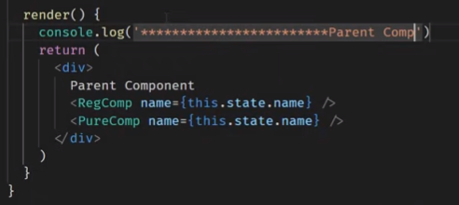

**RegComp**

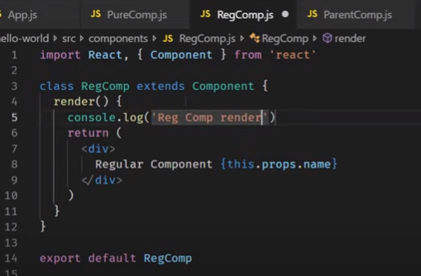

**PureComponent**

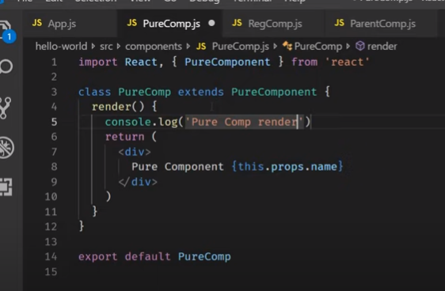

**Output**

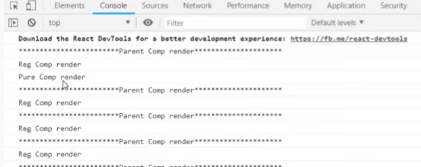

**For every 2secs only Reg component is render… Pure Component is never re-render**

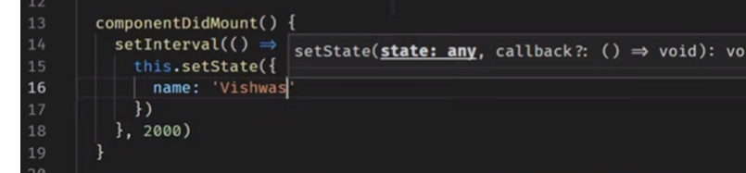

**Because regulare component-shouldComponentUpdate – return value is true to exit.**

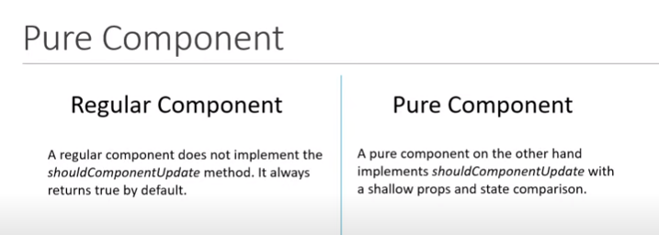

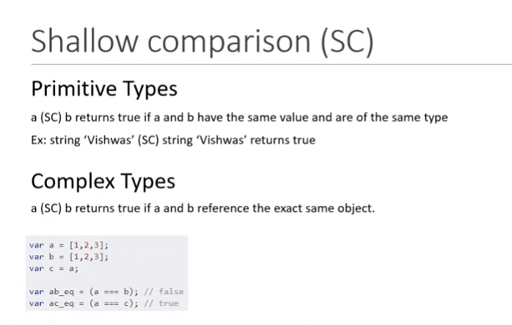

**---a === b flase because not having the same object.**

**Where in case a ===c true.. because c =a ;**

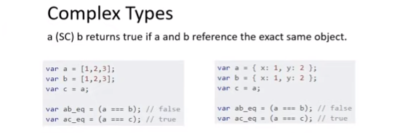

**Lets implement :-**

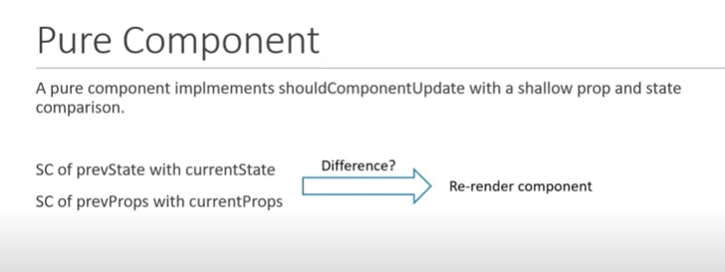

**Lets define the parent component to extends purecomponent**

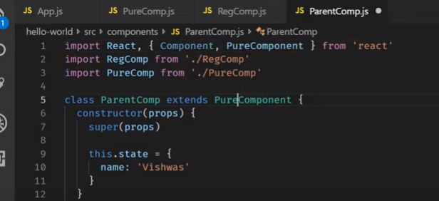

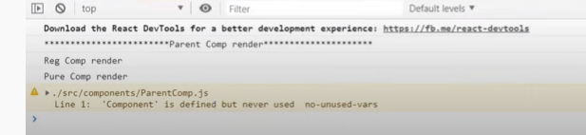

**Its not proceed to render.. Because parent component is checking the previous state and props to render.. ? where in this case.. initial value and latest value is same –vishwas If parent is not re-render then child also never re-rendered.**

**Why to use the pure components – to avoid the unnessary render to avoid for same value its optimize the perfromance**

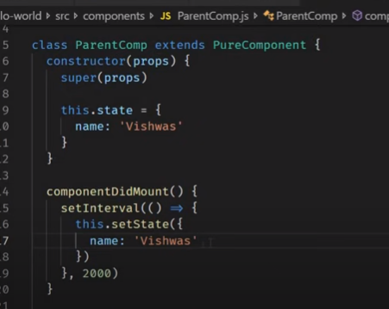

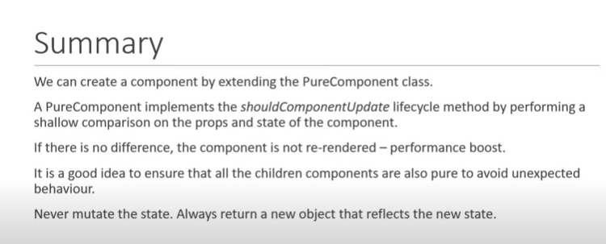

**Suggested to use only the regular components instead of pure componets…**

[**https://www.youtube.com/watch?v=7TaBhrnPH78&list=PLC3y8-rFHvwgg3vaYJgHGnModB54rxOk3&index=27**](https://www.youtube.com/watch?v=7TaBhrnPH78&list=PLC3y8-rFHvwgg3vaYJgHGnModB54rxOk3&index=27)

# ReactJS Tutorial - 27 - memo

**pure componets is for only class level component.. But we want to implement in the functional level then we can go for the memo**

**lets make change in the code**

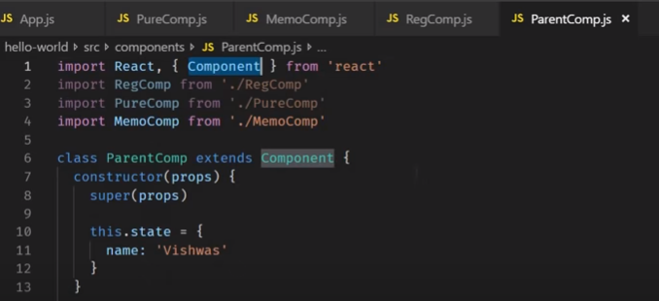

**Every two seconds resulting re-render**

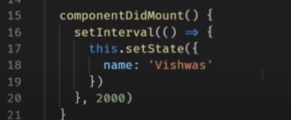

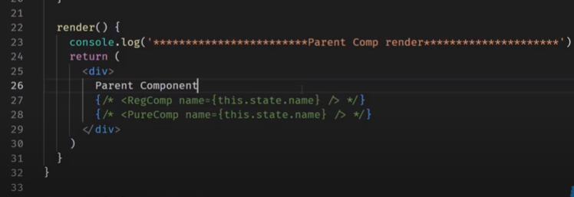

**Passing the props.. such state of value..**

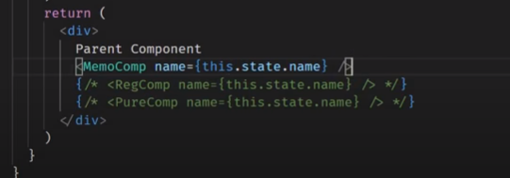

**React.memo(define the meme class) –introuduced react 16 version**

**React and react dom should 16 or 16+ verions**

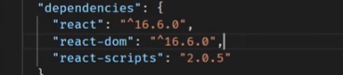

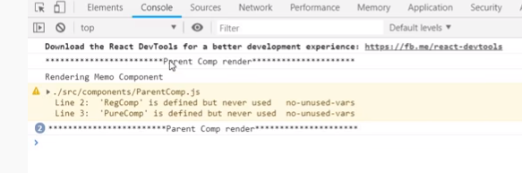

**At application up.. Parent and memo render and after 2secs only parent render,**

**When there is no change props.. then memo component is not re-render.**

**Higher Order Component –add some things to the components are called Higher Order Component.**

**In this I could say.. memo is not re-render when props are not changed..**

[**https://www.youtube.com/watch?v=FXa9mMTKOu8&list=PLC3y8-rFHvwgg3vaYJgHGnModB54rxOk3&index=28**](https://www.youtube.com/watch?v=FXa9mMTKOu8&list=PLC3y8-rFHvwgg3vaYJgHGnModB54rxOk3&index=28)

# ReactJS Tutorial - 28 - Refs

Login form – by default input filed should focus - how to achieve this.. ?

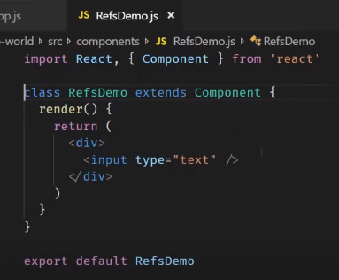

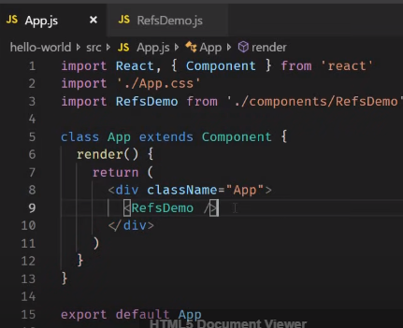

**We want input filed should be focus.. how to achieve this.. ?**

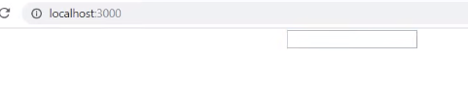

**Step1- create the reference.. i.e this.inputRef = React.createRef()**

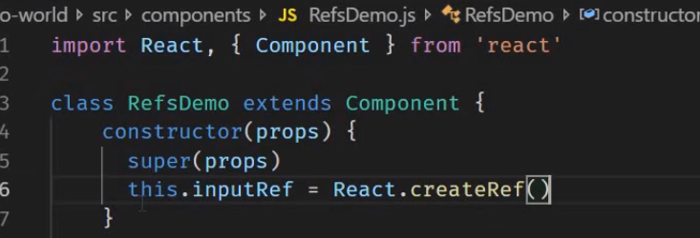

**Step 2**

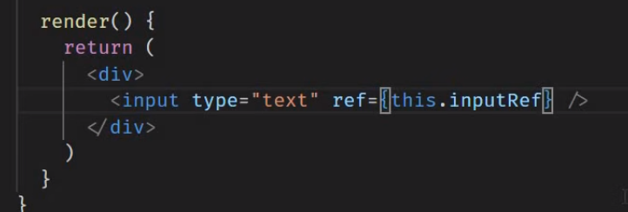

**As we have to know the what is the property defined by this.inputRef.. Then define the method or any default method like componentDidmount()**

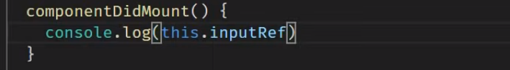

**Complete code**

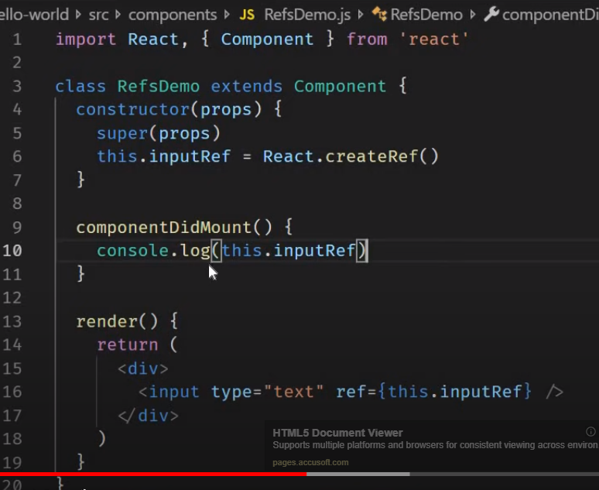

**Lets check in the output on console: -**

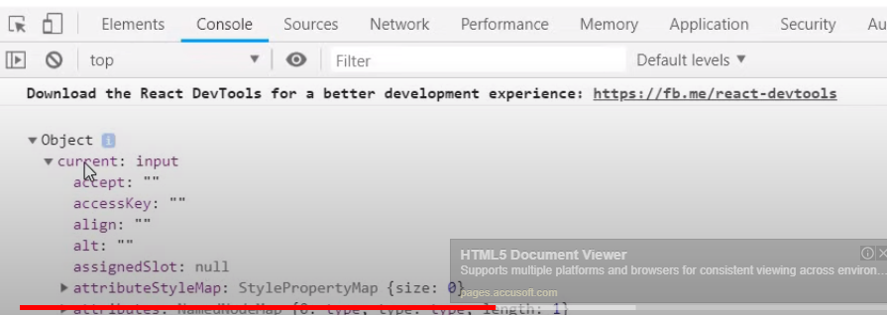

**Try to connect with element current: input in the code**

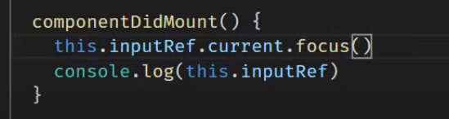

**Input element focus**

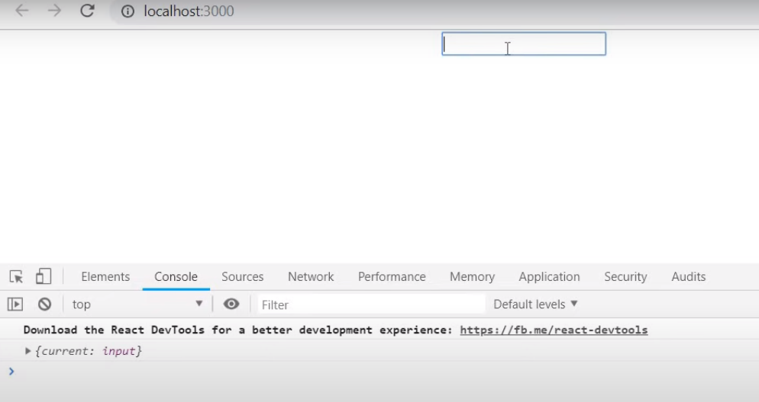

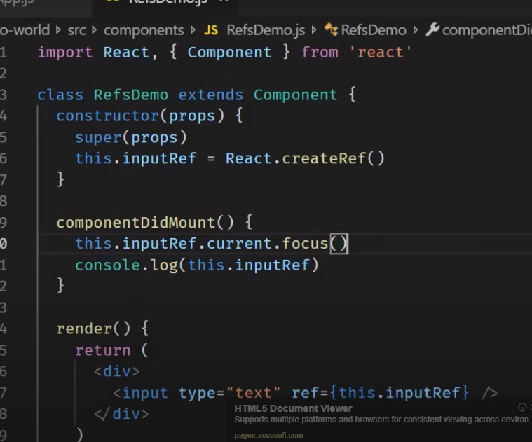

**Let make change in the code**

1. **Way to create and access the reference.**

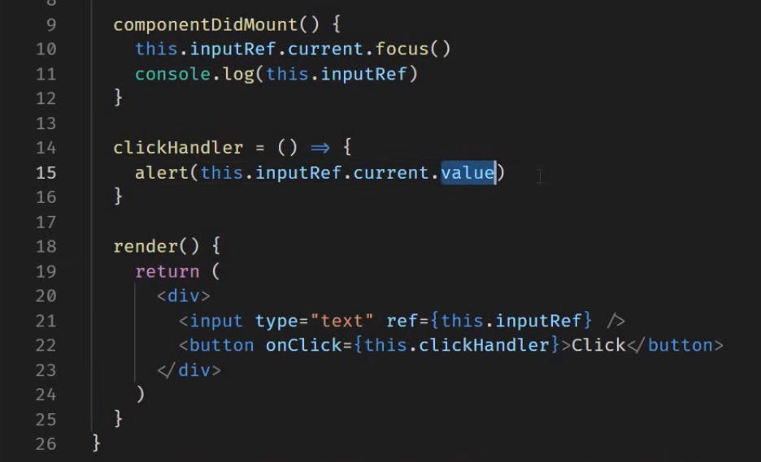

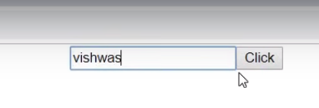

**Click on the button**

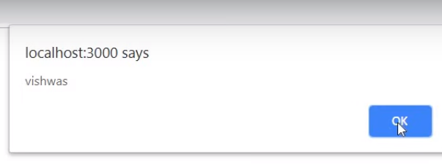

**Flow :- By clicking the button value will pass the clickHandler method and where it alert the value.**

**In componentDidMount() this.inputRef.current.focuse() – called..**

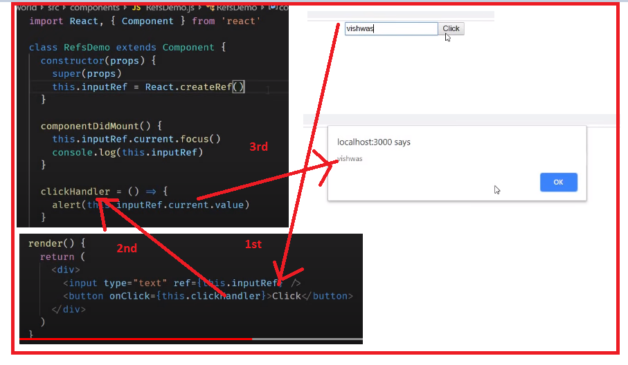

**2nd approach : - call back reference..**

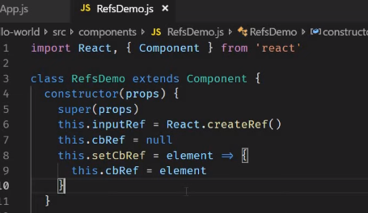

**In the below render method as we are calling the this.setCbref method..**

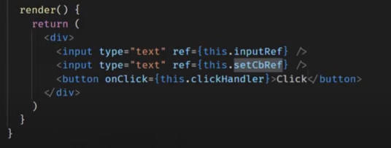

**As we comment the component did mount method.. Y ?**

**React Call the ref with call back**

**Case 1- with dom element when component mounts**

**Case 2- will call with null when its unmounts**

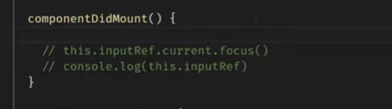

**Unlike the previous approach .. its directly call the access the using the ref property**

**As we checking condition.. (this.cbref) is not null**

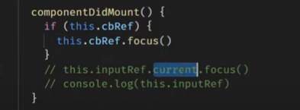

**As we can view the second reference has focus**

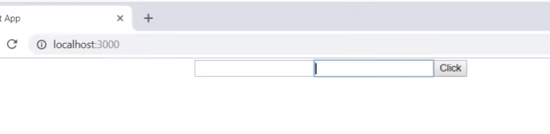

**Flow :- call back ref.. directly access.. i.e cbRef.focuse()**

**Note:- added the ref to normal html element like input element.**

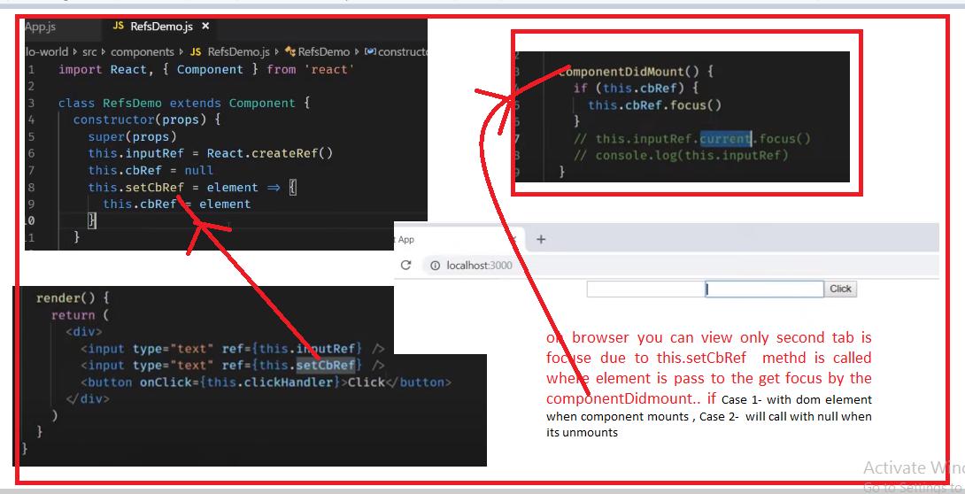

[**https://www.youtube.com/watch?v=8aCXVC9Qmto&list=PLC3y8-rFHvwgg3vaYJgHGnModB54rxOk3&index=29**](https://www.youtube.com/watch?v=8aCXVC9Qmto&list=PLC3y8-rFHvwgg3vaYJgHGnModB54rxOk3&index=29)

# ReactJS Tutorial - 29 - Refs with Class Components

**In last tutorial we have seen how to add the ref to normal html element like input element.**

**In this tutorial we will apply ref to the class component.**

**Lets create the component – input.js**

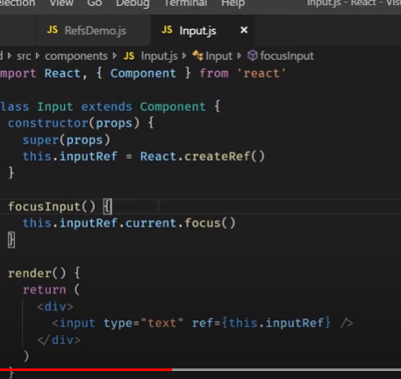

**Lets create the another component : - focus-input – its parent component –**

**When we click on the focus input button in the parent element its should call the child component method i.e focusInput ()**

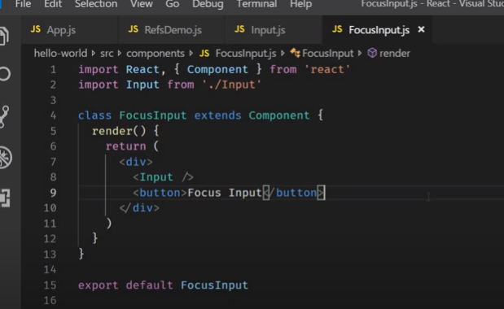

**To achieve this.. we have to create reference and lets define in the jxs**

**Ie. <Input ref ={this.compoentRef}**

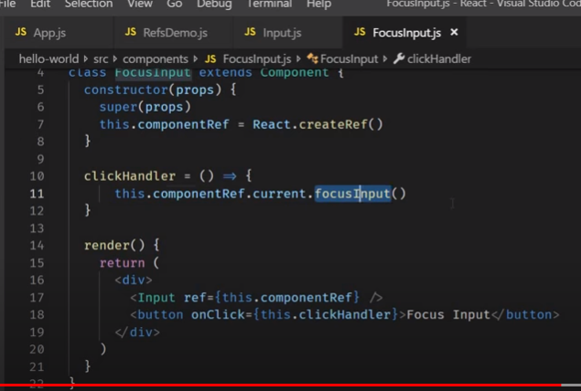

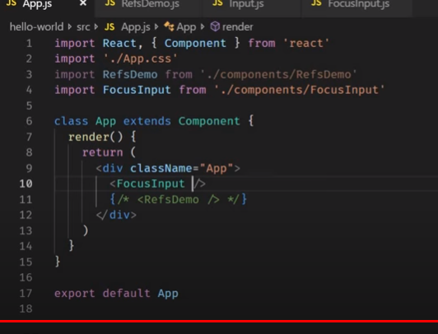

**Before you click**

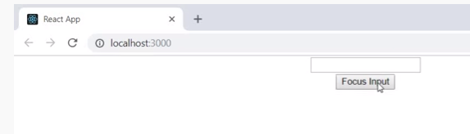

**After you click focus the html element**

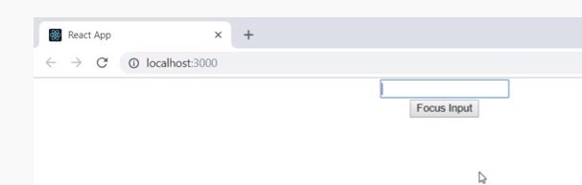

**Flow :-**

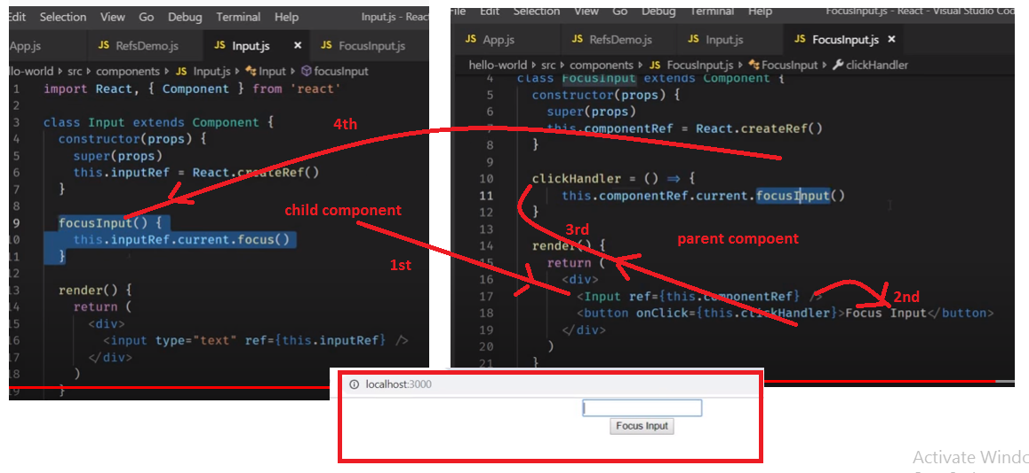

**Ref – can not add to the functional component.**

[**https://www.youtube.com/watch?v=RLWniwmfdq4&list=PLC3y8-rFHvwgg3vaYJgHGnModB54rxOk3&index=30**](https://www.youtube.com/watch?v=RLWniwmfdq4&list=PLC3y8-rFHvwgg3vaYJgHGnModB54rxOk3&index=30)

# ReactJS Tutorial - 30 - Forwarding Refs

**Forwarding refs – used to pass from parent to child automatically**

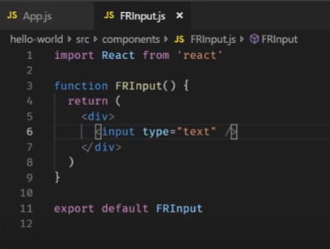

**Parent :-**

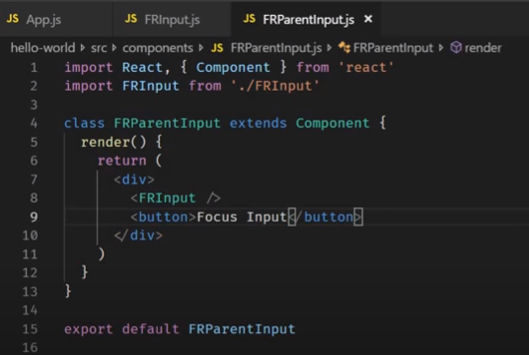

**Output :-**

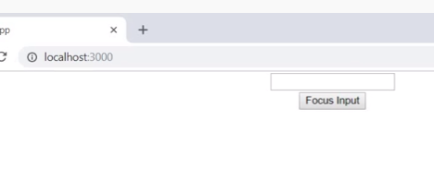

**As we have implement - when click on the button on the parent component it should focus on the text on the chid component..**

* **For this we have to create the reference in the parent component : -**
* **Rconst – short cut key for the constructor ..**

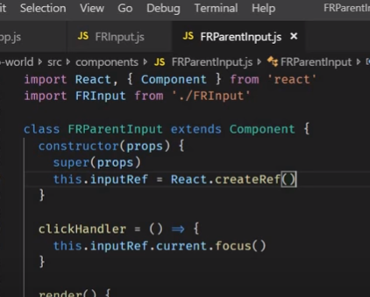

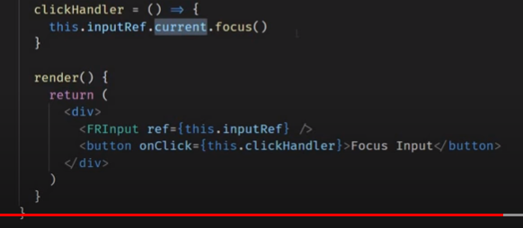

**Function is converted to Array Function i.e const function () = {**

**Return(**

**<div> </div>**

**)}**

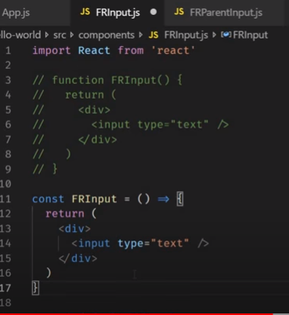

**As we are defining the property for the FRInput = React.forwardRef((props.ref) =>{return(<div> </div>)})**

**1-parma-Props – as we know that every functional component receive the props as its paremeter.**

**When component is passed as a parameter to create ref method its received the ref attribute as second parameter**

**2-param- Ref – we use can this ref parameter and pass it a value to the ref attribute to the native input element.**

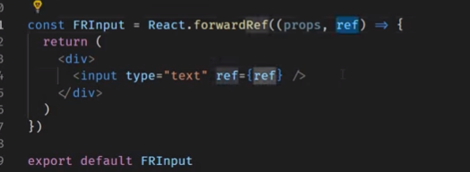

**Before click**

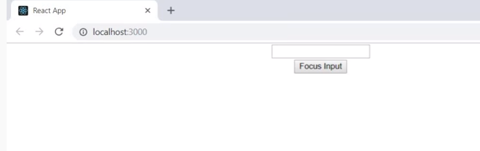

**After click :-**

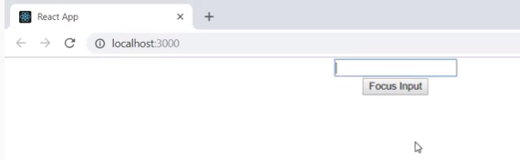

**Flow :- using React.FowardRef**

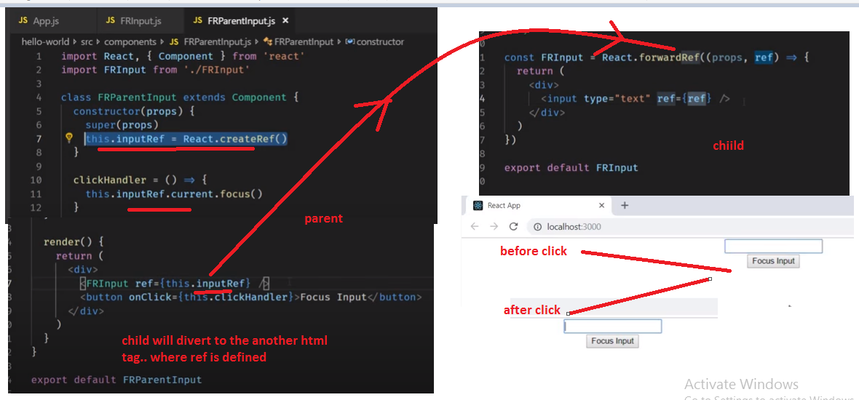

[**https://www.youtube.com/watch?v=HpHLa-5Wdys&list=PLC3y8-rFHvwgg3vaYJgHGnModB54rxOk3&index=31**](https://www.youtube.com/watch?v=HpHLa-5Wdys&list=PLC3y8-rFHvwgg3vaYJgHGnModB54rxOk3&index=31)

# ReactJS Tutorial - 31 - Portals

# React Portals

The **React 16.0** version introduced React portals in **September 2017**. A React portal provides a way to render an element outside of its component hierarchy, i.e., in a separate component.

Before React 16.0 version, it is very tricky to render the child component outside of its parent component hierarchy. If we do this, it breaks the convention where a component needs to render as a new element and follow a **parent-child** hierarchy. In React, the parent component always wants to go where its child component goes. That's why React portal concept comes in.

[**https://www.geeksforgeeks.org/reactjs-portals/**](https://www.geeksforgeeks.org/reactjs-portals/)

[**https://reactjs.org/docs/portals.html**](https://reactjs.org/docs/portals.html)

# Portals

Portals provide a first-class way to render children into a DOM node that exists outside the DOM hierarchy of the parent component.

### Syntax

ReactDOM.createPortal(child, container)

The first argument (child) is any [renderable React child](https://reactjs.org/docs/react-component.html#render), such as an element, string, or fragment. The second argument (container) is a DOM element.

### Example before React v16

Generally, when you want to return an element from a component's render method, it is mounted as a new div into the DOM and render the children of the closest parent component.

render() {

// React mounts a new div and renders the children into it

return (

<div> {this.props.children}

</div> );

}

### Example using portal

However, sometimes it’s useful to insert a child into a different location in the DOM:

render() {

// React does *not* create a new div. It renders the children into `domNode`.

// `domNode` is any valid DOM node, regardless of its location in the DOM.

return ReactDOM.createPortal(

this.props.children,

domNode );

}

A typical use case for portals is when a parent component has an overflow: hidden or z-index style, but you need the child to visually “break out” of its container. For example, dialogs, hovercards, and tooltips.

**Note:**

When working with portals, remember that [managing keyboard focus](https://reactjs.org/docs/accessibility.html#programmatically-managing-focus) becomes very important.

For modal dialogs, ensure that everyone can interact with them by following the [WAI-ARIA Modal Authoring Practices](https://www.w3.org/TR/wai-aria-practices-1.1/#dialog_modal).

## Features

* It uses React version 16 and its official API for creating portals.
* It has a fallback for React version 15.
* It transports its children component into a new React portal which is appended by default to document.body.
* It can also target user specified DOM element.
* It supports server-side rendering
* It supports returning arrays (no wrapper div's needed)
* It uses <Portal /> and <PortalWithState /> so there is no compromise between flexibility and convenience.
* It doesn't produce any DOM mess.
* It has no dependencies, minimalistic.

## When to use?

The common use-cases of React portal include:

* Modals
* Tooltips
* Floating menus
* Widgets

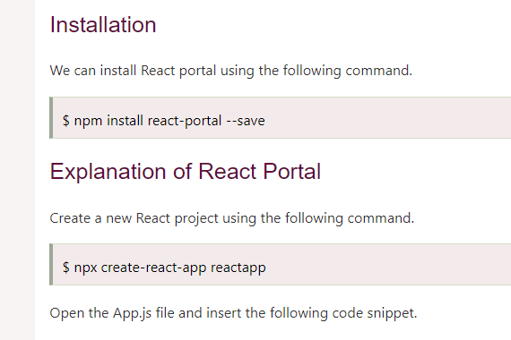

Open the App.js file and insert the following code snippet.

**App.js**

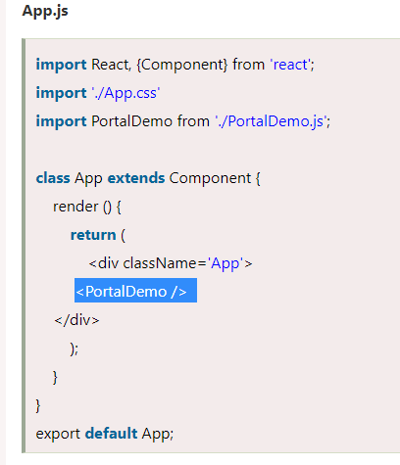

The next step is to create a **portal** component and import it in the App.js file.

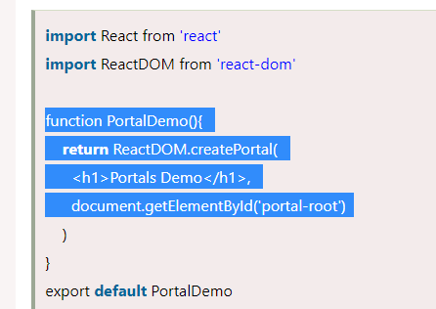

Now, open the Index.html file and add a <div id="portal-root"></div> element to access the child component outside the root node

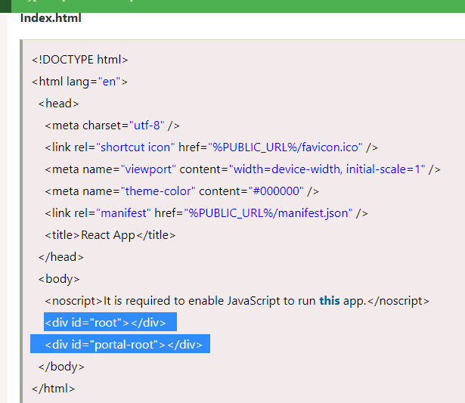

**Output:**

When we execute the React app, we will get the following screen.

Now, open the **Inspect** (ctrl + shift + I). In this window, select the **Elements** section and then click on the <div id="portal-root"></div> component. Here, we can see that each tag is under the "portal-root" DOM node, not the "root" DOM node. Hence, we can see that how React Portal provides the ability to break out of root DOM tree

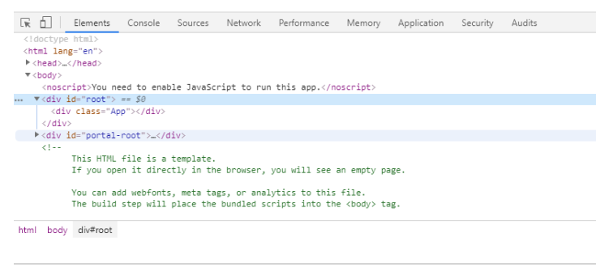

[**https://www.youtube.com/watch?v=DNYXgtZBRPE&list=PLC3y8-rFHvwgg3vaYJgHGnModB54rxOk3&index=32**](https://www.youtube.com/watch?v=DNYXgtZBRPE&list=PLC3y8-rFHvwgg3vaYJgHGnModB54rxOk3&index=32)

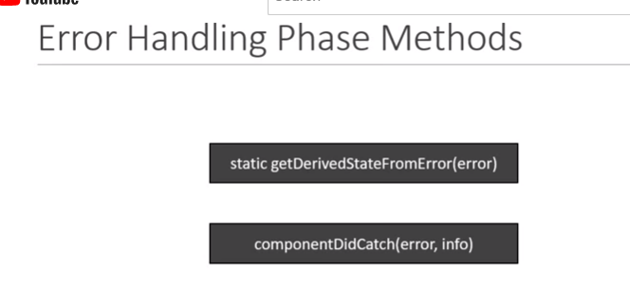

# ReactJS Tutorial - 32 - Error Boundary

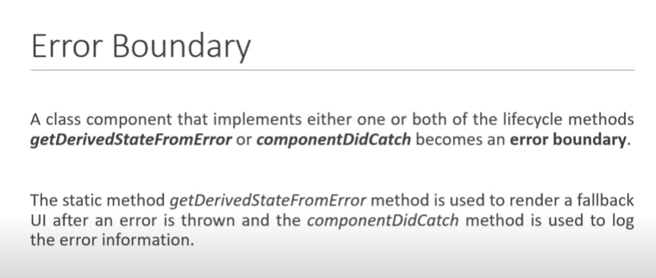

**Lets define the component and lest the props as heroName and make application to throw the error if the heroName is Joker**

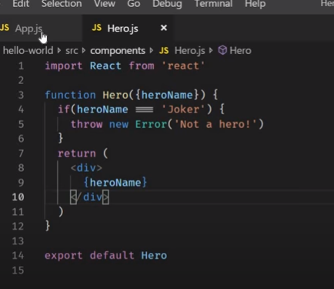

**App.js**

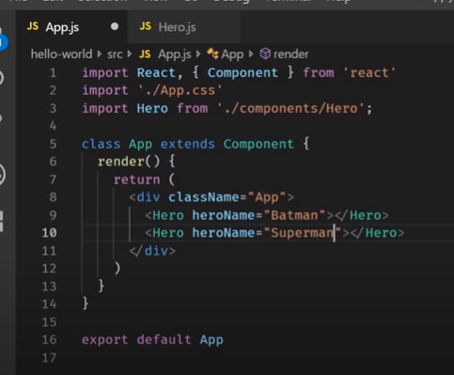

**Output:- no error in the code.**

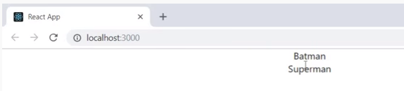

Lets pass the filed name as Jocker

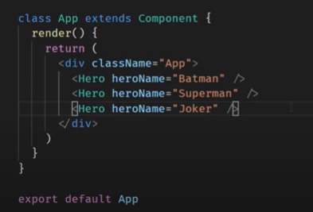

**Out put:- You can see entire application is crash : -**

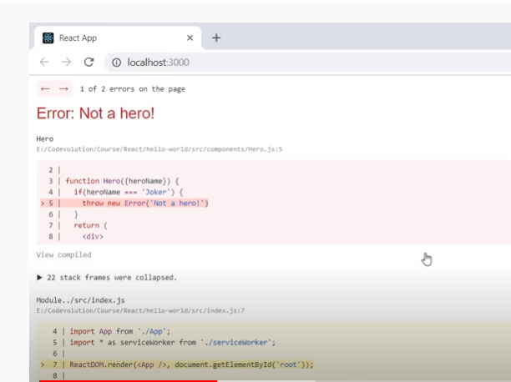

**If the particular component throw the error only that component should fallback in to ui and remaing the component should not effect.**

**This can achieved by the error boundaries**

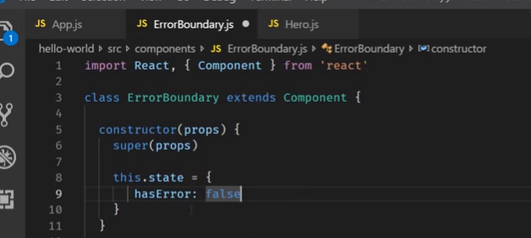

**This below method is used for the fallback ui**

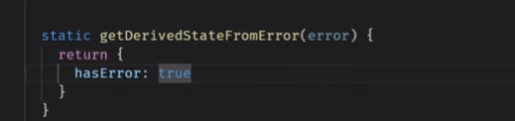

**If the error its goes to the if statement**

**If not error its goes to the this.props.children**

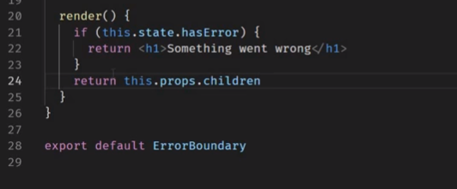

**Now in the App.js.. Wrap all the components in the Error Boundary.**

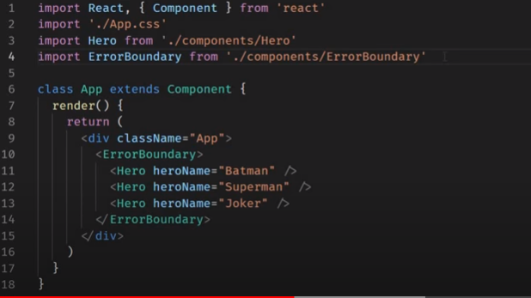

**React team mentioned - ErrorBoundary for the only the production but in development they wont make the errors as highgly visible as possible. So, we always see this error while development**

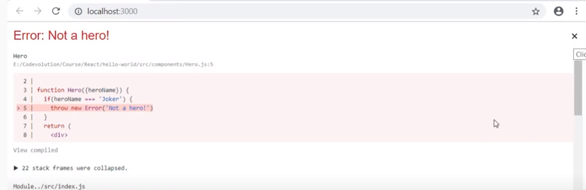

**Now click on the top right on the cross mark :-**

**Now the application back: -**

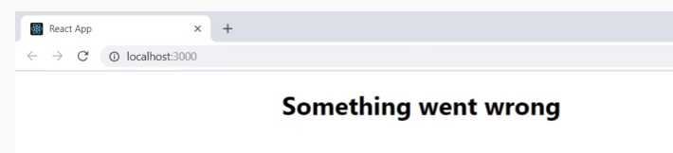

**If you comment the code.. such error boundaries**

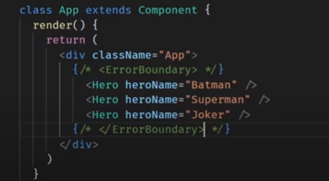

**On the browser you can see the error and if you close the cross button. It will nothing on the browser.**

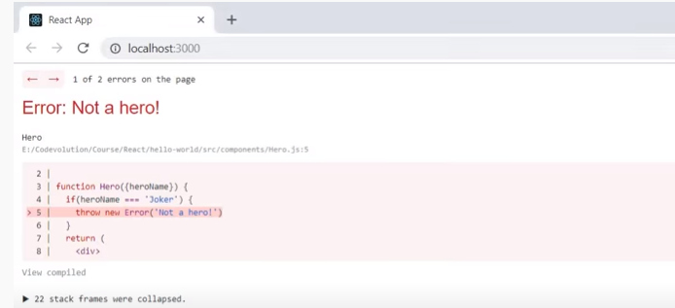

**After close : -**

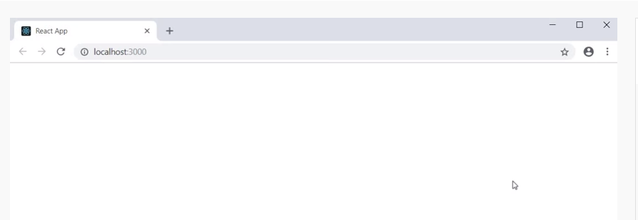

**But in case of error boundry shows the something went wrong**

**There are so many components will be their and we have to wrap the each component t in the Error boundry ..**

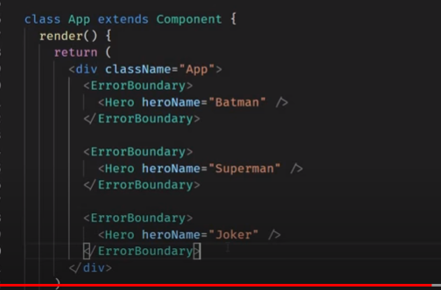

**Error on the browser**

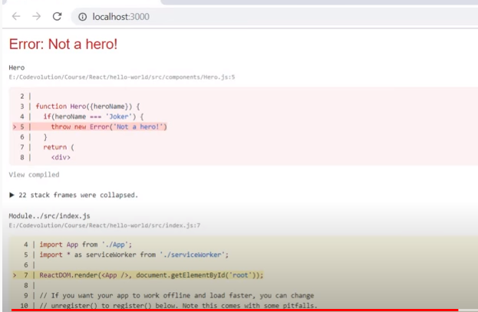

**Close the cross button : you can see the first two components will not effect and other component which has got error will throw the fall back ui .**

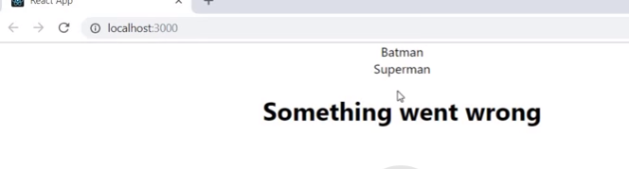

**Lets add the method.- componentDidCatch()**

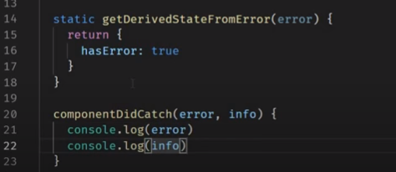

**Erro: not a hero**

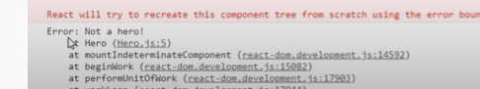

**Object**

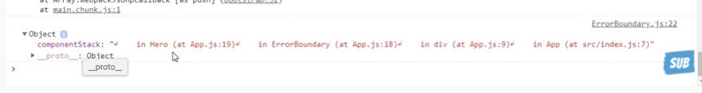

**However, react will automatically logs.**

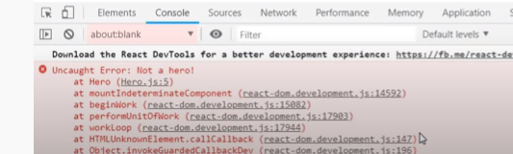

**Error boundaries catch the errors during the rendering and life cycle methods and constructor of whole tree below them and however they don’t catch errors in the event eg: onclick .**

**Then you can use the regular try catch block.**

# React Error Boundaries

# <https://www.javatpoint.com/react-error-boundaries>

In the past, if we get any JavaScript errors inside components, it corrupts the React?s internal state and put React in a broken state on next renders. There are no ways to handle these errors in React components, nor it provides any methods to recover from them.

But, **React 16** introduces a new concept to handle the errors by using the **error boundaries**. Now, if any JavaScript error found in a part of the UI, it does not break the whole app.

Error boundaries are React components which catch JavaScript errors anywhere in our app, log those errors, and display a fallback UI.

 It does not break the whole app component tree and only renders the fallback UI whenever an error occurred in a component.

 Error boundaries catch errors during rendering in component lifecycle methods, and constructors of the whole tree below them.

Note:

Sometimes, it is not possible to catch Error boundaries in React application. These are:

* Event handlers
* Asynchronous code (e.g. setTimeout or requestAnimationFrame callbacks)
* Server-side rendering
* Errors are thrown in the error boundary itself rather than its children.

For simple React app, **we can declare an error boundary once and can use it for the whole application.** For a complex application which have multiple components, we can declare multiple error boundaries to recover each part of the entire application.

We can also report the error to an error monitoring service like **Rollbar**. This monitoring service provides the ability to track how many users are affected by errors, find causes of them, and improve the user experience.

## Error boundary in class

A class component can becomes an error boundary if it defines a new lifecycle methods either static getDerivedStateFromError() or componentDidCatch(error, info). We can use static getDerivedStateFromError() to render a fallback UI when an error has been thrown, and can use componentDidCatch() to log error information.

An error boundary can?t catch the error within itself. If the error boundary fails to render the error message, the error will go to the closest error boundary above it. It is similar to the catch {} block in JavaScript.

## How to implement error boundaries

**Step-1** Create a class which extends React component and passes the props inside it.

**Step-2** Now, add componentDidCatch() method which allows you to catch error in the components below them in the tree.

**Step-3** Next add render() method, which is responsible for how the component should be rendered. For example, it will display the error message like "Something is wrong."

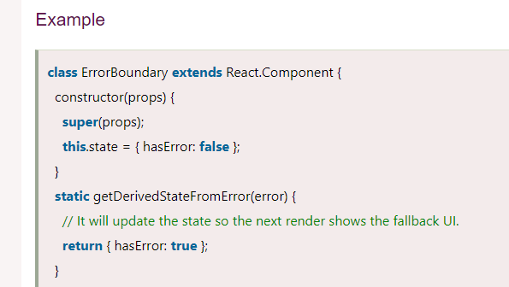

**static getDerivedStateFromError(error) {**

**// It will update the state so the next render shows the fallback UI.**

**return { hasError: true };**

}

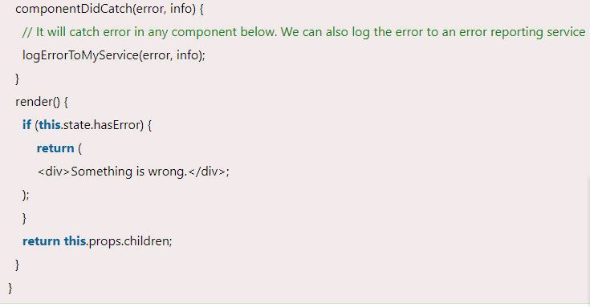

**componentDidCatch(error, info) {**

**// It will catch error in any component below. We can also log the error to an error reporting service.**

**logErrorToMyService(error, info);**

**Step-4** Now, we can use it as a regular component. Add the new component in HTML, which you want to include in the error boundary. In this example, we are adding an error boundary around a MyWidgetCounter component.

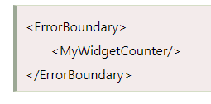

## Where to Place Error Boundaries

An error boundary entirely depends on you. You can use error boundaries on the top-level of the app components or wrap it on the individual components to protect them from breaking the other parts of the app.

Lets consider ErrorBoundary class

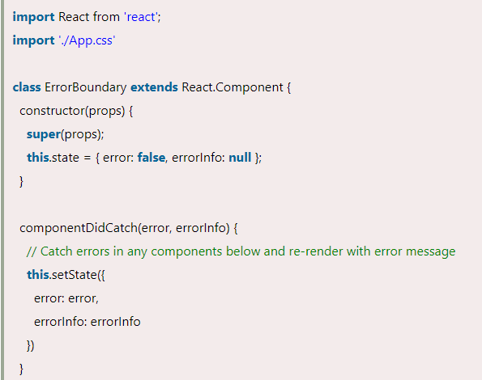

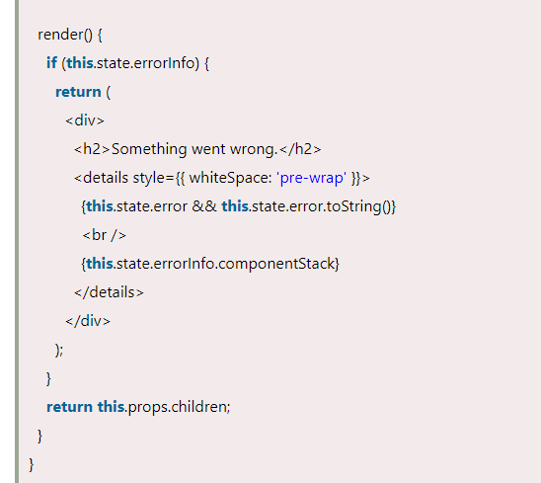

     {**this**.state.errorInfo.componentStack}

BuggyCounter

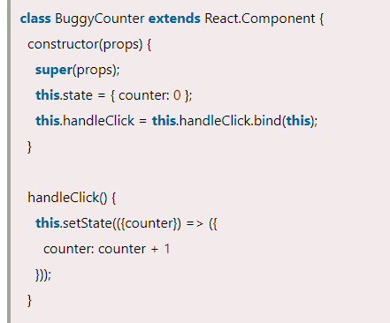

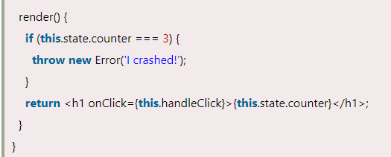

render() {

if (this.state.counter === 3) {

throw new Error('I crashed!');

}

return <h1 onClick={this.handleClick}>{this.state.counter}</h1>;

}

}

**App.js**

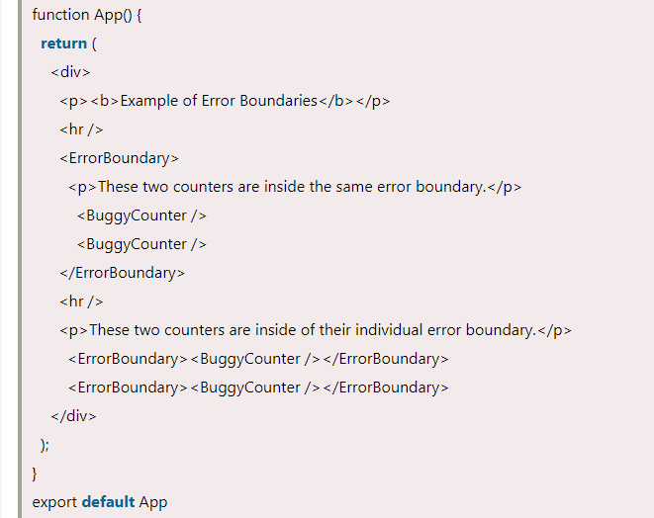

In the above code snippet, when we click on the **numbers**, it increases the **counters**. The counter is programmed to **throw** an error when it reaches **3**. It simulates a JavaScript error in a component. Here, we used an error boundary in **two ways**, which are given below.

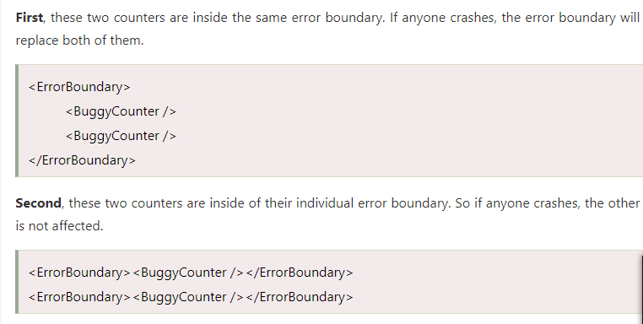 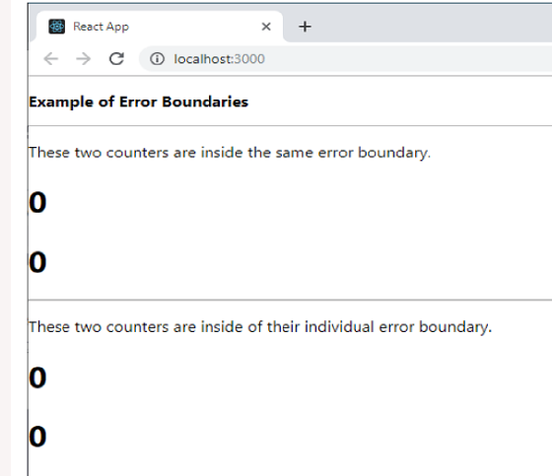

Output

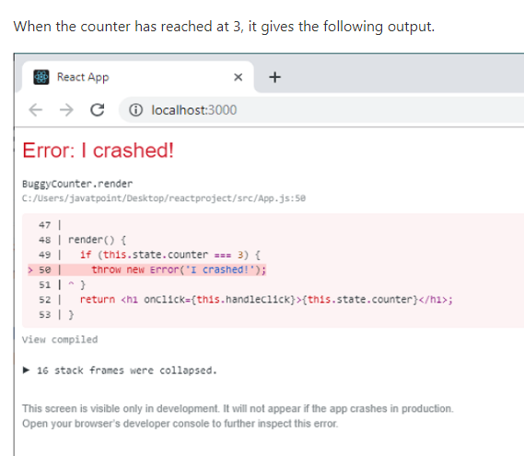

## New Behavior for Uncaught error

It is an important implication related to error boundaries. If the error does not catch by any error boundary, it will result in **unmounting** of the whole React application.

## Error Boundary in Event Handler

Error boundaries do not allow catching errors inside event handlers. React does not need any error boundary to recover from errors in the event handler. If there is a need to catch errors in the event handler, you can use JavaScript **try-catch** statement.

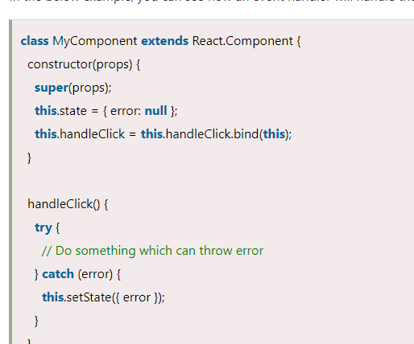

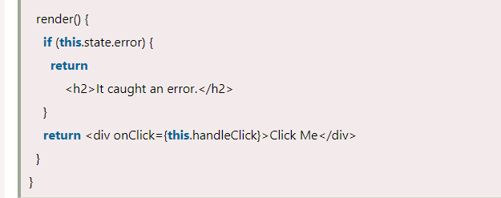

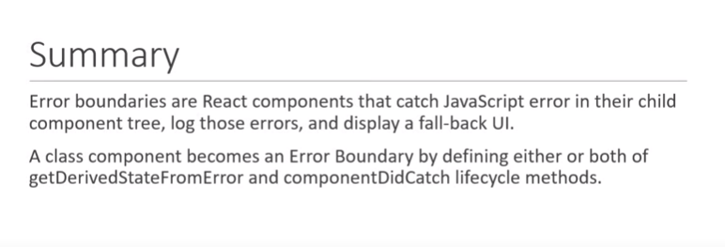

<https://www.youtube.com/watch?v=B6aNv8nkUSw&list=PLC3y8-rFHvwgg3vaYJgHGnModB54rxOk3&index=33>

# Higher Order Components (Part 1)

Lets create the clickcounter .js

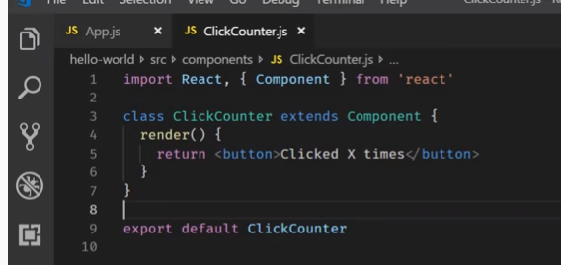

App.js

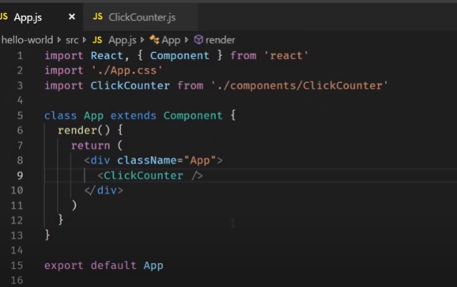

Output:-

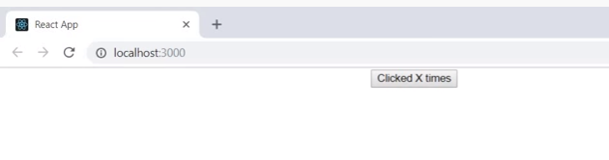

Lets implement the code..

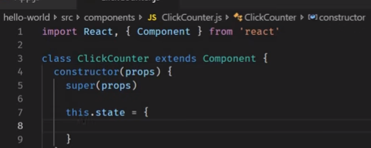

When you click on the **incrementCount** it will take the previousState as parameter and return new **state**..

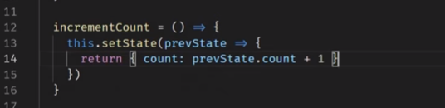

**Lets extract the count from the state and include in the jsx**

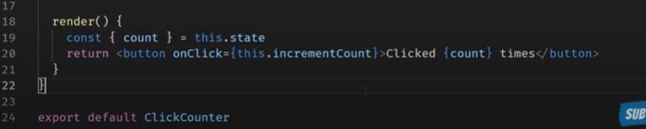

**We have successful created the counter increament.**

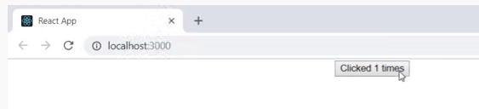

**Same code using the function with the hooks**

<https://contactmentor.com/react-increment-counter-hooks/>

import React, { useState } from "react";

import ReactDOM from "react-dom";

function App() {

// State to store count value

const [count, setCount] = useState(0);

// Function to increment count by 1

const incrementCount = () => {

// Update state with incremented value

setCount(count + 1);

};

return (

<div className="app">

<button onClick={incrementCount}>Click Here</button>

{count}

</div>

);

}

But the client want to change the click event to hover.. how to achieve this.. ?

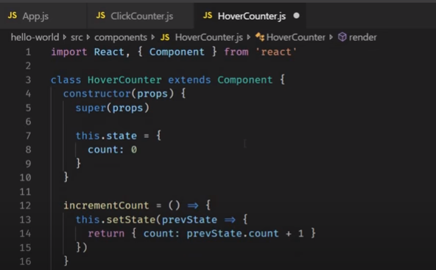

**We have want to the pass the current state in to the jsx then define the const {const} = this.state**

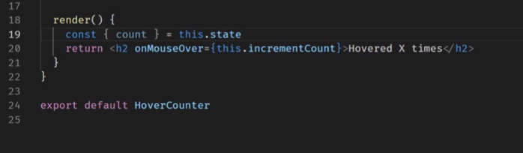

**App.js**

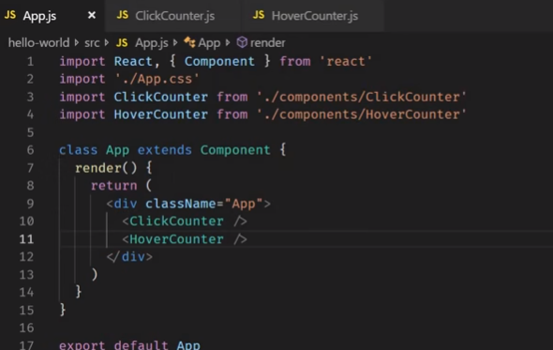

**When hover the mouse count increases**

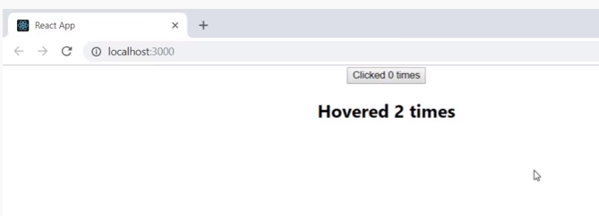

**In the both class/components we have the same the functions like incrementCount() which we are not re-using.. instead we are writing the duplicate code.**

**If ten different components want the counter functionality then the code is duplicate/same code over and over again.**

**Case 1 : Lifting the state of the parent and pass to the child it will work out.**

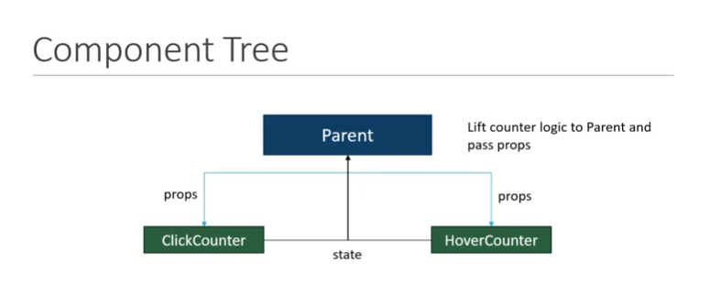

**Case two.. where passing the props to the multiple child compoents will not possible.**

**So, we have to define the common functionality and share between components . i.e**

**Higher Order Component :**

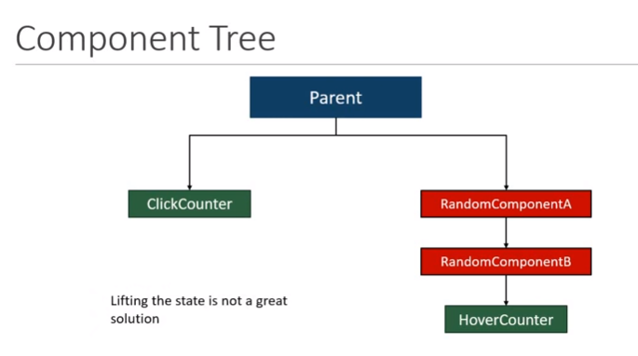

[**https://www.youtube.com/watch?v=rsBQj6X7UK8&list=PLC3y8-rFHvwgg3vaYJgHGnModB54rxOk3&index=34**](https://www.youtube.com/watch?v=rsBQj6X7UK8&list=PLC3y8-rFHvwgg3vaYJgHGnModB54rxOk3&index=34)

# React Higher-Order Components

It is also known as HOC. In React, HOC is an advanced technique for reusing component logic. It is a function that takes a component and returns a new component.

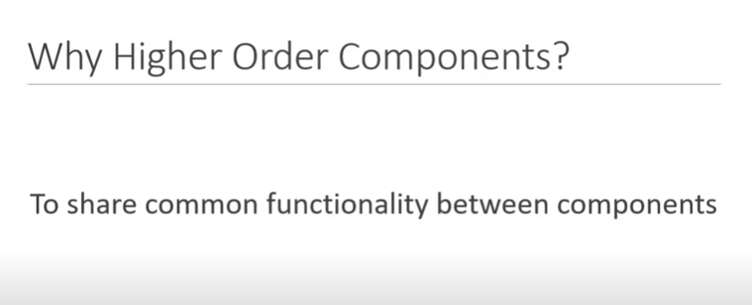

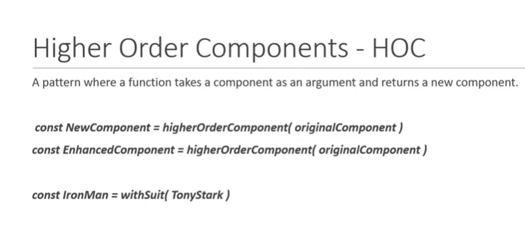

According to the official website, it is not the feature(part) in React API, but a pattern that emerges from React compositional nature. They are similar to JavaScript functions used for **adding additional functionalities to the existing component.**

**A higher order component** **function** **accepts another function as an argument.**

The **map** function is the best example to understand this.

**The main goal of this is to decompose the component logic into simpler and smaller functions that can be reused as you need.**

**Basic Hoc : - As we are not adding the any additional function in it.**

[**https://www.w3schools.com/js/js_arrow_function.asp**](https://www.w3schools.com/js/js_arrow_function.asp)

**Lets define the ArrayFunction ie. const updatedComponent =()=> {}**

**const updatedComponent =(pass the params/argument)=> {} // multiple**

**const updatedComponent =pass the params/argument=> {} // single param**

**const updatedComponent = OriginalComponent => {**

**// hoc- OriginalComponent is parameter**

**// hoc –return new component , its component it self render({return original component}.**

**// hoc –return new component**

**}**

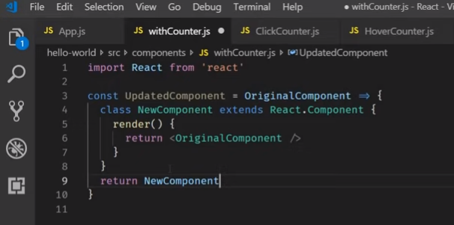

**Lets define some logic OriginalComponent name=’Viswas’ and export the Updated Component**

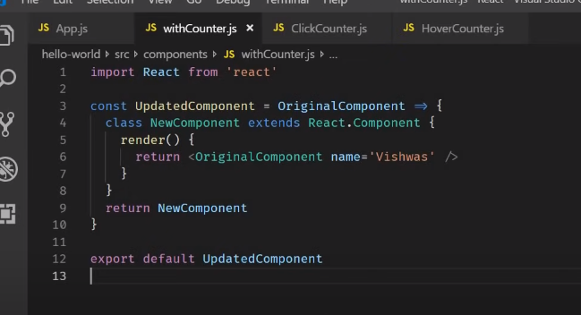

**Lets apply to the Clickcounter and HoverComponent**

**Import the UpdatedComponent**

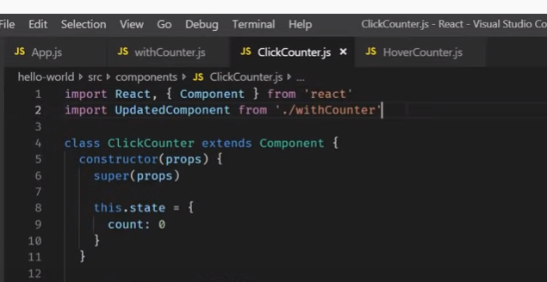

**Export default and UpdatedComponent(ClickCounter)**

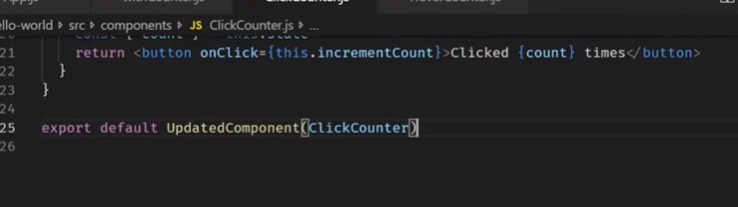

**As same for the HoverCounter – adding the Higher Order Component**

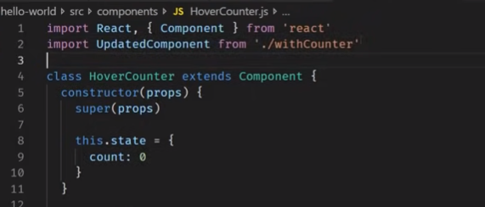

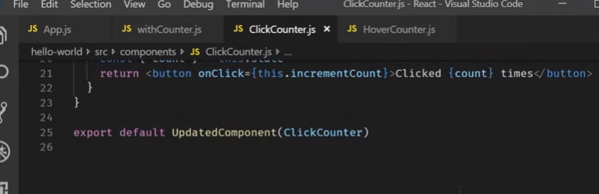

**When add in the both components i.e this.props.name**

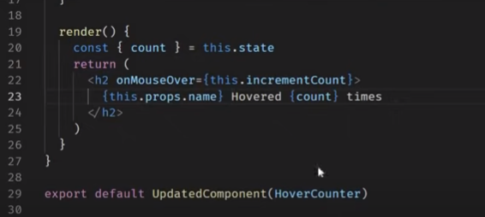

**When you see on the browser – vishwas on the button and Heading..**

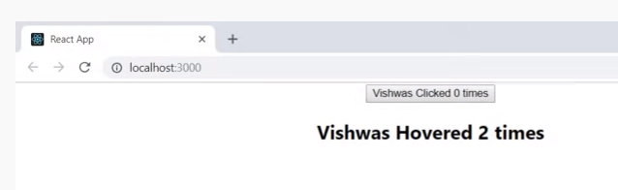

**Actually we want the counter functionality in Hoc :-**

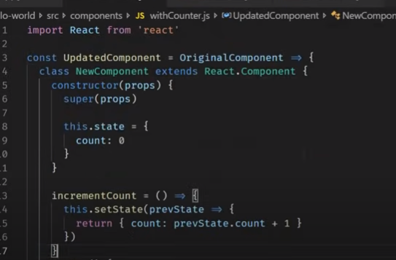

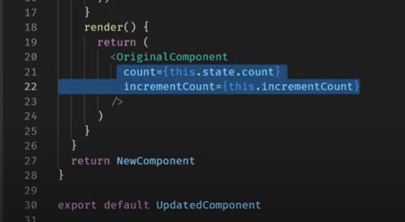

**Lets remove the code in the click and hover components**

**ClickCounter**

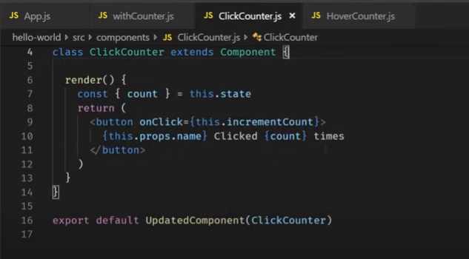

**HoverComponent**

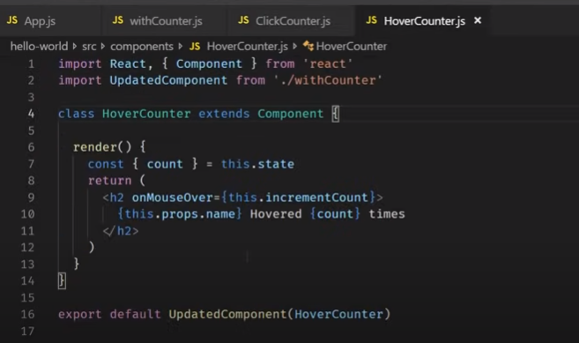

**Now lets make code change in the Hover and Click couter**

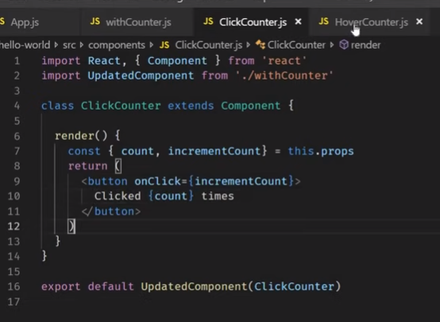

**Lets make change in the code**

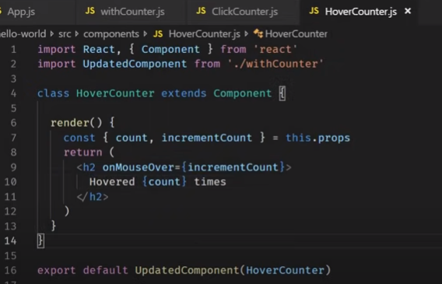

**Flow :- for HoverCounter**

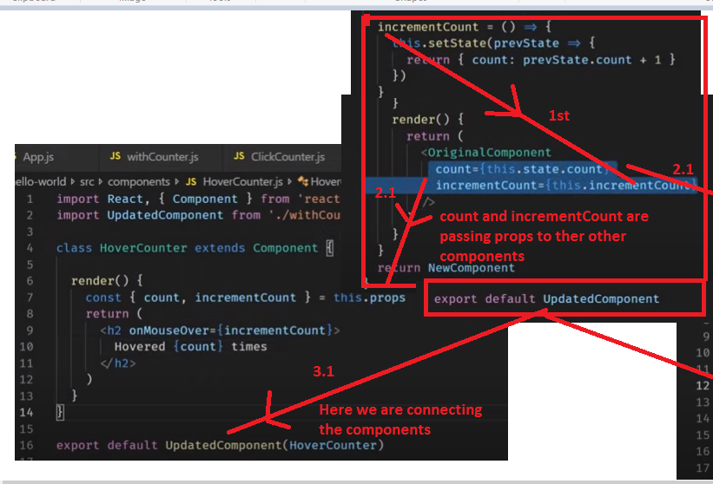

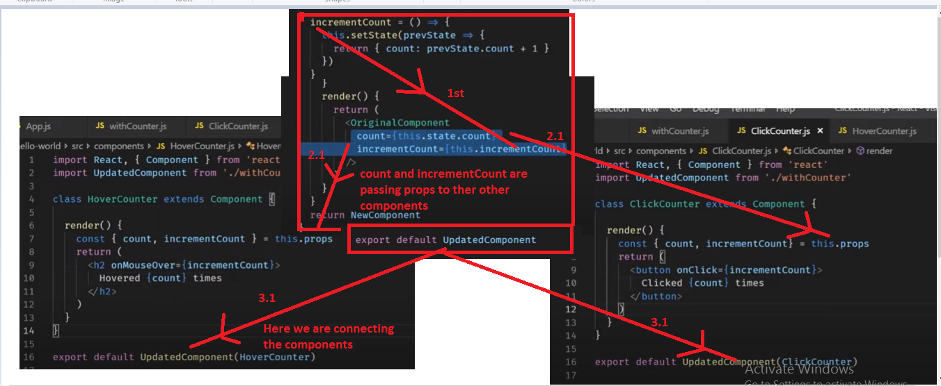

**Note…**

**Updated component is the function which accepts the components as parameter which we get from the other components such as**

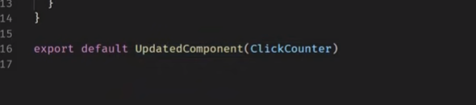

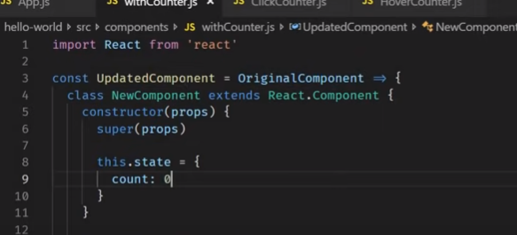

**So here the Original component is the clickcounter.**

**And we have new component which have state and increment function.**

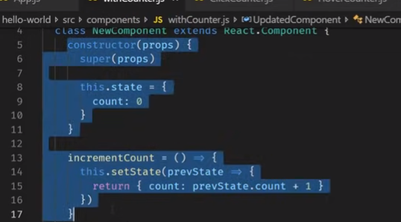

**And we passing the both state and method as props to the orignical component and return new component.**

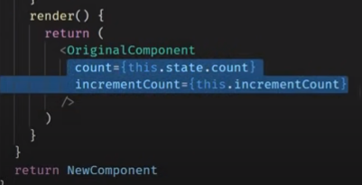

**Then control goes back to the clickcounter from the HOC to the click counter and destructure the props and used in the return statement**

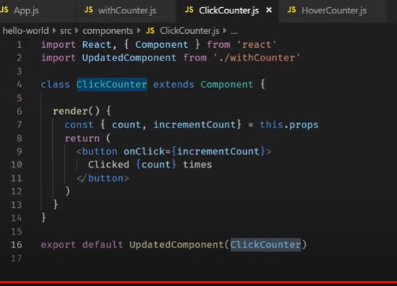

**So, HOC is maintain the state and incrementfunction**. **However, naming convention should be . But no rule that naming should be like this.. but most the articles are defined like this.**

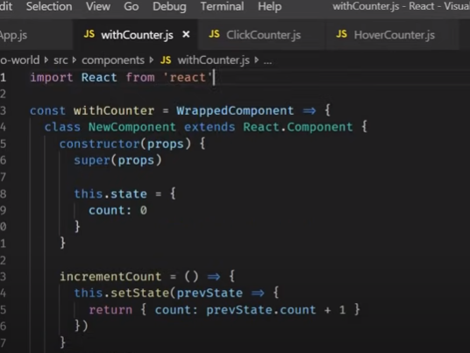

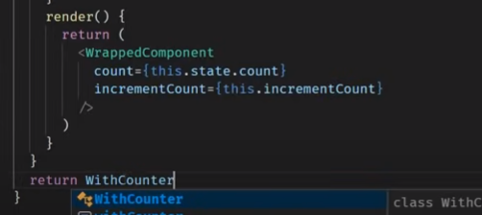

**Now change the name of the component in the hover and click counter**

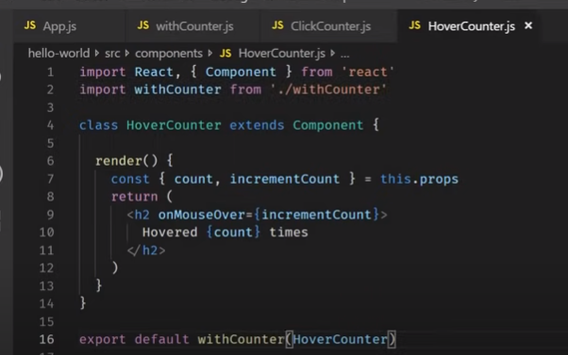

[**https://www.youtube.com/watch?v=rsBQj6X7UK8&list=PLC3y8-rFHvwgg3vaYJgHGnModB54rxOk3&index=34**](https://www.youtube.com/watch?v=rsBQj6X7UK8&list=PLC3y8-rFHvwgg3vaYJgHGnModB54rxOk3&index=34)

# Higher Order Components (Part 3)

**Lets pass the param in the click counter.**

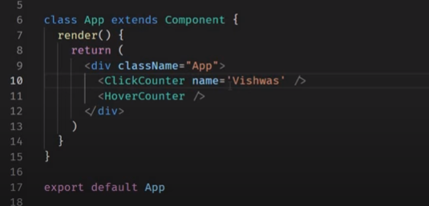

**On click counter : when you define the {this.props.name} – it will not render on the click counter as it pass the props the HOC.**

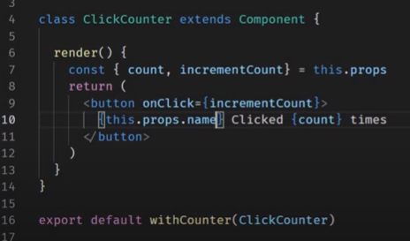

**Output :- You can see the name Vishwas is not displayed**

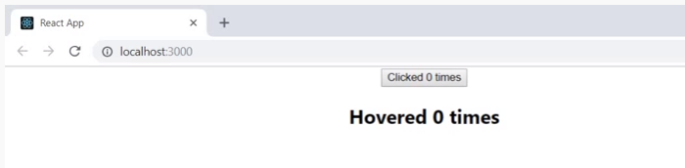

**Here the props sents to the HOC. In hoc:-**

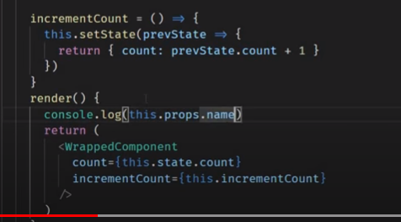

**Output : -**

**In developer tools :- for hoc its reflects and where as for the hover counter it is undefined.**

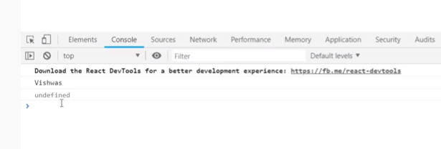

**To over comet the this.. we have to the pass the props(re-maining props) to all other components bythe spread operator – in our case remaing the props are name.**

**So, when create the hoc.. please pass the spread operator for the rest of the props…**

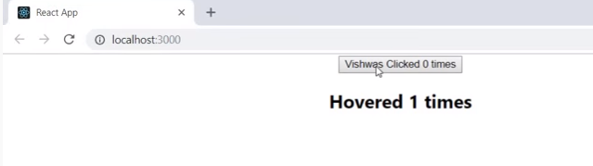

**Passing Parameter in to the hoc function.**

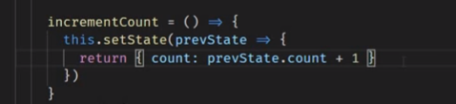

**Instead of sharing the same outcome like increment by only 1, we can change the value by the passing the parameter.**

**Now lets define the parameters in the array function like {WrappedComponet, incrementNumnber} in HOC.**

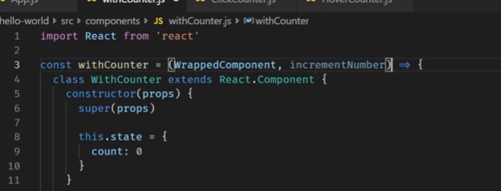

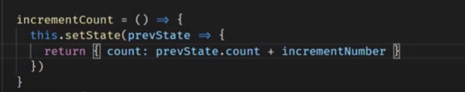

**Lets change the code in the click and hover componets**

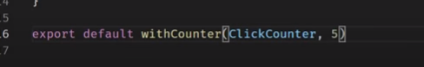



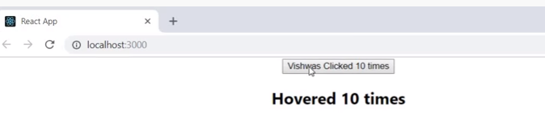

**Hoc are come as react libraries like connet HOC in redux , with router in react router, styles in the material ui.**

[**https://www.youtube.com/watch?v=NdapMDgNhtE&list=PLC3y8-rFHvwgg3vaYJgHGnModB54rxOk3&index=36**](https://www.youtube.com/watch?v=NdapMDgNhtE&list=PLC3y8-rFHvwgg3vaYJgHGnModB54rxOk3&index=36)